Table of Contents

UNITED STATES

SECURITIES AND EXCHANGE COMMISSION

Washington, D.C. 20549

FORM 10-K

- ANNUAL REPORT PURSUANT TO SECTION 13 OR 15(d) OF THE SECURITIES EXCHANGE ACT OF 1934

For the fiscal year ended December 31, 2022

OR

- TRANSITION REPORT PURSUANT TO SECTION 13 OR 15(d) OF THE SECURITIES EXCHANGE ACT OF 1934 FOR THE TRANSITION PERIOD FROM TO

Commission File No. 1-15579
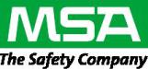

MSA SAFETY INCORPORATED

(Exact name of registrant as specified in its charter)

Pennsylvania |  |  |  |  | 46-4914539
(State or other jurisdiction of incorporation or organization) |  |  |  |  | (IRS Employer Identification No.)
1000 Cranberry Woods Drive
Cranberry Township, Pennsylvania |  |  |  |  | 16066-5207
(Address of principal executive offices) |  |  |  |  |  | (Zip Code)
 | Registrant’s telephone number, including area code: (724) 776-8600
 |  | Securities registered pursuant to Section 12(b) of the Act:
Common Stock, no par value |  | MSA |  |  |  | New York Stock Exchange
(Title of each class) |  | (Trading symbol(s)) |  |  |  | (Name of each exchange on which registered)
 |  | Securities registered pursuant to Section 12(g) of the Act: None
Indicate by check mark whether the registrant is a well-known seasoned issuer, as defined in Rule 405 of the Securities Act. |  |  | Yes | x | No ☐
Indicate by check mark if the registrant is not required to file reports pursuant to Section 13 or Section 15(d) of the Act. Yes |  |  | ☐ | No | x

Indicate by check mark whether the registrant (1) has filed all reports required to be filed by Section 13 or 15(d) of the Securities Exchange Act of 1934 during the preceding 12 months and (2) has been subject to such filing requirements for the past 90 days. Yes x No ☐

Indicate by check mark whether the registrant has submitted electronically every Interactive Data File required to be submitted pursuant to Rule 405 of Regulation S-T (§ 232.405 of this chapter) during the preceding 12 months (or for such shorter period that the registrant was required to submit such files). Yes x No ☐

Indicate by check mark whether the registrant is a large accelerated filer, an accelerated filer, a non-accelerated filer, smaller reporting company, or an emerging growth company. See the definitions of “large accelerated filer,” “accelerated filer,” “smaller reporting company,” and “emerging growth company” in Rule 12b-2 of the Exchange Act.

Large Accelerated Filer x Accelerated filer ☐ Non-accelerated filer ☐ Smaller reporting company ☐ Emerging growth company ☐

If an emerging growth company, indicate by check mark if the registrant has elected not to use the extended transition period for complying with any new or revised financial accounting standards provided pursuant to Section 13(a) of the Exchange Act. ☐

Indicate by check mark whether the registrant has filed a report on and attestation to its management’s assessment of the effectiveness of its internal control over financial reporting under Section 404(b) of the Sarbanes-Oxley Act (15 U.S.C. 7262(b)) by the registered public accounting firm that prepared or issued its audit report. Yes x

If securities are registered pursuant to Section 12(b) of the Act, indicate by check mark whether the financial statements of the registrant included in the filing reflect the correction of an error to previously issued financial statements. ☐

Indicate by check mark whether any of those error corrections are restatements that required a recovery analysis of incentive-based compensation received by any of the registrant’s executive officers during the relevant recovery period pursuant to §240.10D-1(b). ☐

Indicate by check mark whether the registrant is a shell company (as defined in Rule 12b-2 of the Act). Yes ☐ No x

The aggregate market value of voting stock held by non-affiliates as of June 30, 2022 was approximately $4.4 billion. As of February 10, 2023, there were outstanding 39,213,240 shares of common stock, no par value.

DOCUMENTS INCORPORATED BY REFERENCE

Portions of the Proxy Statement for the May 12, 2023 Annual Meeting of Shareholders are incorporated by reference into Part III.

Table of Contents

 |  |  |  |  |  |  |  |  |  |  |  |  |  |  |  |  | Table of Contents
Item No. |  |  |  |  |  |  |  |  |  |  |  |  |  |  |  |  |  |  |  |  |  |  | Page
 | Part I
1. |  |  | Business |  |  |  |  |  |  |  |  |  |  |  |  |  |  |  |  |  |  |  | 4
 |  | 1A. | Risk Factors |  |  |  |  |  |  |  |  |  |  |  |  |  |  |  |  |  |  |  |  |  | 10
 |  | 1B. | Unresolved Staff Comments |  |  |  |  |  |  |  |  |  |  |  |  |  |  |  |  |  |  |  | 20
2. |  |  | Properties |  |  |  |  |  |  |  |  |  |  |  |  |  |  |  |  |  |  |  |  |  | 20
3. |  |  | Legal Proceedings |  |  |  |  |  |  |  |  |  |  |  |  |  |  |  |  |  |  |  |  |  | 20
4. |  |  | Mine Safety Disclosures |  |  |  |  |  |  |  |  |  |  |  |  |  |  |  |  |  |  |  |  |  | 20
 | Part II |  | Executive Officers of the Registrant |  |  |  |  |  |  |  |  |  |  |  |  |  |  |  |  |  |  |  | 21
5. |  |  | Market for the Registrant’s Common Equity, Related Stockholder Matters and Issuer Purchases of Equity Securities |  |  |  |  |  |  |  |  |  |  |  |  |  |  |  |  |  |  |  | 22
6. |  |  | [Reserved] |  |  |  |  |  |  |  |  |  |  |  |  |  |  |  |  |  |  |  |  |  | 23
7. |  |  | Management’s Discussion and Analysis of Financial Condition and Results of Operations |  |  |  |  |  |  |  |  |  |  |  |  |  |  |  |  |  |  |  |  |  | 24
 |  | 7A. | Quantitative and Qualitative Disclosures About Market Risk |  |  |  |  |  |  |  |  |  |  |  |  |  |  |  |  |  |  |  |  |  | 35
8. |  |  | Financial Statements and Supplementary Data |  |  |  |  |  |  |  |  |  |  |  |  |  |  |  |  |  |  |  |  |  | 36
9. |  |  | Changes in and Disagreements with Accountants on Accounting and Financial Disclosure |  |  |  |  |  |  |  |  |  |  |  |  |  |  |  |  |  |  |  | 81
 |  | 9A. | Controls and Procedures |  |  |  |  |  |  |  |  |  |  |  |  |  |  |  |  |  |  |  |  |  | 81
 |  | 9B. | Other Information |  |  |  |  |  |  |  |  |  |  |  |  |  |  |  |  |  |  |  |  |  | 81
 |  | 9C.
 |  | 9C. | Disclosure Regarding Foreign Jurisdictions that Prevent Inspections |  |  |  |  |  |  |  |  |  |  |  |  |  |  |  |  |  |  |  | 81
 | Part III
10. |  |  | Directors, Executive Officers and Corporate Governance |  |  |  |  |  |  |  |  |  |  |  |  |  |  |  |  |  |  |  |  |  | 82
11. |  |  | Executive Compensation |  |  |  |  |  |  |  |  |  |  |  |  |  |  |  |  |  |  |  |  |  | 82
12. |  |  | Security Ownership of Certain Beneficial Owners and Management and Related Stockholder Matters |  |  |  |  |  |  |  |  |  |  |  |  |  |  |  |  |  |  |  | 82
13. |  |  | Certain Relationships and Related Transactions, and Director Independence |  |  |  |  |  |  |  |  |  |  |  |  |  |  |  |  |  |  |  |  |  | 82
14. |  |  | Principal Accountant Fees and Services |  |  |  |  |  |  |  |  |  |  |  |  |  |  |  |  |  |  |  |  |  | 82
 | Part IV
15. |  |  | Exhibits and Financial Statement Schedules |  |  |  |  |  |  |  |  |  |  |  |  |  |  |  |  |  |  |  | 83
16. |  |  | Form 10-K Summary |  |  |  |  |  |  |  |  |  |  |  |  |  |  |  |  |  |  |  |  |  | 85
 |  |  | Signatures |  |  |  |  |  |  |  |  |  |  |  |  |  |  |  |  |  |  |  |  |  | 86
 |  |  |  |  |  | 2

Table of Contents

Cautionary Statement Regarding Forward-Looking Statements

This report may contain (and verbal statements made by MSA® Safety Incorporated (MSA) may contain) "forward-looking statements" within the meaning of the Private Securities Litigation Reform Act of 1995. These statements relate to future events or future financial performance and involve various assumptions, known and unknown risks, uncertainties and other factors that may cause our actual results, levels of activity, performance or achievements to be materially different from any future results, levels of activity, performance or achievements expressed or implied by these forward-looking statements. These risks and other factors include, but are not limited to, those listed in this report under “Risk Factors,” “Management’s Discussion and Analysis of Financial Condition and Results of Operations,” and elsewhere in this report. In some cases, you can identify forward-looking statements by words such as “may,” “will,” “should,” “expects,” “intends,” “plans,” “anticipates,” “believes,” “estimates,” “predicts,” “potential” or other comparable words. Actual results, performance or outcomes may differ materially from those expressed or implied by these forward-looking statements and may not align with historical performance and events due to a number of factors, including those discussed in the sections of this report described above. Although we believe that the expectations reflected in the forward-looking statements are reasonable, we cannot guarantee future results, levels of activity, performance or achievements, and caution should be exercised against placing undue reliance upon such statements. We are under no duty to update publicly any of the forward-looking statements after the date of this report, whether as a result of new information, future events or otherwise, except as required by law.

3

Table of Contents

PART I

Item 1. Business

Overview—Established in 1914, MSA Safety Incorporated is the global leader in the development, manufacture and supply of safety products and software that protect people and facility infrastructures. Recognized for their market leading innovation, many MSA products integrate a combination of electronics, software, mechanical systems and advanced materials to protect users against hazardous or life-threatening situations. The Company's comprehensive product line, which are governed by rigorous safety standards across highly regulated industries, is used by workers around the world in a broad range of markets, including fire service, the oil, gas and petrochemical industry, construction, industrial manufacturing applications, heating, ventilation, air conditioning and refrigeration ("HVAC-R"), utilities, mining and the military. The Company's core products include breathing apparatus where self-contained breathing apparatus ("SCBA") is the principal product, fixed gas and flame detection systems, portable gas detection instruments, industrial head protection products, firefighter helmets and protective apparel and fall protection devices.

The Company’s leading market positions across nearly all of its core products are supported and enabled by a strong commitment to investing in new product development that continually raises the bar for safety equipment performance, all while upholding an unwavering commitment to integrity. We dedicate significant resources to research and development, which allows us to produce innovative safety products that are often first to market. Our global product development teams include cross-functional associates throughout the Company, including research and development, marketing, sales, operations and quality management. Our engineers and technical associates work closely with the safety industry’s leading standards-setting groups and trade associations to develop industry specific product standards and to anticipate their impact on our product line.

Segments—We tailor our product offerings and distribution strategy to satisfy distinct customer preferences that vary across geographic regions. To best serve these customer preferences, we have organized our business into four geographic operating segments that are aggregated into three reportable geographic segments: Americas, International and Corporate. Segment information is presented in Note 8—Segment Information of the consolidated financial statements in Part II Item 8 of this Form 10-K.

Because our consolidated financial statements are stated in U.S. dollars and much of our business is conducted outside the U.S., currency fluctuations may affect our results of operations and financial position and may affect the comparability of our results between financial periods.

Products—We design, manufacture, and sell a comprehensive line of safety products and solutions to protect the health and safety of workers and facility infrastructures around the world in the fire service, the oil, gas and petrochemical industry, construction, industrial manufacturing applications, HVAC-R, utilities, mining and the military. Our products protect people against a wide variety of hazardous or life-threatening situations.

The following is a brief description of each of our product categories:

Core products. MSA's corporate strategy includes a focus on driving sales of core products, where we have leading market positions and a distinct competitive advantage. Core products, as mentioned above, include breathing apparatus where SCBA is the principal product, fixed gas and flame detection systems, portable gas detection instruments, industrial head protection products, firefighter helmets and protective apparel and fall protection devices. Core products comprised approximately 90% and 89% of sales in 2022 and 2021, respectively.

The following is a brief description of our core product offerings:

Breathing apparatus products. The primary breathing apparatus product is the SCBA. SCBA are used by first responders, petrochemical plant workers and anyone entering an environment deemed immediately dangerous to life and health. The SCBA functions together with various MSA cloud-based software modules and proprietary accessories to create a complete and customizable solution for our customers. Our primary breathing apparatus product in the Americas segment, the MSA G1 SCBA, is a revolutionary platform that offers many differentiated features. With new hardware and software upgrades always under development, this platform continues to evolve to meet our customers’ needs. Our newest breathing apparatus product, the MSA M1 SCBA, represents the most advanced and ergonomic SCBA we have ever launched for our International markets. The “M” stands for modular, which is a critical design element that allows this platform to meet the many varied needs of customers around the world. We sell breathing apparatus across both the Americas and International segments.

4

Table of Contents

Fixed gas and flame detection instruments ("FGFD"). Our permanently installed fixed gas and flame detection instruments are used in oil, gas and petrochemical applications, wastewater, heating, ventilation and air conditioning ("HVAC") and general industrial production facilities to detect the presence or absence of various gases in the air. Typical applications of these instruments include the detection of an oxygen deficiency in confined spaces or the presence of combustible or toxic gases. The FGFD product line generates a meaningful portion of overall revenue from recurring business including replacement components and related service. We sell these instruments in both our Americas and International segments. Key products include:

- Permanently installed gas detection monitoring systems. This product line is used to monitor for combustible and toxic gases and oxygen deficiency in virtually any application where continuous monitoring is required. Our systems are used for gas detection in the oil and gas industry, petrochemical, pulp and paper, wastewater, refrigerant monitoring, pharmaceutical production and general industrial applications. Our Ultima®X5000 and S5000 gas monitors enhance facility and worker safety while lowering overall cost of ownership for our customers through differentiated sensor technology. These systems utilize a wide array of sensor technologies including electrochemical, catalytic, infrared and ultrasonic.

- Flame detectors and open-path infrared gas detectors. These instruments are used for plant-wide monitoring of toxic gases and for detecting the presence of flames. These systems use infrared optics to detect potentially hazardous conditions across long distances, making them suitable for use in such applications as offshore oil rigs, storage vessels, refineries, pipelines and ventilation ducts.

In 2021 MSA acquired Bacharach, Inc. and its affiliated companies (Bacharach), a leader in gas detection technologies used in the HVAC-R markets. Bacharach’s advanced instrumentation technologies help protect lives and the environment, while also increasing operational efficiency for its diversified customer base. Bacharach's portfolio of gas detection and analysis products are used to detect, measure and analyze leaks of various gases that are commonly found in both commercial and industrial settings. Bacharach has strong expertise in the refrigerant leak detection market with customers in the HVAC-R, food retail, automotive, commercial and industrial refrigeration, and military markets.

Portable gas detection instruments. Our hand-held portable gas detection instruments are used to detect the presence or absence of various gases in the air. The product line is used by oil, gas and petrochemical workers, general industrial workers, miners, utility workers, first responders or anyone working in a confined space environment. Typical applications of these instruments include the detection of an oxygen deficiency in confined spaces or the presence of combustible or toxic gases. Our single- and multi-gas detectors provide portable solutions for detecting the presence of oxygen, combustible gases and various toxic gases, including hydrogen sulfide, carbon monoxide, ammonia and chlorine, either singularly or up to six gases at once. Our ALTAIR® 2X, ALTAIR 4XR and ALTAIR 5X Multigas Detectors, with our internally developed XCell® sensor technology, provide faster response times and unsurpassed durability. During 2022, we launched the ALTAIR® io™ 4 gas detection wearable, designed with fully integrated connectivity for real-time visibility across worksites. We sell portable gas detection instruments in both our Americas and International segments.

MSA also leverages proprietary Internet of Things solutions and wireless solutions to connect our hardware products directly to our cloud offering ("MSA Grid"). MSA Grid offers solutions for both fleet management and live monitoring while interfacing directly with the breadth of MSA hardware products. Through this cloud technology, MSA provides services that enhance worker safety and accountability by adding this layer of transparency that does not normally exist in industrial settings.

Industrial head protection. We offer a complete line of industrial head protection and accessories that includes the iconic V-Gard® helmet brand, a bellwether product in MSA's portfolio for over 50 years. We offer customers a wide range of color choices and we are a world leader in the application of customized logos. Our industrial head protection products have a wide user base, including oil, gas and petrochemical workers, steel and construction workers, miners and industrial workers. Our Fas-Trac® III Suspension system was designed to provide enhanced comfort without sacrificing safety. Our strongest sales of head protection products have historically been in the Americas segment.

Firefighter helmets and protective apparel. We offer a complete line of fire helmets that includes our Cairns® and Gallet® helmet brands. Our Cairns helmets are primarily used by firefighters in North America while the Gallet helmets are primarily used by firefighters across our International segment. Globe® Holding Company, LLC ("Globe") and B T Q Limited ("Bristol Uniforms"), are both leading innovators and providers of firefighter personal protective equipment ("PPE") and boots. MSA's firefighter safety PPE offering in the Americas segment protects firefighters from head to toe, with Cairns Helmets, our industry leading G1 SCBA, and Globe turnout gear and boots. MSA's firefighter safety PPE offering in the International segment includes the XF1 Gallet Helmet and Bristol Uniforms turnout gear, in addition to the M1 SCBA described above.

5

Table of Contents

Fall protection. Our broad line of fall protection equipment includes harnesses, lanyards, self-retracting lifelines, engineered systems and confined space equipment. Fall protection equipment is used by workers in the construction industry, oil, gas and petrochemical market, utilities industry, aerospace industry, general industrial applications and anyone working at height. MSA’s new V-Series fall protection equipment has transformed the Company’s harness and self-retracting lanyard portfolio, with approximately 50 new fall protection products launched over the past several years. The V-Series brand of fall protection equipment is inspired by MSA's iconic V-Gard hard hat, which is used by millions of workers around the world. Additionally, we recently launched a patent-pending Personal Fall Limiter with a smart hook connector that uses radio -frequency identification ("RFID") technology to alert wearers when they are not secured to an anchorage point.

MSA+™. Our new safety solutions platform that integrates safety hardware technology, cloud software solutions and safety services was launched in 2022. By integrating our offerings and coupling them with subscription pricing, MSA improved access to our solutions and facilitates the digital transformation of safety programs while further accelerating our recurring revenue business.

Non-core products. MSA maintains a portfolio of non-core products. Non-core products reinforce and extend the core offerings, drawing upon our customer relationships, distribution channels, geographical presence and technical experience. These products are complementary to the core offerings and sometimes reflect more episodic or contract-driven growth patterns. Key non-core products include air-purifying respirators ("APR"), eye and face protection, ballistic helmets and gas masks. Ballistic helmet and gas mask sales are the primary sales to our military customers and were approximately $55 million globally in 2022 compared to $43 million in 2021.

We have patents and pending patents across substantially all of our products.

Customers—Our customers generally fall into two categories: distributors and end-users. In our Americas segment, the majority of our sales are made through distribution. In our International segment, sales are made through both indirect and direct sales channels. For the year ended December 31, 2022, no individual customer represented more than 10% of our sales.

Sales and Distribution—Our sales and distribution team consists of marketing, field sales and customer service organizations. In most geographic areas, our field sales organizations work jointly with select distributors to call on end-users and educate them about hazards, exposure limits, safety requirements and product applications, as well as the specific performance attributes of our products. We believe that understanding end-user requirements is critical to increasing MSA's market share.

The in-depth customer training and education provided by our sales associates to our customers is critical to ensuring proper use of many of our products, such as SCBA and gas detection instruments. As a result of our sales associates working closely with end-users, they gain valuable insight into customer preferences and needs. To better serve our customers and to ensure that our sales associates are among the most knowledgeable and professional in the industry, we place significant emphasis on training our sales associates in product application, industry standards and regulations.

We believe our sales and distribution strategy allows us to deliver a customer value proposition that differentiates our products and services from those of our competitors, resulting in increased customer loyalty and demand.

In areas where we use indirect selling, we promote, distribute and service our products to general industry through authorized national, regional and local distributors. We distribute fire service products primarily through specially trained local and regional distributors who provide advanced training and service capabilities to volunteer and paid municipal fire departments. Because of our broad and diverse product line and our desire to reach as many markets and market segments as possible, we have over 2,200 authorized distributor locations worldwide.

MSA maintains a diversified portfolio of safety products that protect workers and facility infrastructure across a broad array of end markets. While the Company sells its products through distribution, which can limit end-user visibility, the Company provides estimated ranges of end market exposure to facilitate understanding of its growth drivers. The Company estimates that approximately 35%-40% of its overall revenue is derived from the fire service market and approximately 25%-30% of its revenue is derived from the energy market. The remaining revenue is split among construction, utilities, general industrial applications, military and mining.

Competition—The global safety products market is broad and highly fragmented with few participants offering a comprehensive line of safety products. The sophisticated safety products market in which we compete is comprised of both core and non-core offerings and is a subset of the larger safety market. We maintain leading positions in nearly all of our core products. Over the long-term, we believe global demand for safety products will continue to grow. Purchases of these products are non-discretionary, protecting workers' health in hazardous and life-threatening work environments. Their use is often mandated by government and industry regulations, which are increasingly enforced on a global basis.

6

Table of Contents

The safety products market is highly competitive, with participants ranging in size from small companies focusing on a single type of PPE to several large multinational corporations that manufacture and supply many types of sophisticated safety products. Our main competitors vary by region and product. We believe that participants in this industry compete primarily on the basis of product characteristics (such as functional performance, technology, cost of ownership, comfort, design and style), brand name recognition and after-market service support.

We believe we compete favorably within each of our operating segments as a result of our high quality, innovative offerings and strong brand trust and recognition.

Research and Development—To achieve and maintain our market leading positions, we operate several sophisticated research and development facilities. We believe our dedication and commitment to innovation and research and development allows us to produce state-of-the-art safety products that are often first to market and exceed industry standards. Our primary engineering groups are located in the United States, Germany and China. Our global product development teams include cross-geographic and cross-functional members from various areas throughout the Company, including research and development, marketing, sales, operations and quality management. These teams are responsible for setting product line strategies based on their understanding of customers' needs and available technology, as well as the opportunities and challenges they foresee in each product area. We believe our team-based, cross-geographical and cross-functional approach to new product development is a source of competitive advantage. Our approach to the new product development process allows us to tailor our product offerings and product line strategies to satisfy distinct customer preferences and industry regulations that vary across our operating segments.

We believe another important aspect of our approach to new product development is that our engineers and technical associates work closely with the safety industry’s leading standards-setting groups and trade associations. These organizations include the National Institute for Occupational Safety and Health ("NIOSH"), the National Fire Protection Association ("NFPA"), American National Standards Institute ("ANSI"), International Safety Equipment Association ("ISEA") and their overseas counterparts. Key members of our management team understand the impact that these standard-setting organizations have on our new product development pipeline. As such, management devotes significant time and attention to anticipating a new standard's impact on our sales and operating results. Because of our understanding of customer needs, membership on global standards-setting bodies, investment in research and development and our unique new product development process, we believe we are well positioned to anticipate and adapt to changing product standards. While the length of the approval process can be unpredictable, we believe that we are well positioned to gain the approvals and certifications necessary to meet new government and multinational product regulations.

Patents and Intellectual Property—We own significant intellectual property, including a number of domestic and foreign patents, patent applications and trademarks related to our products, processes and business. Although our intellectual property plays an important role in maintaining our competitive position in a number of markets that we serve, no single patent, or patent application, trademark or license is, in our opinion, of such value to us that our business would be materially affected by the expiration or termination thereof, other than the “MSA” trademark. Our patents expire at various times in the future not exceeding 20 years. Our general policy is to apply for patents on an ongoing basis in the United States and other countries, as appropriate, to perfect our patent development. In addition to our patents, we have also developed or acquired a substantial body of manufacturing know-how that we believe provides a significant competitive advantage over our competitors.

Raw Materials and Suppliers—Many of the components of our products are formulated, machined, tooled or molded in-house and by select tier one supplier partners, which comprise approximately two-thirds of our cost of sales. For example, we rely on integrated manufacturing capabilities for breathing apparatus, gas masks, ballistic helmets, hard hats and circuit boards. The primary materials that we source from third parties include electronic components, high density polyethylene, chemical filter media, rubber and plastic components, eye and face protective lenses, air cylinders, certain metals and ballistic resistant, flame resistant and non-ballistic fabrics. We purchase these materials both domestically and internationally, and we believe our supply sources are both well established and reliable. In spite of some market-softening, especially in the consumer space, the demand for industrial-based electronic components continues to outpace supply. For these industrial-based electronic components, lead times remain extended and the overall market constrained, which is not unique to MSA. We continue to navigate these supply chain issues. We have close supplier relationship programs with our key raw material distributors and strategic supplier partners. Although we generally do not have long-term supply contracts with all suppliers, thus far we have not experienced any significant problems in obtaining adequate raw materials by prioritizing formal supply agreements with our select strategic supplier partners.

Please refer to MSA's Form SD filed on May 25, 2022 for further information on our conflict minerals analysis. Form SD may be obtained free of charge at www.sec.gov.

7

Table of Contents

Human Capital—As of December 31, 2022, the Company employed approximately 5,000 people worldwide, of which approximately 2,200 were employed in the United States and 2,800 were employed outside of the United States. Approximately 20% of our global workforce is covered by collective bargaining agreements or works councils. Overall, we consider our employee relations to be good. Our culture is important to our success. To that end, we maintain seven core values that define our culture. They are Integrity, Customer Focus, Diversity and Inclusion, Innovation and Change, Engagement, Teamwork and Speed and Agility. Our core values are encircled by “A Culture of Safety.”

Workplace Health & Safety—As a company whose mission is dedicated to worker safety, MSA places great emphasis on the health and safety of our own associates. The Company maintains a global Environmental, Health and Safety Management System, deploys a variety of programs to reduce and eliminate injuries and promote safety and regularly measures the progress of those programs. These programs promote personal responsibility for workplace safety and encourage associates to set a meaningful example as safety ambassadors.

Employee Health and Well-Being—To support mental health and emotional well-being, all associates and their dependents worldwide have access to an Employee Assistance Program, at no cost to them. This includes access to visits with mental health care providers through the program.

Diversity and Inclusion—Diversity and Inclusion is a Core Value at MSA, and the Company seeks a wide variety of people, thoughts, perspectives, and ideas.

MSA strives to provide a diverse and inclusive work environment, paired with a culture of excellence in which associates feel comfortable openly sharing thoughts and ideas. Creating an inclusive environment helps to recruit and retain talent, promoting engagement, fostering innovation, and achieving MSA’s business objectives.

The Company maintains several Employee Resource Business Groups designed to foster a culture that is both engaged and inclusive. These groups are voluntary, associate-driven communities that capitalize on the wide variety of people and perspectives at MSA, driving our core value of Diversity and Inclusion. The Company also maintains an Executive Diversity Council and several regional councils focused on increasing organizational awareness, accountability and impact of Diversity and Inclusion initiatives.

MSA also partners with a number of non-profit and community-based organizations to help to build a pipeline of future talent with differing backgrounds, thoughts, experiences, and perspectives.

Approximately 52% of our U.S. workforce self-identifies as diverse. This includes women who comprise approximately 41% of our U.S. workforce. Among associates within executive pay grades, 41% self-identify as diverse. We determine race and gender diversity based on our employees’ self-identification or other information compiled to meet the requirements of the U.S. government, compiled as of December 31, 2022. We count a diverse woman as one individual.

Leadership and Development—MSA provides programs to enable continuous learning, growth and development opportunities.

First, our "MOVE" (Meaningful, Ongoing, Vital Exchanges) Performance Management philosophy is a core element of associate engagement. Exchanges between associates and supervisors provide a flexible, ongoing feedback loop to drive and enhance the engagement of associates, while facilitating the achievement of our strategic goals.

Second, the MSA Leader model sets the expectations of MSA people leaders. Grounded in core principles that define MSA’s high performance culture of excellence, the MSA Leader model guides the development of current and aspiring leaders. It outlines the traits, knowledge, competencies, and experiences that MSA requires for successful leadership while encouraging leaders to remain true to their personal styles. The model is the foundation of leadership development at MSA. By combining leadership development, culture, and business acumen, leaders are better prepared to drive a high-performance culture while maintaining an engaged workforce with opportunities for development and growth.

Beyond these core programs, MSA designs and delivers a variety of associate leadership and development programs to further enhance the associate experience and opportunities for growth. Associates are empowered to own their career development through business-aligned resources, tools and programs.

Compensation and Rewards—MSA’s Global Compensation Philosophy strives to provide total compensation for all associates at the market median, utilizing base salary, cash incentives and, in some cases, equity grants to achieve this goal. We further strive to provide above-market compensation opportunities for associates who exceed goals and expectations. This approach to Total Rewards is designed to help MSA attract, retain and motivate high-performing individuals who foster an innovative culture and drive business results.

8

Table of Contents

Environmental Matters—Our facilities and operations are subject to laws and regulations relating to environmental protection and human health and safety. In the opinion of management, compliance with current environmental protection laws will not have a material adverse effect on our financial condition. See Item 1A—Risk Factors, for further information regarding our environmental risks which could impact the Company.

Seasonality—Our operating results are not significantly affected by seasonal factors. Sales are generally higher during the second and fourth quarters. During periods of economic expansion or contraction and following significant catastrophes, our sales by quarter have varied from this seasonal pattern. Government-related sales tend to increase in the fourth quarter. Americas segment sales tend to be strong during the oil and gas market turnaround seasons late in the first quarter, early in the second quarter and then again at the end of the third quarter and beginning of the fourth quarter. International segment sales are typically weaker for the Europe region in the summer holiday months of July and August and seasonality can be affected by the timing of delivery of larger orders. Invoicing and the delivery of larger orders can affect sales patterns variably across all reportable segments.

Available Information—Our Internet address is www.MSAsafety.com. We make the following filings available free of charge on the Investor Relations page on our website as soon as they have been electronically filed with or furnished to the Securities and Exchange Commission ("SEC"): our annual reports on Form 10-K, our quarterly reports on Form 10-Q, our current reports on Form 8-K and any amendments to those reports filed or furnished pursuant to Section 13(a) or 15(d) of the Securities Exchange Act of 1934, as well as our proxy statement. Information contained on our website is not part of this annual report on Form 10-K or our other filings with the SEC. The SEC maintains an Internet site at www.sec.gov that contains reports, proxy and information statements and other information regarding issuers like us who file electronically with the SEC.

9

Table of Contents

Item 1A. Risk Factors

RISKS RELATED TO LEGAL AND REGULATORY CHALLENGES

Claims of injuries or potential safety issues or quality concerns could be made against our various subsidiaries.

Our products and solutions are often used in high-risk and unpredictable environments and our mission, reputation and business success rely on our ability to design and provide safe, high quality and reliable products that earn and maintain customer trust. In the event the parties using our products are injured, or if any of our products are alleged to have contributed, we could be subject to claims or suffer reputational harm. In addition, we may be required to or may voluntarily recall or redesign certain products or components due to concern about product safety, quality, ease of use or customer confidence. Any significant claims, recalls or field actions that result in significant expense or negative publicity against us could have a material adverse effect on our business, operating results, financial condition and liquidity, including any successful claim brought against us in excess or outside of available insurance coverage.

Our subsidiaries, may experience losses from product liability claims, which could have a material adverse effect on our business, operating results, financial condition and liquidity.

Our subsidiaries face an inherent business risk of exposure to product liability or other legal claims or penalties related to the design, manufacture, marketing, or sale of any of our current or former products and solutions. Our subsidiaries are named periodically in single incident lawsuits, or, at times, in cumulative trauma product liability lawsuits which may be numerous, and the number of claims newly asserted in any given period is difficult to predict and may aggregate or escalate suddenly. Any type of product injury claim may result in losses in excess of available insurance coverage and have a material adverse effect on our business, operating results, financial condition and liquidity.

On January 5, 2023, the Company divested MSA LLC, a wholly owned subsidiary that holds legacy product liability claims relating to coal dust, asbestos, silica, and other exposures, to a joint venture between R&Q Insurance Holdings Ltd. and Obra Capital, Inc. (the "Purchaser") The transaction is subject to risks related to counterparty commercial risk as well as agreement enforcement and interpretation. Third parties also could seek to assert claims against us for which MSA LLC is the legally responsible party, and we may be required to incur fees and expenses to enforce that wrongly asserted claims are properly redirected to MSA LLC. The divested subsidiary MSA LLC and the Purchaser have indemnified us with respect to MSA LLC’s cumulative trauma product liability losses and other defined exposures. The ability of MSA LLC and the Purchaser to honor their indemnity obligations is subject to commercial risk and, in addition, in the event of a dispute, the transaction, negotiated indemnities, and the extent of other legally-available protections may be subject to future judicial interpretation. MSA and its remaining subsidiaries continue to be responsible for claims relating to any current or former products and solutions that were not transferred as part of the divestiture.

Our ability to market and sell our products is subject to existing government laws, regulations and standards. Changes in such laws, regulations and standards or our failure to comply with them could materially and adversely affect our results of operations.

Most of our products are required to meet performance and test standards designed to protect the safety of people and infrastructures around the world. Our inability to comply with these standards could result in declines in revenue, profitability and cash flow. Changes in laws and regulations could reduce the demand for our products or require us to re-engineer our products, thereby creating opportunities for our competitors. Regulatory approvals for our products may be delayed or denied for a variety of reasons that are outside of our control. Additionally, market anticipation of significant new standards can cause customers to accelerate or delay buying decisions.

10

Table of Contents

We are subject to various federal, state and local laws and regulations across our global organization and any violation of these laws and regulations could adversely affect our results of operations.

We are subject to numerous, and sometimes conflicting, laws and regulations on matters as diverse as anti-corruption, import/export controls, product content requirements, trade restrictions, tariffs, taxation, sanctions, internal and disclosure control obligations, securities regulation, anti-competition, data privacy, Brexit changes and labor relations, among others. This includes laws and regulations in emerging markets where legal systems may be less developed or familiar to us. Compliance with diverse legal requirements is costly, time consuming and requires significant resources. Violations of one or more of these laws or regulations in the conduct of our business could result in significant fines, criminal sanctions against us or our officers, prohibitions on doing business and damage to our reputation. These actions could result in liability for significant monetary damages, fines and/or criminal prosecution, unfavorable publicity and other reputational damage and have a material adverse effect on our business, consolidated results of operations and financial condition.

We are subject to various environmental laws and any violation of these laws could adversely affect our results of operations.

Included in the extensive laws, regulations and ordinances to which we are subject, are those relating to the protection of the environment. Examples include those governing discharges to water, discharges to air (including greenhouse gas emissions), handling and disposal practices for solid and hazardous wastes and the maintenance of a safe workplace. These laws impose penalties for noncompliance and liability for response costs and certain damages resulting from past and current spills, disposals, other releases of hazardous materials and other noncompliance with such laws. These environmental laws may continue to change in the future due to a variety of factors, such as government focus on climate change. We could incur substantial costs as a result of noncompliance with or liability for cleanup pursuant to these environmental laws. Such laws continue to change, and we may be subject to more stringent environmental laws in the future. If more stringent environmental laws are enacted, these future laws could have a material adverse effect on our business, consolidated results of operations and financial condition.

We are subject to risks related to our environmental, social and governance activities and disclosures.

Environmental social and governance, often referred to as ESG, reporting and disclosure requirements continue to evolve, with increasing investor expectations and additional regulatory requirements anticipated. Failure to accurately and timely meet these expectations and requirements may result in reputational damage, regulatory penalties and litigation among other consequences.

We are subject to various U.S and foreign tax laws and any changes in these laws related to the taxation of businesses and resolutions of tax disputes could adversely affect our results of operations.

The U.S. Congress, the Organization for Economic Co-operation and Development (or, OECD) and other government agencies in jurisdictions in which we and our affiliates invest or do business have maintained a focus on issues related to the taxation of multinational companies. The OECD has changed numerous long-standing tax principles through its base erosion and profit shifting project which could adversely impact our effective tax rate.

We are subject to regular review and audit by both foreign and domestic tax authorities. While we believe our tax positions will be sustained, the final outcome of tax audits and related litigation may differ materially from the tax amounts recorded in our consolidated financial statements, which could have a material adverse effect on our consolidated results of operations, financial condition and cash flows.

11

Table of Contents

RISKS RELATED TO SUPPLY AND MANUFACTURING

Our future results are subject to the risk that purchased components and materials are unavailable or available at excessive cost due to material shortages, excessive demand, currency fluctuation, inflationary pressure and other factors.

We depend on various components, materials and services from supply chain partners to manufacture our products. It is possible that any of our supplier relationships could be terminated or otherwise disrupted, or that our suppliers may be unable to timely deliver to us. Any sustained interruption in our receipt of adequate supplies or services could have a material adverse effect on our business, results of operations and financial condition. Our inability to successfully manage price fluctuations due to market demand, currency risks or material shortages, or future price fluctuations (whether due to inflationary pressures or otherwise) could have a material adverse effect on our business and our consolidated results of operations and financial condition.

Our plans to continue to improve productivity and reduce complexity may not be successful, which could adversely affect our ability to compete.

MSA has integrated parts of its European operating segment that have historically been individually managed entities, into a centrally managed organization model. We plan to continue to leverage the benefits of scale created from this approach and are in the process of implementing a more efficient and cost-effective enterprise resource planning system in additional locations across the International Segment. MSA runs the risk that these and similar initiatives may not be completed substantially as planned, may be more costly to implement than expected, or may not result in the efficiencies or cost savings anticipated. In addition, if not properly managed, these initiatives could cause disruptions in our day-to-day operations and have a negative impact on MSA's financial results. It is also possible that other major productivity and streamlining programs may be required in the future.

RISKS RELATED TO ECONOMIC, MARKET AND COMPETITIVE CONDITIONS

Unfavorable economic and market conditions could materially and adversely affect our business, results of operations and financial condition.

We are subject to risks arising from adverse changes in global economic conditions. We have significant operations in a number of countries outside the U.S., including some in emerging markets. Long-term economic uncertainty in some of the regions of the world in which we operate, such as Asia, Latin America, the Middle East and Europe, could result in declines in revenue, profitability and cash flow due to reduced orders, payment delays, supply chain disruptions or other factors caused by the economic challenges faced by our customers and suppliers.

A portion of MSA's sales are made to customers in the oil, gas and petrochemical market. We estimate that between approximately 25% - 30% of our global business is sold into the energy market vertical with the most significant exposure in industrial head protection, portable gas detection and FGFD. Approximately 10% - 15% of consolidated revenue, primarily in industrial head protection and portable gas detection, is more exposed to a pullback in employment trends across the energy market. Another 5% - 10% of consolidated revenue, primarily in FGFD is more exposed to a pullback in capital equipment spending within the energy market. It is possible that volatility in the oil, gas and petrochemical industry, whether related to economic, climate-related energy policy, or other conditions, could negatively impact our business and could result in declines in our consolidated results of operations and cash flow.

12

Table of Contents

Pandemics or disease outbreaks, such as COVID-19, may cause unfavorable economic or market conditions which could impact demand patterns and/or disrupt global supply chains and manufacturing operations. Collectively, these outcomes could materially and adversely affect our business, results of operations and financial condition.

Pandemics or disease outbreaks such as COVID-19 could result in a widespread health crisis that could adversely affect the economies of developed and emerging markets, potentially resulting in an economic downturn that could affect customers’ demand for our products in certain industrial-based end-markets. The spread of pandemics or disease outbreaks may also disrupt the Company’s manufacturing operations, supply chain, or logistics necessary to import, export and deliver products to our customers. During a pandemic or crisis, applicable laws and response directives such as vaccine mandates or occupational safety and health requirements, could, in some circumstances, result in skilled labor impacts including voluntary attrition or difficulty finding labor, or otherwise adversely affect our ability to operate our plants, obtain inputs from suppliers, or to deliver our products in a timely manner. Some laws and directives may also hinder our ability to move certain products across borders. Economic conditions can also influence order patterns. These factors could negatively impact our consolidated results of operations and cash flow.

A reduction in the spending patterns of government agencies or delays in obtaining government approval for our products could materially and adversely affect our net sales, earnings and cash flow.

The demand for our products sold to the fire service market, the homeland security market and other government agencies is, in large part, driven by available government funding. Government budgets are set annually, and we cannot assure that government funding will be sustained at similar levels in the future. A significant reduction in available government funding could result in declines in our consolidated results of operations and cash flow.

The markets in which we compete are highly competitive, and some of our competitors have greater financial and other resources than we do. The competitive pressures faced by us could materially and adversely affect our business, results of operations and financial condition.

The safety products market is highly competitive, with participants ranging in size from small companies focusing on single types of safety products, to large multinational corporations that manufacture and supply many types of safety products. Our main competitors vary by region and product. We believe that participants in this industry compete primarily on the basis of product characteristics (such as functional performance, technology, cost of ownership, comfort, design and style), price, service and delivery, customer support, the ability to meet the special requirements of customers, brand name trust and recognition, and e-business capabilities. Some of our competitors have greater financial and other resources than we do and our business could be adversely affected by competitors’ new product innovations, technological advances made to competing products and pricing changes made by us in response to competition from existing or new competitors. We may not be able to compete successfully against current and future competitors, and the competitive pressures faced by us could have a material adverse effect our business, consolidated results of operations and financial condition. In addition, e-business is a rapidly developing area, and the execution of a successful e-business strategy involves significant time, investment and resources. If we are unable to successfully expand e-business capabilities in support of our customer needs, our brands may lose market share, which could negatively impact revenue and profitability.

RISKS RELATED TO NEW AND ADJACENT INITIATIVES

Our plans to improve future profitability through restructuring programs may not be successful and could lead to unintended consequences.

We have incurred and may incur restructuring charges primarily related to severance costs for staff reductions associated with our ongoing initiatives to drive profitable growth and right size our operations as well as programs to adjust our operations in response to current business conditions. For example, in 2022, 151 positions were eliminated in response to the changing business environment. Our cost structure in future periods is somewhat dependent upon our ability to maintain increased productivity without backfilling certain positions. If our programs are not successful, there could be a material adverse effect on our business and consolidated results of operations.

13

Table of Contents

Our inability to successfully identify, consummate and integrate current and future acquisitions or to realize anticipated cost savings and other benefits could adversely affect our business.

Additionally, divestitures may expose us to alleged potential liabilities which could adversely affect our business.

One of our operating strategies is to selectively pursue acquisitions. Any future acquisitions will depend on our ability to identify suitable acquisition candidates and successfully consummate such acquisitions. Acquisitions involve a number of risks including:

- failure of the acquired businesses to achieve the results we expect;

- diversion of our management’s attention from operational matters;

- our inability to retain key personnel of the acquired businesses;

- risks associated with unanticipated events or liabilities;

- potential disruption of our existing business; and

- customer dissatisfaction or performance problems at the acquired businesses.

If we are unable to integrate or successfully manage businesses that we have recently acquired or may acquire in the future, we may not realize anticipated cost savings, improved manufacturing efficiencies and increased revenue, which may result in material adverse short and long-term effects on our consolidated operating results, financial condition and liquidity. Even if we are able to integrate the operations of our acquired businesses into our operations, we may not realize the full benefits of the cost savings, revenue enhancements or other benefits that we may have expected at the time of acquisition. In addition, even if we achieve the expected benefits, we may not be able to achieve them within the anticipated time frame, and such benefits may be offset by costs incurred in integrating the acquired companies and increases in other expenses.

We have also divested businesses and may consider divesting businesses in the future. Divestiture risks relate to our ability to find appropriate purchasers, execute transactions on favorable terms, separate divested business operations with minimal impact to our remaining operations, and effectively manage any transitional service arrangements. Any of these factors could materially and adversely affect our consolidated results of operations and financial condition.

If we fail to introduce successful new products or extend our existing product line, we could lose our market position and our financial performance could be materially and adversely affected.

In the safety products market, there are frequent introductions of new products and product line extensions. If we are unable to identify emerging customer and technological trends, maintain and improve the competitiveness of our products and introduce new products, we may lose our market position, which could have a material adverse effect on our business, financial condition and results of operations. We continue to invest significant resources in research and development and market research, which includes the development of software platforms for our connected products. However, continued product and/or service development and marketing efforts are subject to the risks inherent in the development process. These risks include delays, the failure of new products and product line extensions to achieve anticipated levels of market acceptance and the risk of failed product introductions.

14

Table of Contents

RISKS RELATED TO CYBERSECURITY OR MISAPPROPRIATION OF OUR CRITICAL INFORMATION

A failure of our information systems or a cybersecurity breach could materially and adversely affect our business, results of operations and financial condition.

The proper functioning and security of our information systems is critical to the operation and reputation of our business. This includes the systems that support and operate our Safety io and MSA+™ platforms. Our information systems may be vulnerable to damage or disruption from natural or man-made disasters, computer viruses, power losses or other system or network failures. In addition, hackers, cyber-criminals and other persons could attempt to gain unauthorized access to our information systems with the intent of harming the Company, harming our information systems or obtaining sensitive information such as intellectual property, trade secrets, financial and business development information, and customer and vendor related information. To date, we have not experienced any material breaches or material losses related to cyber-attacks. If our information systems or security fail, or if there is any compromise or breach of our security, it could disrupt our operations and/or result in a violation of applicable privacy and other laws, legal and financial exposure, remediation costs, negative impacts on our customers' willingness to transact business with us, or a loss of confidence in our security measures, which could have an adverse effect on our business, our reputation and our consolidated results of operations and financial condition.

Like many companies, from time to time, we have experienced attempts on our computer systems by unauthorized outside parties. Because the techniques used by computer hackers and others to access or sabotage networks continually evolve and generally are not recognized until launched against a target, we may be unable to anticipate, prevent or detect these attacks. As a result, the impact of any future incident cannot be predicted, including the failure of our information systems or misappropriation of our technologies and/or processes. Any such system failure or loss of such information could harm our competitive position or cause us to incur significant costs to remedy the damages caused by the incident. We have taken steps and incurred costs to further strengthen the security of our computer systems and continue to assess, maintain and enhance the ongoing effectiveness of our information security systems. While we attempt to mitigate these risks by employing a number of measures, including employee training, comprehensive monitoring of our networks and systems, and maintenance of backup and protective systems, our systems, networks remain potentially vulnerable to advanced persistent threats. We cannot assure that ongoing improvements to our infrastructure and cybersecurity programs will be sufficient to prevent or limit the damage from any future cyber-attack or disruption to our information systems. It is therefore possible that in the future we may suffer an attack, unauthorized parties may gain access to personal information in our possession and we may not be able to identify any such incident in a timely manner.

Our continued success depends on our ability to protect our intellectual property. If we are unable to protect our intellectual property, our business could be materially and adversely affected.

Our success depends, in part, on our ability to obtain and enforce patents, maintain trade secret protection and operate without infringing on the proprietary rights of third parties. We have been issued patents and have registered trademarks with respect to many of our products, but our competitors could independently develop similar or superior products or technologies, duplicate any of our designs, trademarks, processes or other intellectual property or design around any processes or designs on which we have or may obtain patents or trademark protection. In addition, it is possible that third parties may have, or will acquire, licenses for patents or trademarks that we may use or desire to use, so that we may need to acquire licenses to, or to contest the validity of, such patents or trademarks of third parties. Such licenses may not be made available to us on acceptable terms, if at all, and we may not prevail in contesting the validity of third party rights.

We also protect trade secrets, know-how and other confidential information against unauthorized use by others or disclosure by persons who have access to them, such as our employees, through contractual arrangements. These agreements may not provide meaningful protection for our trade secrets, know-how or other proprietary information in the event of any unauthorized use, misappropriation or disclosure of such trade secrets, know-how or other proprietary information. Our inability to maintain the proprietary nature of our technologies could have a material adverse effect on our consolidated results of operations and financial condition.

15

Table of Contents

RISKS RELATED TO HUMAN CAPITAL MANAGEMENT

If we lose any of our key personnel or are unable to attract, train and/or retain qualified personnel or plan the succession of senior management, our ability to manage our business and continue our growth could be negatively impacted.

Our success depends in large part on the continued contributions of our key management, engineering and sales and marketing personnel, many of whom are highly skilled and would be difficult to replace. Our success also depends on the abilities of new personnel to function effectively, both individually and as a group. If we are unable to attract, effectively integrate and retain management, engineering, sales and marketing or other key personnel, then the execution of our growth strategy and our ability to react to changing market requirements may be impeded, and our business could suffer as a result.

In addition, hiring, training, and successfully integrating replacement critical personnel could be time consuming, may cause additional disruptions to our operations, and may be unsuccessful, which could negatively impact future revenues. Competition for personnel is intense, and we cannot assure that we will be successful in attracting and retaining qualified personnel. The hiring of new personnel may also result in increased costs and we do not currently maintain key person life insurance.

Our success also depends on effective succession planning. Failure to ensure effective transfer of knowledge and smooth transitions involving senior management could hinder our strategic planning and execution. From time to time, senior management or other key employees may leave the Company. While we strive to reduce the negative impact of such changes, the loss of any key employee could result in significant disruptions to our operations, including adversely affecting the timeliness of product releases, the successful implementation and completion of company initiatives, the effectiveness of our disclosure controls and procedures and our internal control over financial reporting, and the results of our operations.

We may be unable to hire or retain and develop a highly skilled and diverse global workforce or effectively manage changes in our workforce and respond to shifts in labor availability.

It it important to our business to hire, retain and develop a highly skilled and diverse global workforce. We compete to hire new personnel with a variety of capabilities in the many countries in which we manufacture and market our products. We also invest resources and time to develop and retain our employees' skills and competencies. We could experience unplanned or increased turnover of employees with key capabilities, or fail to develop adequate succession plans for leadership positions or hire and retain a workforce with the skills and in the locations we need to operate and grow our business. We could also fail to attract and develop personnel with key emerging capabilities that we need to continue to respond to changing consumer and customer needs and grow our business, including skills in the areas of manufacturing, engineering, sales, service, and various functional support areas. Occurrence of any of these conditions could deplete our institutional knowledge base and erode our competitiveness.

We are experiencing continuing a tight and competitive labor market and could face unforeseen challenges in the availability of labor. A sustained labor shortage or increased turnover rates within our employee base have led and could lead to increased costs such as increased overtime to meet demand and increased wages to attract and retain employees. We have also been negatively affected and could continue to be negatively affected by labor shortages or constraints experienced by our partners, including our external manufacturing partners and freight providers. Failure to achieve and maintain a diverse workforce, compensate our employees competitively and fairly, maintain a safe and inclusive environment or promote the well-being of our employees could affect our reputation and also result in lower performance and an inability to retain valuable employees.

16

Table of Contents

RISKS RELATED TO DOING BUSINESS INTERNATIONALLY

We have significant international operations and are subject to the risks of doing business in foreign countries and global supply chains.

We have business operations in more than 40 international locations. In 2022, approximately one-half of our net sales were made by operations located outside the United States. We also rely on global supply chains or otherwise source critical components and raw materials from suppliers based in foreign countries, which at times are used in manufacturing operations across our global footprint. In certain cases, components could be sole sourced or otherwise not easily substituted due to the highly regulated nature of our products. Therefore, our operations and sourcing strategies are subject to supply shortages, sourcing delays, or disruption due to various geopolitical, economic, disasters, and other risks and uncertainties, which could have a material adverse effect on our business. These risks include the following:

- Scarcity of parts and components necessary to manufacture our products;

- unexpected changes in regulatory requirements;

- changes in trade policy or tariff regulations;

- changes in tax laws and regulations;

- unintended consequences due to changes to the Company's legal structure;

- additional valuation allowances on deferred tax assets due to an inability to generate sufficient profit in certain foreign jurisdictions;

- intellectual property protection difficulties or intellectual property theft;

- difficulty in collecting accounts receivable;

- complications in complying with a variety of foreign laws and regulations, some of which may conflict with U.S. laws;

- foreign privacy laws and regulations;

- trade protection measures and price controls;

- trade sanctions and embargoes;

- nationalization and expropriation;

- increased international instability, potential instability of foreign governments or impacts from geopolitical conflict such as supplier or transportation disruptions;

- effectiveness of worldwide compliance with MSA's anti-bribery policy, the U.S. Foreign Corrupt Practices Act, and similar local laws;

- difficulty in hiring and retaining qualified employees;

- the ability to effectively negotiate with labor unions in foreign countries;

- the need to take extra security precautions for our international operations;

- costs and difficulties in managing culturally and geographically diverse international operations;

- pandemics, severe weather events, or other disasters; and

- risks associated with the United Kingdom's decision to exit the European Union, including disruptions to trade and free movement of goods, services and people to and from the United Kingdom; increased foreign exchange volatility with respect to the British pound; and additional legal and economic uncertainty.

Any one or more of these risks could have a negative impact on the success of our international operations and, thereby, have a material adverse effect on our business, consolidated results of operations and financial condition.

17

Table of Contents

Because we derive a significant portion of our sales from the operations of our foreign subsidiaries, future currency exchange rate fluctuations could adversely affect our results of operations and financial condition, and could affect the comparability of our results between financial periods.

Our operations outside of the United States account for a significant portion of our net sales. The results of our foreign operations are generally reported in local currency and then translated into U.S. dollars at the applicable exchange rates for inclusion in our consolidated financial statements. The exchange rates between some of these currencies and the U.S. dollar have fluctuated significantly in recent years and may continue to do so in the future. A weakening of the currencies in which sales are generated relative to the currencies in which costs are denominated would decrease our results of operations and cash flow. Although the Company uses instruments to hedge certain foreign currency risks, these hedges only offset a portion of the Company’s exposure to foreign currency fluctuations.

In addition, because our consolidated financial statements are stated in U.S. dollars, such fluctuations may affect our consolidated results of operations and financial position, and may affect the comparability of our results between financial periods. Our inability to effectively manage our exchange rate risks or any volatility in currency exchange rates could have a material adverse effect on our business, consolidated results of operations and financial condition.

We benefit from free trade laws and regulations, such as the United States-Mexico-Canada Agreement and any changes to these laws and regulations could adversely affect our results of operations.

Existing free trade laws and regulations, such as the United States-Mexico-Canada Agreement, provide certain beneficial duties and tariffs for qualifying imports and exports, subject to compliance with the applicable classification and other requirements. Changes in laws or policies governing the terms of foreign trade, and in particular increased trade restrictions, tariffs or taxes on imports from countries where we manufacture products, such as China and Mexico, could have a material adverse effect on our business, consolidated results of operations and financial condition.

GENERAL RISK FACTORS

Damage to the reputation of MSA or to one or more of our product brands could adversely affect our business.

Developing and maintaining our reputation, as well as the reputation of our brands, is a critical factor in our relationship with customers, distributors and others. Our inability to address negative publicity or other issues, including concerns about product safety or quality, real or perceived, could negatively impact our business which could have a material adverse effect on our business, consolidated results of operations and financial condition.

If our goodwill, other intangible assets and long-lived assets become impaired, we may be required to record significant charges to earnings.

We review our long-lived assets for impairment when events or changes in circumstances indicate the carrying amount may not be recoverable. Goodwill and indefinite-lived intangible assets are required to be assessed for impairment at least annually. Factors that may be considered a change in circumstances, indicating that the carrying amount of our goodwill, indefinite-lived intangible assets or long-lived assets may not be recoverable, include slower growth rates in our markets, reduced expected future cash flows, increased country risk premiums as a result of political uncertainty and a decline in stock price and market capitalization. We consider available current information when calculating our impairment charge. If there are indicators of impairment, our long-term cash flow forecasts for our operations deteriorate or discount rates increase, we may be required to recognize additional impairment charges in later periods. See Note 13—Goodwill and Intangible Assets of the consolidated financial statements in Part II Item 8 of this Form 10-K for the carrying amounts of goodwill in each of our reporting segments and details on indefinite-lived intangible assets that we hold.

Risks related to our defined benefit pension and other post-retirement plans could adversely affect our results of operations and cash flow.

Significant changes in actual investment return on pension assets, discount rates, and other factors could adversely affect our results of operations and pension contributions in future periods. U.S. generally accepted accounting principles require that we calculate income or expense for the plans using actuarial valuations. These valuations reflect assumptions about financial markets and interest rates, which may change based on economic conditions. Funding requirements for our pension plans may become more significant. However, the ultimate amounts to be contributed are dependent upon, among other things, interest rates, underlying asset returns and the impact of legislative or regulatory changes related to pension funding obligations. For further information regarding our pension plans, refer to Note 15—Pensions and Other Post-retirement Benefits of the consolidated financial statements in Part II Item 8 of this Form 10-K.

18

Table of Contents

If we fail to meet our debt service requirements or the restrictive covenants in our debt agreements or if interest rates increase, our results of operations and financial condition could be materially and adversely affected.

We have a substantial amount of debt upon which we are required to make scheduled interest and principal payments and we may incur additional debt in the future. A significant portion of our debt bears interest at variable rates that may increase in the future.

Our debt agreements require us to comply with certain restrictive covenants. If we are unable to generate sufficient cash to service our debt or if interest rates increase, our consolidated results of operations and financial condition could be materially and adversely affected. Additionally, a failure to comply with the restrictive covenants contained in our debt agreements could result in a default, which if not waived by our lenders, could substantially increase borrowing costs and require accelerated repayment of our debt. Please refer to Note 12—Long-Term Debt of the consolidated financial statements in Part II Item 8 of this Form 10-K for commentary on our compliance with the restrictive covenants.

Any period of interest rate increases may adversely affect our ability to obtain new financing or to refinance existing debt on terms the Company deems attractive, the cost of such financing, exchange-rates, and our profitability, which in turn may have a material adverse effect on our liquidity and capital resources. As of December 31, 2022, we had $308.6 million of variable rate borrowings under our revolving credit facility. A 50 basis point increase or decrease in interest rates could result in $1.4 million of additional interest expense. When the $315.0 million of variable rate debt undertaken to complete the MSA, LLC divestiture is taken into account, a 50 basis point increase or decrease in interest rates could result in $3.0 million of additional interest expense. Please refer to Note 20—Contingencies of the consolidated financial statements in Part II Item 8 of this Form 10-K for additional information regarding the divestiture.

19

Table of Contents

Item 1B. Unresolved Staff Comments

None.

Item 2. Properties

Our principal executive offices are located at 1000 Cranberry Woods Drive, Cranberry Township, PA, United States. We own or lease our primary facilities. Our primary manufacturing locations in the Americas segment are located in Cranberry Township, PA; Jacksonville, NC; Murrysville, PA; New Kensington, PA; and Pittsfield, NH, and our primary distribution center is located in New Galilee, PA. The primary manufacturing locations in the International segment are located in Berlin, Germany; Bristol, United Kingdom; Châtillon-sur-Chalaronne, France, Devizes, United Kingdom; Galway, Ireland; and Suzhou, China. Our primary research and development centers are located in Berlin, Germany; Cranberry Township, PA; and Suzhou, China.

We believe that all of our facilities, including the manufacturing facilities, are in good repair and in suitable condition for the purposes for which they are used.

Item 3. Legal Proceedings

Please refer to Note 20—Contingencies to the consolidated financial statements in Part II Item 8 of this Form 10-K.

Item 4. Mine Safety Disclosures

Not applicable.

20

Table of Contents

Information about our Executive Officers

The following sets forth the names and ages of our executive officers as of February 16, 2023:

Name |  | Age |  | Title
Nishan J. Vartanian^{(a)} |  | 63 |  | Chairman, President and Chief Executive Officer since May 2020.
Steven C. Blanco^{(b)} |  | 56 |  | Sr. Vice President and President, MSA Americas segment since June 2022.
Bob Leenen^{(c)} |  | 49 |  | Sr. Vice President and President, MSA International segment since June 2022.
Lee B. McChesney^{(d)} |  | 51 |  | Sr. Vice President, Chief Financial Officer and Treasurer since October 2022.
Stephanie L. Sciullo^{(e)} |  | 38 |  | Sr. Vice President and Chief Legal Officer, Corporate Social Responsibility & Public Affairs since June 2022.

- Prior to his present position, Mr. Vartanian was President and Chief Executive Officer since May 2018.

- Prior to his present position, Mr. Blanco served as Vice President and President, MSA Americas segment since August 2017.

- Prior to his present position, Mr. Leenen served as Vice President and President, MSA International segment since September 2017.

- Prior to his present position, Mr. McChesney was Vice President, Corporate Finance and Chief Financial Officer, Global Tools and Storage for Stanley Black & Decker's (a manufacturer of industrial tools and household hardware) since January 2021; Chief Financial Officer, Global Tools and Storage and Corporate FP&A since November 2019; and prior thereto served as President, Hand Tools, Accessories and Storage since 2016.

- Prior to her present position, Ms. Sciullo was Vice President and Chief Legal Officer, Corporate Social Responsibility & Public Affairs since August 2021; Vice President and Chief Legal Officer since January 2020; and prior thereto served as Deputy General Counsel since 2016.

21

Table of Contents

PART II

Item 5. Market for the Registrant’s Common Equity, Related Stockholder Matters and Issuer Purchases of Equity Securities

Our common stock is traded on the New York Stock Exchange under the symbol “MSA.” On February 10, 2023, there were 153 registered holders of our shares of common stock.

Issuer Purchases of Equity Securities

 |  |  |  |  |  | Total Number of Shares |  | Maximum Number of Shares
 | Total Number of Shares |  |  |  |  | Purchased as Part of Publicly |  | Maximum Number of Shares
Period |  |  |  | Average Price Paid Per Share |  | Announced |  | that May Yet Be Purchased
Period | Purchased |  |  |  |  | Plans or Programs |  | Under the Plans or Programs
October 1 — October 31, 2022 | — |  | $ | — |  | — |  | 203,214
November 1 — November 30, 2022 | — |  | $ | — |  | — |  | 193,458
December 1 — December 31, 2022 | 231 |  | $ | 134.47 |  | — |  | 189,191

The share repurchase program authorizes up to $100.0 million in repurchases of MSA common stock in the open market and in private transactions. The share purchase program has no expiration date. The maximum number of shares that may be purchased is calculated based on the dollars remaining under the program and the respective month-end closing share price. We have purchased a total of 778,814 shares, or $72.7 million, since this program's inception.

The above shares purchased during the quarter related to stock-based compensation transactions.

We do not have any other share repurchase programs.

22

Table of Contents

Comparison of Five-Year Cumulative Total Return

The following paragraph compares the most recent five-year performance of MSA stock with (1) the Standard & Poor’s 500 Composite Index, (2) S&P Midcap 400 Index and (3) S&P Midcap 400 Industrials. Because our competitors are principally privately held concerns or subsidiaries or divisions of corporations engaged in multiple lines of business, we do not believe it feasible to construct a peer group comparison on an industry or line-of-business basis. The S&P 500 Composite Index, S&P Midcap 400 Index and the S&P Midcap 400 Industrials, while including corporations both larger and smaller than MSA in terms of market capitalization, is composed of corporations with an average market capitalization similar to us.

COMPARISON OF 5 YEAR CUMULATIVE TOTAL RETURN

ASSUMES INITIAL INVESTMENT OF $100

Among MSA Safety Incorporated, the S&P 500 Index, S&P Midcap 400, and S&P Midcap 400 Industrials
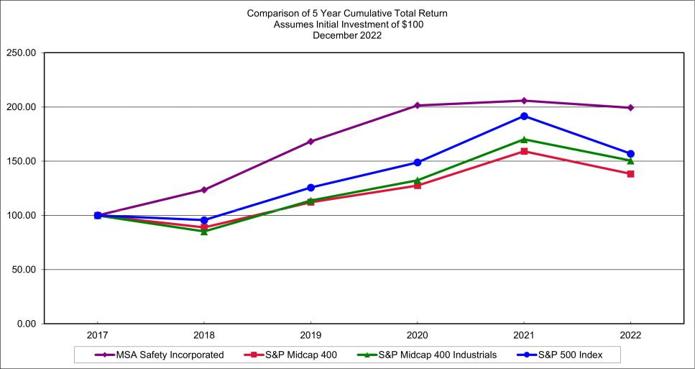

Assumes $100 invested on December 31, 2017 in stock or index, including reinvestment of dividends. Fiscal year ending December 31.

 |  |  |  |  |  |  |  | Value at December 31,
 | 2017 |  |  | 2018 |  |  |  | 2019 |  |  | 2020 |  |  | 2021 |  |  | 2022
MSA Safety Incorporated | $ | 100.00 |  | $ | 123.58 |  | $ | 168.18 |  | $ | 201.44 |  | $ | 205.77 |  | $ | 199.25
S&P 500 Index |  | 100.00 |  |  | 95.62 |  |  | 125.72 |  |  | 148.85 |  |  | 191.58 |  |  | 156.88
S&P Midcap 400 |  | 100.00 |  |  | 88.92 |  |  | 112.21 |  |  | 127.54 |  |  | 159.12 |  |  | 138.34
S&P Midcap 400 Industrials |  | 100.00 |  |  | 85.11 |  |  | 113.67 |  |  | 132.41 |  |  | 170.07 |  |  | 150.52

Prepared by Zacks Investment Research, Inc. Used with permission. All rights reserved. Copyright 1980-2023.

Index Data: Copyright Standard and Poor’s, Inc. Used with permission. All rights reserved.

Item 6. [Reserved]

23

Table of Contents

Item 7. Management’s Discussion and Analysis of Financial Condition and Results of Operations

The following discussion and analysis should be read in conjunction with the historical financial statements and other financial information included elsewhere in this annual report on Form 10-K. This discussion may contain forward-looking statements that involve risks and uncertainties. The forward-looking statements are not historical facts, but rather are based on current expectations, estimates, assumptions and projections about our industry, business and future financial results. Our actual results could differ materially from the results contemplated by these forward-looking statements due to a number of factors, including those discussed in the sections of this annual report entitled “Forward-Looking Statements” and “Risk Factors.”

This section generally discusses the results of our operations for the year ended December 31, 2022 compared to the year ended December 31, 2021. For a discussion on the year ended

December 31, 2021 compared to the year ended December 31, 2020, please refer to Part II, Item 7, "Management's Discussion and Analysis of Financial Condition and Results of Operations" in our

Annual Report on Form 10-K for the year ended December 31, 2021 filed with the Securities and Exchange Commission on February 19, 2021.

MSA Safety Incorporated ("MSA") is organized into four geographical operating segments that are aggregated into three reportable geographic segments: Americas, International and Corporate. The Americas segment is comprised of our operations in North America and Latin America geographies. The International segment is comprised of our operations of all geographies outside of the Americas. Certain global expenses are allocated to each segment in a manner consistent with where the benefits from the expenses are derived. Please refer to Note 8—Segment Information of the consolidated financial statements in Part II Item 8 of this Form 10-K for further information.

On January 5, 2023, the Company divested Mine Safety Appliances LLC ("MSA LLC") a wholly owned subsidiary that holds legacy product liability claims relating to coal dust, asbestos, silica, and other exposures, to a joint venture between R&Q Insurance Holdings Ltd. and Obra Capital, Inc. In connection with the closing, MSA contributed $341 million in cash and cash equivalents, while R&Q and Obra contributed an additional $35 million. As a result of the transaction, MSA will derecognize all legacy cumulative trauma product liability reserves, related insurance assets, and associated deferred tax assets of the divested subsidiary from its balance sheet in the first quarter of 2023. R&Q and Obra have assumed management of the divested subsidiary, including the management of its claims. Refer to Note 20—Contingencies of the consolidated financial statements in Part II Item 8 of this Form 10-K for further information.

On July 1, 2021, the Company acquired Bacharach, Inc. and its affiliated companies ("Bacharach") in a transaction valued at $329.4 million, net of cash acquired. Headquartered near Pittsburgh in New Kensington, Pa., Bacharach is a leader in gas detection technologies used in the heating, ventilation, air conditioning and refrigeration ("HVAC-R") markets. Bacharach’s advanced instrumentation technologies help protect lives and the environment, while also increasing operational efficiency for its diversified customer base. Bacharach's portfolio of gas detection and analysis products are used to detect, measure and analyze leaks of various gases that are commonly found in both commercial and industrial settings. Bacharach has strong expertise in the refrigerant leak detection market with customers in the HVAC-R, food retail, automotive, commercial and industrial refrigeration, and military markets. Refer to Note 14—Acquisitions of the consolidated financial statements in Part II Item 8 of this Form 10-K for further information.

During July 2021, the Company purchased the remaining 10% noncontrolling interest in MSA (China) Safety Equipment Co., Ltd. from our former China partner for $19.0 million, inclusive of a $5.6 million distribution.

On January 25, 2021, the Company acquired 100% of the common stock of B T Q Limited, including Bristol Uniforms and Bell Apparel ("Bristol") in an all-cash transaction valued at

$63.0 million, net of cash acquired. Bristol, which is headquartered in the United Kingdom ("U.K."), is a leading innovator and provider of protective apparel to the fire, rescue services, and utility

sectors. The acquisition strengthens MSA's position as a global market leader in fire service personal protective equipment ("PPE") products, which include breathing apparatus, firefighter helmets,

thermal imaging cameras, and firefighter protective apparel, while providing an avenue to expand its business in the U.K. and key European markets. The fire service equipment brands of MSA,

which include Gallet Firefighter Helmets, the M1 and G1 Self-Contained Breathing Apparatus range, Cairns Helmets, Globe Manufacturing, and now Bristol, represent more than 460 combined years

of innovation in the fire service industry, with a common mission: protecting the health and safety of firefighters. Bristol is also a leading manufacturer of flame-retardant, waterproof, and other

protective work wear for the utility industry. Marketed under the Bell Apparel brand, this line complements MSA's existing and broad range of offerings for the global utilities market. Refer to Note

14—Acquisitions of the consolidated financial statements in Part II Item 8 of this Form 10-K for further information.

24

Table of Contents

BUSINESS OVERVIEW

MSA is a global leader in the development, manufacture and supply of safety products that protect people and facility infrastructures. Recognized for their market leading innovation, many MSA products integrate a combination of electronics, mechanical systems and advanced materials to protect users against hazardous or life-threatening situations. The Company's comprehensive product line, which is governed by rigorous safety standards across highly regulated industries, is used by workers around the world in a broad range of markets, including fire service, oil, gas and petrochemical industry, construction, industrial manufacturing applications, utilities, mining and the military. MSA's core products include breathing apparatus, fixed gas and flame detection systems, portable gas detection instruments, industrial head protection products, firefighter helmets and protective apparel, and fall protection devices. We are committed to providing our customers with service unmatched in the safety industry and, in the process, enhancing our ability to provide a growing line of safety solutions for customers in key global markets.

We tailor our product offerings and distribution strategy to satisfy distinct customer preferences that vary across geographic regions. To best serve these customer preferences, we have organized our business into four geographical operating segments that are aggregated into three reportable geographic segments: Americas, International and Corporate. In 2022, 68% and 32% of our net sales were made by our Americas and International segments, respectively.

Americas. Our largest manufacturing and research and development facilities are located in the United States. We serve our markets across the Americas with manufacturing facilities in the U.S., Mexico and Brazil. Operations in the other countries within the Americas segment focus primarily on sales and distribution in their respective home country markets.

International. Our International segment includes companies in Europe, the Middle East and Africa ("EMEA") and the Asia Pacific region. In our largest International subsidiaries (in Germany, France, U.K., Ireland and China), we develop, manufacture and sell a wide variety of products. In China, the products manufactured are sold primarily in China as well as in regional markets. Operations in other International segment countries focus primarily on sales and distribution in their respective home country markets. Although some of these companies may perform limited production, most of their sales are of products manufactured in our plants in Germany, France, the U.S., U.K., Ireland and China or are purchased from third-party vendors.

Corporate. The Corporate segment primarily consists of general and administrative expenses incurred in our corporate headquarters, costs associated with corporate development initiatives, legal expense, interest expense, foreign exchange gains or losses and other centrally-managed costs. Corporate general and administrative costs comprise the majority of the expense in the Corporate segment. During the years ended December 31, 2022, 2021 and 2020 corporate general and administrative costs were $40.3 million, $37.6 million, and $28.5 million, respectively. These increases primarily reflect an increase in centrally managed functions.

25

Table of Contents

Year Ended December 31, 2022 Compared to Year Ended December 31, 2021

Net Sales |  |  |  |  | Dollar |  | Percent
(In millions) | 2022 |  | 2021 |  | Increase |  | Increase
(In millions) | 2022 |  | 2021 |  | (Decrease) |  | (Decrease)
Consolidated | $1,527.9 |  | $1,400.2 |  | $127.7 |  | 9.1%
Americas | 1,043.2 |  | 908.1 |  | 135.1 |  | 14.9%
International | 484.7 |  | 492.1 |  | (7.4) |  | (1.5)%

Net Sales. Net sales for the year ended December 31, 2022, were $1.53 billion, an increase of $127.7 million, from $1.40 billion for the year ended December 31, 2021, driven by strategic price increases, volume growth, and acquisitions, partially offset by foreign currency translation. We saw strong growth across most of our core products and across both reporting segments. Constant currency sales increased by 12.2% for the year ended December 31, 2022. Please refer to the Net Sales table below for a reconciliation of the year over year sales change.

Net Sales |  | Year Ended December 31, 2022 versus December 31, 2021
(Percent Change) | Americas | International | Consolidated
GAAP reported sales change | 14.9% | (1.5)% | 9.1%
Currency translation effects | 0.2% | 8.5% | 3.1%
Constant currency sales change | 15.1% | 7.0% | 12.2%
Less: Acquisitions | (2.8)% | (1.6)% | (2.3)%
Organic constant currency change | 12.3% | 5.4% | 9.9%

Note: Constant currency sales change and Organic constant currency sales change are non-GAAP financial measure provided by the Company to give a better understanding of the Company's underlying business performance. Constant currency sales change is calculated by deducting the percentage impact from currency translation effects from the overall percentage change in net sales. Organic constant currency sales change is calculated by deducting the percentage impact from acquisitions and currency translation effects from the overall percentage change in net sales.

Net sales for the Americas segment were $1,043.2 million for the year ended December 31, 2022, an increase of $135.1 million, or 14.9%, compared to $908.1 million for the year ended December 31, 2021. During 2022, constant currency sales in the Americas segment increased 15.1% or on an organic constant currency basis increased 12.3%, excluding acquisitions. Growth was driven by favorable unit growth, new products, pricing and this volume growth was across most product categories. The inclusion of Bacharach drove the acquisition related sales.

Net sales for the International segment were $484.7 million for the year ended December 31, 2022, a decrease of $7.4 million, or 1.5%, compared to $492.1 million for the year ended December 31, 2021. Constant currency sales in the International segment increased 7.0% compared to the prior year period with organic constant currency growth of 5.4%. Growth was driven by favorable unit growth, new products, pricing and this volume growth was across most product categories; however, the unfavorable impact of foreign currency translation offset this growth on a reported basis. The inclusion of Bacharach drove acquisition related sales.

Looking ahead, we continue to operate in a very dynamic environment. There are a number of other evolving factors that will continue to influence our revenue and earnings outlook. These factors include, among other things, supply chain constraints, raw material or semiconductor availability, the risk of additional COVID lockdowns, industrial employment rates, interest rate changes, military conflict, currency exchange volatility, the pace of economic recovery, as well as geopolitical risk, particularly as it relates to energy uncertainty which could affect operations and suppliers based in Germany and broader Europe. These or other conditions could impact our future results and growth expectations well into 2023.

Refer to Note 8—Segment Information to the consolidated financial statements in Part II Item 8 of this Form 10-K, for information regarding sales by product group.

Gross profit. Gross profit for the year ended December 31, 2022 was $673.8 million, an increase of $58.5 million, or 9.5%, compared to $615.3 million for the year ended December 31, 2021. The ratio of gross profit to net sales was 44.1% in 2022 compared to 43.9% in 2021. Pricing and productivity efforts were partially offset by inflation, inventory and product warranty charges.

26

Table of Contents

Selling, general and administrative expenses. Selling, general and administrative ("SG&A") expenses were $338.9 million for the year ended December 31, 2022, an increase of $6.0 million, or 1.8%, compared to $332.9 million for the year ended December 31, 2021. Overall, selling, general and administrative expenses were 22.2% of net sales in 2022 compared to 23.8% of net sales in 2021. Organic constant currency SG&A increased $13 million or 4.0%, demonstrating leverage on revenue growth. This increase was driven by wage inflation and strategic investments to support revenue growth. Areas of savings included lower acquisition related costs and savings from our restructuring programs in our International segment. Please refer to the Selling, general and administrative expenses table for a reconciliation of the year-over-year expense change.

Selling, general, and administrative expenses | Year Ended
Selling, general, and administrative expenses | December 31, 2022 versus December 31, 2021
(Percent Change) | Consolidated
GAAP reported change | 1.8%
Currency translation effects | 2.9%
Constant currency change | 4.7%
Less: Acquisitions and strategic transaction costs | (0.7)%
Organic constant currency change | 4.0%

Note: Constant currency SG&A change and Organic constant currency SG&A change are non-GAAP financial measure provided by the Company to give a better understanding of the Company's underlying business performance. Constant currency SG&A change is calculated by deducting the percentage impact from currency translation effects from the overall percentage change in SG&A. Organic constant currency SG&A change is calculated by deducting the percentage impact from acquisitions and related strategic transaction costs and currency translation effects from the overall percentage change in SG&A.

Research and development expense. Research and development expense was $57.0 million for the year ended December 31, 2022, a decrease of $0.8 million, or 1.4%, compared to $57.8 million for the year ended December 31, 2021. Research and development expense was 3.7% of net sales in 2022, compared to 4.1% of net sales in 2021.

We capitalized approximately $8.7 million and $8.1 million of software development costs during the years ended December 31, 2022 and 2021, respectively. Depreciation expense for capitalized software development cost of $7.9 million and $4.9 million during the years ended December 31, 2022 and 2021, was recorded in costs of products sold on the Consolidated Statements of Income. Refer to Note 1—Significant Accounting Policies of the consolidated financial statements in Part II Item 8 of this Form 10-K for further details regarding our software development costs.

MSA remains committed to dedicating significant resources to research and development activities, including the development of technology-based safety solutions. As we continue to invest a significant portion of our new product development into technology-based safety solutions, we anticipate that the historical relationship of research and development expense to net sales will continue to evolve; however, we do not anticipate reductions in the relative level of total spend on research and development activities on an annual basis. Total spend on both software development and research and development activities was $65.7 million and $65.9 million during the years ended December 31, 2022 and 2021.

Restructuring charges. During the year ended December 31, 2022, the Company recorded restructuring charges of $8.0 million primarily related to our ongoing international initiatives to drive profitable growth and right size operations. This compared to restructuring charges of $16.4 million during the year ended December 31, 2021, primarily related to our ongoing initiatives to drive profitable growth and acquisition integration activities. We remain focused on executing programs to optimize our cost structure.

Currency exchange. Currency exchange losses were $10.3 million during the year ended December 31, 2022, compared to $0.2 million during the year ended December 31, 2021. The currency exchange losses for the current period related primarily due to foreign currency exposure on unsettled inter-company balances and the recognition of non-cash cumulative translation losses as result of our plan to close a foreign subsidiary. Currency exchange in 2021 related to foreign currency exposure on unsettled inter-company balances.

Refer to Note 18—Derivative Financial Instruments of the consolidated financial statements in Part II Item 8 of this Form 10-K for information regarding our currency exchange rate risk management strategy.

27

Table of Contents

Product liability expense. Product liability expense during the year ended December 31, 2022 was $20.6 million compared to $185.3 million for the year ended December 31, 2021. Product liability expense for both periods primarily relates to increases in MSA LLC's reserve for cumulative trauma product liability claims and defense costs incurred for these claims. Adjustments to the reserve for the year ended December 31, 2022 totaled $8.4 million net of insurance receivable of $1.6 million. The reserve includes estimated amounts for claims expected to be resolved through the year 2075. On January 5, 2023, the Company divested MSA LLC, a wholly owned subsidiary that holds legacy product liability claims relating to coal dust, asbestos, silica, and other exposures. As a result of the transaction, we will derecognize in the first quarter of 2023 all legacy cumulative trauma product liability reserves, related insurance assets, and associated deferred tax assets of the divested subsidiary from our balance sheet and recognize a loss of approximately $200 million. Please refer to Note 20—Contingencies of the consolidated financial statements in Part II Item 8 of this Form 10-K for additional information.

GAAP operating income. Consolidated operating income for the year ended December 31, 2022 was $239.1 million compared to $22.8 million for the year ended December 31, 2021. The increase in operating results was driven by the factors described in the preceding sections.

Adjusted operating income. Americas adjusted operating income for the year ended December 31, 2022 was $267.4 million, an increase of $64.9 million or 32%, compared to $202.5 million for the year ended December 31, 2021. The increase in adjusted operating income is primarily attributable to higher sales volumes driven by the full year impact of the Bacharach acquisition and organic business activity, partially offset by higher SG&A expenses to support business growth.

International adjusted operating income for the year ended December 31, 2022 was $60.9 million, a decrease of $12.4 million, or 17%, compared to adjusted operating income of $73.3 million for the year ended December 31, 2021. The decrease in adjusted operating income is primarily attributable to lower revenue and gross margins as a result of unfavorable currency translation and transactional impact, inflationary pressures, partially offset by lower SG&A expenses.

Corporate segment adjusted operating loss for the year ended December 31, 2022 was $37.9 million, an increase of $2.7 million, or 8%, compared to an adjusted operating loss of $35.2 million for the year ended December 31, 2021 due primarily to increased costs to support higher business activity.

The following tables represent a reconciliation from GAAP operating income to adjusted operating income (loss) and adjusted EBITDA. Adjusted operating margin % is calculated as adjusted operating income (loss) divided by net sales and adjusted EBITDA margin % is calculated as adjusted EBITDA divided by net sales.

 | Adjusted operating income |  |  |  |  | Year Ended December 31, 2022
 | (In thousands) |  |  | Americas |  | International |  | Corporate | Consolidated
 | Net sales |  | $ | 1,043,238 | $ | 484,715 | $ | — $ | 1,527,953
 | GAAP operating income |  |  |  |  |  |  |  | 239,137
 | Restructuring charges (Note 3) |  |  |  |  |  |  |  | 7,965
 | Currency exchange losses, net |  |  |  |  |  |  |  | 10,255
 | Product liability expense (Note 20) |  |  |  |  |  |  |  | 20,590
 | Acquisition related costs (Note 14)^{(a)} |  |  |  |  |  |  |  | 12,440
 | Adjusted operating income (loss) |  |  | 267,392 |  | 60,923 |  | (37,928) | 290,387
 | Adjusted operating margin % |  |  | 25.6 % |  | 12.6 %
 | Depreciation and amortization^{(a)} |  |  | 34,334 |  | 12,256 |  | 520 | 47,110
 | Adjusted EBITDA |  |  | 301,726 |  | 73,179 |  | (37,408) | 337,497
 | Adjusted EBITDA % |  |  | 28.9 % |  | 15.1 %
 |  | 28

Table of Contents

Adjusted operating income |  |  |  | Year Ended December 31, 2021
(In thousands) |  | Americas |  | International |  | Corporate | Consolidated
Net sales | $ | 908,068 | $ | 492,114 | $ | — $ | 1,400,182
GAAP operating income |  |  |  |  |  |  | 22,780
Restructuring charges (Note 3) |  |  |  |  |  |  | 16,433
Currency exchange losses, net |  |  |  |  |  |  | 216
Product liability expense (Note 20) |  |  |  |  |  |  | 185,264
Acquisition related costs (Note 14)^{(a)} |  |  |  |  |  |  | 15,884
Adjusted operating income (loss) |  | 202,496 |  | 73,279 |  | (35,198) | 240,577
Adjusted operating margin % |  | 22.3 % |  | 14.9 %
Depreciation and amortization^{(a)} |  | 31,236 |  | 13,718 |  | 463 | 45,417
Adjusted EBITDA |  | 233,732 |  | 86,997 |  | (34,735) | 285,994
Adjusted EBITDA % |  | 25.7 % |  | 17.7 %

- Acquisition related costs include advisory, legal, accounting, valuation, and other professional or consulting fees incurred during due diligence and integration. These costs are included in SG&A expense in the unaudited Condensed Consolidated Statements of Income. Acquisition-related costs also include the acquisition related amortization, which is included in Cost of products sold in the Consolidated Statements of Income.

Note: Adjusted operating income (loss) and adjusted EBITDA are non-GAAP financial measures. Adjusted operating income (loss) is reconciled above to the nearest GAAP financial measure, Operating income (loss), and excludes restructuring, currency exchange, product liability expense, and acquisition related costs. Adjusted EBITDA is reconciled above to the nearest GAAP financial measure, Operating income (loss) and excludes depreciation and amortization expense. Adjusted operating margin % and Adjusted EBITDA % are operating ratios derived from non-GAAP financial measures.

Total other expense (income), net. Total other expense, net, for the year ended December 31, 2022, was $0.6 million, a decrease of $1.4 million compared to other income, net, of $0.8 million for the year ended December 31, 2021, driven primarily by higher interest expense, related to rising interest rate environment, and a write-down of an equity investment, partially offset by higher pension income, resulting from higher expected rate of return on plan assets. We expect total interest expense for 2023 to be between $48 million and $50 million, this increase is primarily related to the additional long-term debt to divest MSA LLC as of January 5, 2023. We expect non-cash pension income to decline by $8 million compared to 2022.

Income taxes. The reported effective tax rate for the year ended December 31, 2022 was 24.7%, which includes a benefit of 0.8% for share-based payments, expense of 0.1% related to higher profits in foreign jurisdictions, and an expense of 1.2% due to nondeductible compensation. This compared to a reported effective tax rate for the year ended December 31, 2021 of 7.7%, which included a benefit of 18.3% for share-based payments, a benefit of 10.9% related to higher profits in foreign jurisdictions and settlement of a foreign audit, and an expense of 15.3% due to nondeductible compensation.

We are subject to regular review and audit by both foreign and domestic tax authorities. While we believe our tax positions will be sustained, the final outcome of tax audits and related litigation may differ materially from the tax amounts recorded in our consolidated financial statements.

Net income attributable to MSA Safety Incorporated. Net income was $179.6 million for the year ended December 31, 2022, or $4.56 per diluted share, compared to $21.3 million, or $0.54 per diluted share, for the year ended December 31, 2021.

29

Table of Contents

Non-GAAP Financial Information

To supplement our Consolidated Financial Statements presented in accordance with generally accepted accounting principles (“GAAP”), we use, and this report includes, certain non-GAAP financial measures. These financial measures include organic constant currency changes, financial measures excluding the impact of acquisitions and related acquisition related costs (including acquisition related amortization), adjusted operating income, adjusted operating margin percentage, adjusted EBITDA and adjusted EBITDA margin percentage. We believe that the use of these non-GAAP financial measures provide investors with additional useful information and provide a more complete understanding of our operating performance and trends, and facilitate comparisons with the performance of our peers. Management also uses these measures internally to assess and better understand our underlying business performance and trends related to core business activities. The non-GAAP financial measures and key performance indicators we use, and computational methods with respect thereto, may differ from the non-GAAP financial measures and key performance indicators, and computational methods, that our peers use to assess their performance and trends.

The presentation of these non-GAAP financial measures does not comply with U.S. GAAP. These non-GAAP financial measures should be viewed as supplemental in nature, and not as a substitute for, or superior to, our reported results prepared in accordance with GAAP. When non-GAAP financial measures are disclosed, the Securities and Exchange Commission's Regulation G requires: (i) the presentation of the most directly comparable financial measure calculated and presented in accordance with GAAP and (ii) a reconciliation of the differences between the non-GAAP financial measure presented and the most directly comparable financial measure calculated and presented in accordance with GAAP. For an explanation of these measures, together with a reconciliation to the most directly comparable GAAP financial measure, please refer to the reconciliations referenced above in Management's Discussion & Analysis.

We may also provide financial information on a constant currency basis, which is a non-GAAP financial measure. These references to a constant currency basis do not include operational impacts that could result from fluctuations in foreign currency rates, which are outside of management's control. To provide information on a constant currency basis, the applicable financial results are adjusted by translating current and prior period results in local currency to a fixed foreign exchange rate. This approach is used for countries where the functional currency is the local country currency. This information is provided so that certain financial results can be viewed without the impact of fluctuations in foreign currency rates, thereby facilitating period-to-period comparisons of business performance. Constant currency information is not recognized under U.S. GAAP and it is not intended as an alternative to U.S. GAAP measures.

LIQUIDITY AND CAPITAL RESOURCES

Our main source of liquidity is operating cash flows, supplemented by borrowings. Our principal liquidity requirements are for working capital, capital expenditures, principal and interest payments on debt, declared dividend payments and acquisitions. At December 31, 2022, approximately 46% of our long-term debt is at fixed interest rates with repayment schedules through 2036. The remainder of our long-term debt is at variable rates on an unsecured revolving credit facility that is due in 2026. At December 31, 2022, approximately 82% of our borrowings are denominated in US dollars, which limits our exposure to currency exchange rate fluctuations.

At December 31, 2022, the Company had cash and cash equivalents, including restricted cash, totaling $164.4 million, and access to sufficient capital, providing ample liquidity and flexibility to continue to maintain our balanced capital allocation strategy. At December 31, 2022, $589.9 million of the existing $900.0 million senior revolving credit facility was unused, including letters of credit issued under the facility. The facility also provides an accordion feature that allows the Company to access an additional $400.0 million of capacity pending approval by MSA’s board of directors and from the bank group. The Company believes our healthy balance sheet and access to significant capital at the year ended December 31, 2022, positions us well to navigate through challenging business conditions.

Operating activities. Operating activities provided cash of $157.5 million in 2022, compared to providing cash of $199.1 million in 2021. The reduced operating cash flow as compared to the same period in 2021 was primarily related to increased working capital requirements, notably increased inventory balances at year-end 2022 to support the higher backlog and accounts receivable related to stronger fourth quarter 2022 revenue. Payments for subsidiary MSA LLC's product liability claims exceeded collections from insurance companies by $27.2 million in the year ended December 31, 2022, compared to $24.1 million in 2021. On January 5, 2023, the Company divested MSA LLC and as a result, will derecognize all legacy cumulative trauma product liability reserves, related insurance assets, and associated deferred tax assets of the divested subsidiary from our balance sheet and will recognize a loss of approximately $200 million in the first quarter of 2023 and expect related cash outflows to be recognized within operating activities in the consolidated statements of cash flows. R&Q and Obra have assumed management of the divested subsidiary, including the management of its claims. The divestiture enhances operating cash flow predictability by eliminating costs associated with defending and settling the transferred claims.

30

Table of Contents

Please refer to Note 20—Contingencies of the consolidated financial statements in Part II Item 8 of this Form 10-K for additional information.

Investing activities. Investing activities used cash of $4.5 million for the year ended December 31, 2022, compared to using $415.5 million in 2021. The decrease in cash used in investing activities as compared to the same period in 2021 was primarily related to the absence of acquisitions. We remain active in evaluating additional acquisition opportunities that will allow us to continue to grow in key end markets and geographies.

Financing activities. Financing activities used cash of $113.4 million for the year ended December 31, 2022, compared to providing cash of $203.9 million in 2021. During 2022, we had net payments on long-term debt of $13.0 million as compared to net proceeds on long-term debt of $293.2 million during the same period in 2021 to fund the acquisitions of Bacharach and Bristol and buy-out our minority partner in our China business. We paid cash dividends of $71.5 million during 2022, compared to $68.6 million, exclusive of a $5.6 million dividend to our former noncontrolling interest partner in China as part of the buy-out, during 2021. We also used cash of $34.4 million during 2022 to repurchase shares, compared to using $6.2 million during the same period in 2021. In 2022, $30.4 million of our repurchase activity was related to purchases under our 2015 stock repurchase program.

In January 2023, we entered into a new $250 million term loan and $65 million was drawn down from our revolving credit facility to fund the divestiture of MSA LLC, a wholly owned subsidiary that, at the time of divestiture held legacy product liability claims relating to coal dust, asbestos, silica, and other exposures. Subsequent to this transaction, we have more than $500 million of availability remaining on our revolving credit facility.

CUMULATIVE TRANSLATION ADJUSTMENTS

The year-end position of the U.S. dollar relative to international currencies at December 31, 2022, resulted in a translation loss of $19.5 million being recorded to cumulative translation adjustments shareholders' equity account for the year ended December 31, 2022, compared to a translation loss of $25.4 million being recorded to the cumulative translation adjustments account during 2021.

COMMITMENTS AND CONTINGENCIES

We are obligated to make future payments under various contracts, including debt and lease agreements. Our significant cash obligations as of December 31, 2022, are as follows:

(In millions) |  | Total |  |  | 2023 |  |  | 2024 |  |  | 2025 |  |  | 2026 |  |  | 2027 |  |  | Thereafter
Long-term debt | $ | 575.2 |  | $ | 7.4 |  | $ | 7.4 |  | $ | 7.4 |  | $ | 316.0 |  | $ | 7.4 |  | $ | 229.6
Operating leases |  | 52.2 |  |  | 10.0 |  |  | 7.5 |  |  | 5.2 |  |  | 4.1 |  |  | 3.4 |  |  | 22.0
Inventory costing method change tax |  | 8.0 |  |  | 2.7 |  |  | 2.7 |  |  | 2.6 |  |  | — |  |  | — |  |  | —
Transition tax |  | 2.0 |  |  | 0.7 |  |  | 1.3 |  |  | — |  |  | — |  |  | — |  |  | —
Totals | $ | 637.4 |  | $ | 20.8 |  | $ | 18.9 |  | $ | 15.2 |  | $ | 320.1 |  | $ | 10.8 |  | $ | 251.6

The significant obligations table does not include obligations to taxing authorities due to uncertainty surrounding the ultimate settlement of amounts and timing of these obligations. It also does not include $315 million of variable rate debt related to the January 5, 2023, divestiture of MSA LLC.

We expect to meet our future debt service obligations through cash provided by operations. Approximately $308.6 million of debt payable in 2026, included in the table above, relates to our unsecured senior revolving credit facility that has a weighted average interest rate of 5.13% as of December 31, 2022. We expect to generate sufficient operating cash flow to make payments against this amount each year. To the extent that a balance remains when the facility matures in 2026, we expect to refinance the remaining balance through new borrowing facilities. Interest expense on fixed rate debt over the next five years is expected to be approximately $7.5 million in 2023, $7.3 million in 2024, $7.0 million in 2025, $6.8 million in 2026 and $6.6 million in 2027. We expect total interest expense for 2023 to be between $48 million and $50 million.

31

Table of Contents

The Company had outstanding bank guarantees and standby letters of credit with banks as of December 31, 2022 totaling $9.3 million, of which $1.5 million relate to the senior revolving credit facility. These letters of credit serve to cover customer requirements in connection with certain sales orders and insurance companies. The Company is also required to provide cash collateral in connection with certain arrangements. At December 31, 2022, the Company has $1.5 million of restricted cash in support of these arrangements.

We expect to make net contributions of $8.2 million to our pension plans in 2023 which are primarily associated with our International segment. We have not been required to make contributions to our U.S. based qualified defined benefit pension plan in many years.

We have purchase commitments for materials, supplies, services and property, plant and equipment as part of our ordinary conduct of business.

Please refer to Note 20—Contingencies to the consolidated financial statements in Part II Item 8 of this Form 10-K for further discussion on the Company's product liabilities.

CRITICAL ACCOUNTING POLICIES AND ESTIMATES

We prepare our consolidated financial statements in accordance with U.S. generally accepted accounting principles (U.S. GAAP). The preparation of these financial statements requires us to make estimates and judgments that affect the reported amounts of assets, liabilities, revenues and expenses and the related disclosures. We evaluate these estimates and judgments on an on-going basis based on historical experience and various assumptions that we believe to be reasonable under the circumstances. However, different amounts could be reported if we had used different assumptions and in light of different facts and circumstances. Actual amounts could differ from the estimates and judgments reflected in our consolidated financial statements. A summary of the Company's significant accounting policies is included in Note 1—Significant Accounting Policies to the consolidated financial statements in Part II, Item 8 of this Form 10-K.

The more critical judgments and estimates used in the preparation of our consolidated financial statements are discussed in Item 7. Management’s Discussion and Analysis of Financial Condition and Results of Operations in this Form 10-K for the year ended December 31, 2022. During 2021, the Company made acquisitions that raised business combinations to a critical accounting policy and estimate. There were no business combinations during 2022.

Business combinations. In accordance with the accounting guidance for business combinations, the Company uses the acquisition method of accounting to allocate costs of acquired businesses to the assets acquired and liabilities assumed based on their estimated fair values at the dates of acquisition. The excess costs of acquired businesses over the fair values of the assets acquired and liabilities assumed will be recognized as goodwill. The valuations of the acquired assets and liabilities will impact the determination of future operating results. In addition to using management estimates and negotiated amounts, the Company uses a variety of information sources to determine the estimated fair values of acquired assets and liabilities including: third-party appraisals for the estimated value and lives of identifiable intangible assets and property, plant and equipment; third-party actuaries for the estimated obligations of defined benefit pension plans and similar benefit obligations; and legal counsel or other experts to assess the obligations associated with legal, environmental and other contingent liabilities.

The business and technical judgment of management was used in determining which intangible assets have indefinite lives and in determining the useful lives of finite-lived intangible assets in accordance with the accounting guidance for goodwill and other intangible assets.

Cumulative trauma product liability. The Company and its subsidiaries face an inherent business risk of exposure to product liability claims arising from the alleged failure of our products to prevent the types of personal injury or death against which they are designed to protect. Product liability claims are categorized as either single incident or cumulative trauma.

Single incident product liability claims involve incidents of short duration that are typically known when they occur and involve observable injuries, which provide a more objective basis for quantifying damages. The Company estimates its subsidiaries' liability for single incident product liability claims based on expected settlement costs for asserted single incident product liability claims and an estimate of costs for single incident product liability claims incurred but not reported ("IBNR"). Single incident product liability exposures are evaluated on an annual basis, or more frequently if changing circumstances warrant. Adjustments are made to the reserve as appropriate.

32

Table of Contents

Cumulative trauma product liability claims involve exposures to harmful substances that occurred over many years and may have developed over long periods of time into diseases. In the case of MSA LLC, the subsidiary's combined cumulative trauma product liability reserve is based upon estimates of its liability for asserted and IBNR cumulative trauma product liability claims. In addition, in connection with finalizing and reporting the Company's results of operations, management works annually (unless significant changes in trends or new developments warrant an earlier review) with an outside valuation consultant and outside legal counsel to review MSA LLC's potential exposure to all cumulative trauma product liability claims. Each of these factors may increase or decrease significantly within an individual period depending on, among other things, the timing of claims filings or settlements, or litigation outcomes during a particular period that are especially favorable or unfavorable to MSA LLC. We accordingly consider MSA LLC’s claims experience over multiple periods and/or whether there are changes in MSA LLC’s claims experience and trends that are likely to continue for a significant time into the future in determining whether to make an adjustment to the reserve, rather than evaluating such factors solely in the short term.

Please refer to Note 20—Contingencies to the consolidated financial statements in Part II Item 8 of this Form 10-K for further discussion on the Company's product liabilities and divestiture of MSA LLC on January 5, 2023.

Income taxes. We recognize deferred tax assets and liabilities using enacted tax rates to record the tax effect of temporary differences between the book and tax basis of recorded assets and liabilities. We record valuation allowances to reduce deferred tax assets to the amounts that we estimate are probable to be realized. When assessing the need for valuation allowances, we consider projected future taxable income and prudent and feasible tax planning strategies. Should a change in circumstances lead to a change in our judgments about the realizability of deferred tax assets in future years, we adjust the related valuation allowances in the period that the change in circumstances occurs.

We record an estimated income tax liability based on our best judgment of the amounts likely to be paid in the various tax jurisdictions in which we operate. We record tax benefits related to uncertain tax positions taken or expected to be taken on a tax return when such benefits meet a more likely than not threshold. We recognize interest related to unrecognized tax benefits in interest expense and penalties in operating expenses. The tax liabilities ultimately paid are dependent on a number of factors, including the resolution of tax audits, and may differ from the amounts recorded. Tax liabilities are adjusted through income when it becomes probable that the actual liability differs from the amount recorded.

Pensions and other post-retirement benefits. We sponsor certain pension and other post-retirement benefit plans. Accounting for the net periodic benefit costs and credits for these plans requires us to estimate the cost of benefits to be provided well into the future and to attribute these costs over the expected work life of the employees participating in these plans. These estimates require our judgment about discount rates used to determine these obligations, expected returns on plan assets, rates of future compensation increases, rates of increase in future health care costs, participant withdrawal and mortality rates and participant retirement ages. Differences between our estimates and actual results may significantly affect the cost of our obligations under these plans and could cause net periodic benefit costs and credits to change materially from year-to-year. Discount rates and plan asset valuations are point-in-time measures. The discount rate assumptions used in determining projected benefit obligations for our U.S. and foreign plans were based on the spot rate method at December 31, 2022.

Expected returns on plan assets are based on capital market expectations by asset class.

The following table summarizes the impact of changes in significant actuarial assumptions on our December 31, 2022 actuarial valuations.

 |  |  |  |  |  | Impact of Changes in Actuarial Assumptions
 |  | Change in Discount |  |  |  |  |  | Change in Expected |  |  |  |  |  | Change in Market Value of Assets
 |  | Rate |  |  |  |  |  | Return
(In thousands) |  | 1% |  |  | (1)% |  |  | 1% |  |  | (1)% |  |  | 5% |  |  | (5)%
(Decrease) increase in net benefit cost | $ | (7,875) |  | $ | 9,942 |  | $ | (5,682) |  | $ | 5,682 |  | $ | (1,482) |  | $ | 1,333
(Decrease) increase in projected benefit obligation |  | (61,274) |  |  | 77,324 |  |  | — |  |  | — |  |  | — |  |  | —
Increase (decrease) in funded status |  | 61,274 |  |  | (77,324) |  |  | — |  |  | — |  |  | 25,853 |  |  | (25,853)
 |  | 33

Table of Contents

Goodwill and Indefinite-lived Intangible Assets. On October 1st of each year, or more frequently if indicators of impairment exist or if a decision is made to sell a business, we evaluate goodwill for impairment. Such indicators may include a decline in expected cash flows, a significant adverse change in the business climate, unanticipated competition, slower growth rates, or negative developments in equity and credit markets, among others.

All goodwill is assigned to and evaluated for impairment at the reporting unit level, which is defined as an operating segment or one level below an operating segment. The evaluation of impairment involves using either a qualitative or quantitative approach as outlined in Accounting Standards Codification ("ASC") Topic 350. In 2022, we performed a quantitative test at October 1, 2022. Quantitative testing involves comparing the estimated fair value of each reporting unit to its carrying value. We estimate reporting unit fair value using a weighted average of fair values determined by discounted cash flow ("DCF") and market approach methodologies, as we believe both are important indicators of fair value. A number of assumptions and estimates are involved in the application of the DCF model, including sales volumes and prices, costs to produce, tax rates, capital spending, discount rates, and working capital changes. Cash flow forecasts are generally based on approved business unit operating plans for the early years and historical relationships in later years. The market approach methodology measures value through an analysis of peer companies. The analysis entails measuring the multiples of EBITDA at which peer companies are trading.

In the event the carrying value is in excess of the estimated fair value of a reporting unit per the weighted average of the DCF and market approach models, an impairment loss equal to such excess would be recognized, which could materially and adversely affect reported consolidated results of operations and shareholders’ equity. At October 1, 2022, based on our quantitative test, the fair values of each of our reporting units exceeded their respective carrying value by at least 42%.

The intangible asset with an indefinite life is also subject to impairment testing on October 1st of each year, or more frequently if indicators of impairment exist. The impairment test compares the fair value of the intangible asset with its carrying amount. We perform a quantitative assessment of the indefinite lived trade name intangible asset as outlined in ASC 350 by comparing the estimated fair value of the trade name intangible asset to its carrying value. We estimate the fair value using the relief from royalty income approach. A number of significant assumptions and estimates are involved in the application of the relief from royalty model, including sales volumes and prices, royalty rates and tax rates. Forecasts are based on sales generated by the underlying trade name assets and are generally based on approved business unit operating plans for the early years and historical relationships in later years. At October 1, 2022, based on our quantitative test, the fair value of the trade name asset exceeded its carrying value by approximately 37%.

RECENTLY ADOPTED AND RECENTLY ISSUED ACCOUNTING STANDARDS

None

34

Table of Contents

Item 7A. Quantitative and Qualitative Disclosures About Market Risk

Market risk represents the risk of adverse changes in the value of a financial instrument caused by changes in currency exchange rates, interest rates and equity prices. We are exposed to market risks related to currency exchange rates and interest rates.

Currency exchange rates. We are subject to the effects of fluctuations in currency exchange rates on various transactions and on the translation of the reported financial position and operating results of our non-U.S. companies from local currencies to U.S. dollars. A hypothetical 10% strengthening or weakening of the U.S. dollar would increase or decrease our reported sales and net income for the year ended December 31, 2022 by approximately $62.8 million and $6.5 million, or 4.1% and 3.6%, respectively.

When appropriate, we may attempt to limit our transactional exposure to changes in currency exchange rates through forward contracts or other actions intended to reduce existing exposures by creating offsetting currency exposures. At December 31, 2022, we had open foreign currency forward contracts with a U.S. dollar notional value of $103.0 million. A hypothetical 10% increase in December 31, 2022 forward exchange rates would result in a $10.3 million increase in the fair value of these contracts.

Interest rates. We are exposed to changes in interest rates primarily as a result of borrowing and investing activities used to maintain liquidity and fund business operations. Because of the relatively short maturities of temporary investments and the variable rate nature of our revolving credit facility, these financial instruments are reported at carrying values which approximate fair values.

At December 31, 2022, we had $266.5 million of fixed rate debt which matures at various dates through 2036. The incremental increase in the fair value of fixed rate long-term debt resulting from a hypothetical 10% decrease in interest rates would be approximately $8.0 million. However, our sensitivity to interest rate declines and the corresponding increase in the fair value of our debt portfolio would unfavorably affect earnings and cash flows only to the extent that we elected to repurchase or retire all or a portion of our fixed rate debt portfolio at prices above carrying values.

At December 31, 2022, we had $308.6 million of variable rate borrowings under our revolving credit facility. A 50 basis point increase or decrease in interest rates could have a $1.4 million impact on future pre-tax earnings under our current capital structure. A 50 basis point increase or decrease in interest rates could have a $3.0 million impact on future pre-tax earnings when the additional $315.0 million of variable rate debt undertaken to complete the MSA, LLC divestiture is taken into account.

35

Table of Contents

Item 8. Financial Statements and Supplementary Data

Management’s Reports to Shareholders

Management’s Report on Responsibility for Financial Reporting

Management of MSA Safety Incorporated (the Company) is responsible for the preparation of the consolidated financial statements included in this annual report. The consolidated financial statements were prepared in accordance with accounting principles generally accepted in the United States of America and include amounts that are based on the best estimates and judgments of management. The other financial information contained in this annual report is consistent with the consolidated financial statements.

Management’s Report on Internal Control Over Financial Reporting

Management is responsible for establishing and maintaining adequate internal control over financial reporting. The Company’s internal control over financial reporting is a process designed to provide reasonable assurance regarding the reliability of financial reporting and the preparation of financial statements for external purposes in accordance with generally accepted accounting principles.

The Company’s internal control over financial reporting includes policies and procedures that (1) pertain to the maintenance of records that, in reasonable detail, accurately and fairly reflect transactions and dispositions of assets; (2) provide reasonable assurance that transactions are recorded as necessary to permit preparation of financial statements in accordance with generally accepted accounting principles, and that receipts and expenditures are being made only in accordance with authorizations of management and the directors of the Company; and (3) provide reasonable assurance regarding prevention or timely detection of unauthorized acquisition, use or disposition of the Company’s assets that could have a material effect on our financial statements.

Because of its inherent limitations, internal control over financial reporting may not prevent or detect misstatements. Also, projections of any evaluation of effectiveness to future periods are subject to the risk that controls may become inadequate because of changes in conditions, or that the degree of compliance with the policies or procedures may deteriorate.

Management assessed the effectiveness of the Company’s internal control over financial reporting as of December 31, 2022. In making this assessment, management used the criteria set forth by the Committee of Sponsoring Organizations of the Treadway Commission (COSO) in Internal Control-Integrated Framework (2013). Based on our assessment and those criteria, management has concluded that the Company maintained effective internal control over financial reporting as of December 31, 2022.

The Company's independent registered public accounting firm that audited the consolidated financial statements included in this annual report issued an attestation report on the Company's internal control over financial reporting.

/s/ NISHAN J. VARTANIAN

Nishan J. Vartanian

Chairman, President and Chief Executive Officer

/s/ LEE B. MCCHESNEY

Lee B. McChesney

Senior Vice President and Chief Financial Officer

February 16, 2023

36

Table of Contents

Report of Independent Registered Public Accounting Firm

To the Shareholders and the Board of Directors of MSA Safety Incorporated

Opinion on Internal Control over Financial Reporting

We have audited MSA Safety Incorporated’s internal control over financial reporting as of December 31, 2022, based on criteria established in Internal Control - Integrated Framework issued by the Committee of Sponsoring Organizations of the Treadway Commission (2013 framework) (the COSO criteria). In our opinion, MSA Safety Incorporated (the Company) maintained, in all material respects, effective internal control over financial reporting as of December 31, 2022, based on the COSO criteria.

We also have audited, in accordance with the standards of the Public Company Accounting Oversight Board (United States) (PCAOB), the consolidated balance sheets of the Company as of December 31, 2022 and 2021, the related consolidated statements of income, comprehensive income, cash flows, and changes in retained earnings, accumulated other comprehensive loss and noncontrolling interests for each of the three years in the period ended December 31, 2022, and the related notes and financial statement schedule listed in the Index at Item 15(a) 2 and our report dated February 16, 2023 expressed an unqualified opinion thereon.

Basis for Opinion

The Company’s management is responsible for maintaining effective internal control over financial reporting and for its assessment of the effectiveness of internal control over financial reporting included in the accompanying Management’s Report on Internal Control Over Financial Reporting. Our responsibility is to express an opinion on the Company’s internal control over financial reporting based on our audit. We are a public accounting firm registered with the PCAOB and are required to be independent with respect to the Company in accordance with the U.S. federal securities laws and the applicable rules and regulations of the Securities and Exchange Commission and the PCAOB.

We conducted our audit in accordance with the standards of the PCAOB. Those standards require that we plan and perform the audit to obtain reasonable assurance about whether effective internal control over financial reporting was maintained in all material respects.

Our audit included obtaining an understanding of internal control over financial reporting, assessing the risk that a material weakness exists, testing and evaluating the design and operating effectiveness of internal control based on the assessed risk, and performing such other procedures as we considered necessary in the circumstances. We believe that our audit provides a reasonable basis for our opinion.

Definition and Limitations of Internal Control Over Financial Reporting

A company’s internal control over financial reporting is a process designed to provide reasonable assurance regarding the reliability of financial reporting and the preparation of financial statements for external purposes in accordance with generally accepted accounting principles. A company’s internal control over financial reporting includes those policies and procedures that (1) pertain to the maintenance of records that, in reasonable detail, accurately and fairly reflect the transactions and dispositions of the assets of the company; (2) provide reasonable assurance that transactions are recorded as necessary to permit preparation of financial statements in accordance with generally accepted accounting principles, and that receipts and expenditures of the company are being made only in accordance with authorizations of management and directors of the company; and (3) provide reasonable assurance regarding prevention or timely detection of unauthorized acquisition, use, or disposition of the company’s assets that could have a material effect on the financial statements.

Because of its inherent limitations, internal control over financial reporting may not prevent or detect misstatements. Also, projections of any evaluation of effectiveness to future periods are subject to the risk that controls may become inadequate because of changes in conditions, or that the degree of compliance with the policies or procedures may deteriorate.

/s/ Ernst & Young LLP

Pittsburgh, Pennsylvania

February 16, 2023

37

Table of Contents

Report of Independent Registered Public Accounting Firm

To the Shareholders and the Board of Directors of MSA Safety Incorporated

Opinion on the Financial Statements

We have audited the accompanying consolidated balance sheets of MSA Safety Incorporated (the Company) as of December 31, 2022 and 2021, the related consolidated statements of income, comprehensive income, cash flows, and changes in retained earnings, accumulated other comprehensive loss and noncontrolling interests for each of the three years in the period ended December 31, 2022, and the related notes and financial statement schedule listed in the Index at Item 15(a) 2 (collectively referred to as the “consolidated financial statements”). In our opinion, the consolidated financial statements present fairly, in all material respects, the financial position of the Company at December 31, 2022 and 2021, and the results of its operations and its cash flows for each of the three years in the period ended December 31, 2022, in conformity with U.S. generally accepted accounting principles.

We also have audited, in accordance with the standards of the Public Company Accounting Oversight Board (United States) (PCAOB), the Company's internal control over financial reporting as of December 31, 2022, based on criteria established in Internal Control-Integrated Framework issued by the Committee of Sponsoring Organizations of the Treadway Commission (2013 framework), and our report dated February 16, 2023 expressed an unqualified opinion thereon.

Basis for Opinion

These financial statements are the responsibility of the Company's management. Our responsibility is to express an opinion on the Company’s financial statements based on our audits. We are a public accounting firm registered with the PCAOB and are required to be independent with respect to the Company in accordance with the U.S. federal securities laws and the applicable rules and regulations of the Securities and Exchange Commission and the PCAOB.

We conducted our audits in accordance with the standards of the PCAOB. Those standards require that we plan and perform the audit to obtain reasonable assurance about whether the financial statements are free of material misstatement, whether due to error or fraud. Our audits included performing procedures to assess the risks of material misstatement of the financial statements, whether due to error or fraud, and performing procedures that respond to those risks. Such procedures included examining, on a test basis, evidence regarding the amounts and disclosures in the financial statements. Our audits also included evaluating the accounting principles used and significant estimates made by management, as well as evaluating the overall presentation of the financial statements. We believe that our audits provide a reasonable basis for our opinion.

Critical Audit Matter

The critical audit matter communicated below is a matter arising from the current period audit of the consolidated financial statements that was communicated or required to be communicated to the audit committee and that: (1) relates to accounts or disclosures that are material to the financial statements and (2) involved our especially challenging, subjective or complex judgments. The communication of the critical audit matter does not alter in any way our opinion on the consolidated financial statements, taken as a whole, and we are not, by communicating the critical audit matter below, providing a separate opinion on the critical audit matter or on the accounts or disclosures to which it relates.

38

Table of Contents

Valuation of cumulative trauma product liability claims

Description of the Matter As more fully described in Notes 1 and 20 to the consolidated financial statements, the Company's subsidiary MSA LLC is named as a defendant in lawsuits comprised of cumulative trauma product liability claims involving potential exposures to substances that are alleged to have occurred over a number of years. In recent periods, this has included asbestos, silica and coal dust claims. It is probable that MSA LLC will incur losses related to asserted and incurred but not reported (IBNR) claims and that the amount of losses can be reasonably estimated. At December 31, 2022, the Company’s reserve for cumulative trauma product liability claims was $395.1 million, representing its best estimate of the expected losses related to these claims.

Auditing management’s accounting for and disclosure of loss contingencies arising from cumulative trauma product liability claims was especially challenging, as the estimate of probable loss is highly subjective. In particular, the estimate was sensitive to significant assumptions that included, among others, the number of claims asserted against MSA LLC and the counsel asserting those claims, the percentage of claims resolved through settlement and the values of settlements paid to claimants.

How We Addressed the Matter in Our Audit We obtained an understanding, evaluated the design and tested the operating effectiveness of relevant internal controls over the Company’s assessment and measurement of its estimate of probable loss for its subsidiary's cumulative trauma product liability claims. Our audit procedures included testing controls over the Company’s assessment and measurement of the best estimate of the expected losses related to cumulative trauma product liability claims.

To test the Company’s assessment of its subsidiary's cumulative trauma product liability claims, we performed audit procedures which included, among others: reading the minutes of the meetings of the committees of the board of directors, requesting and receiving internal and external legal counsel letters, meeting with internal and external counsel to discuss the claims, meeting with management’s valuation consultant, testing the completeness and accuracy of data from underlying systems that are used in the Company’s assessment, performing a historical lookback analysis on claims data, performing a search for new or contrary evidence affecting the assessment, and obtaining a representation letter from the Company. Additional audit procedures to test the Company’s valuation of the expected losses related to cumulative trauma product liability claims included: evaluating significant assumptions underlying the estimate, including the number of claims asserted against MSA LLC and the counsel asserting those claims, the percentage of claims resolved through settlement and the values of settlements paid to claimants. We engaged our actuarial specialists to assist in the analysis of the significant assumptions and methodology used by management. Our procedures also included evaluating the sufficiency of the Company’s disclosures with respect to cumulative trauma product liability claims described in Note 20 to the consolidated financial statements.

/s/ Ernst & Young LLP

We have served as the Company’s auditor since 2014.

Pittsburgh, Pennsylvania

February 16, 2023

39

Table of Contents

MSA SAFETY INCORPORATED

CONSOLIDATED STATEMENTS OF INCOME

 |  |  |  | Year ended December 31,
(In thousands, except per share amounts) |  | 2022 |  |  | 2021 |  |  | 2020
Net sales | $ | 1,527,953 |  | $ | 1,400,182 |  | $ | 1,348,223
Cost of products sold |  | 854,122 |  |  | 784,834 |  |  | 752,731
Gross profit |  | 673,831 |  |  | 615,348 |  |  | 595,492
Selling, general and administrative |  | 338,872 |  |  | 332,862 |  |  | 290,334
Research and development |  | 57,012 |  |  | 57,793 |  |  | 58,268
Restructuring charges (Note 3) |  | 7,965 |  |  | 16,433 |  |  | 27,381
Currency exchange losses, net |  | 10,255 |  |  | 216 |  |  | 8,578
Product liability expense (Note 20) |  | 20,590 |  |  | 185,264 |  |  | 39,036
Operating income |  | 239,137 |  |  | 22,780 |  |  | 171,895
Interest expense |  | 21,660 |  |  | 10,758 |  |  | 9,432
Other income, net (Note 16) |  | (21,056) |  |  | (11,582) |  |  | (5,684)
Total other expense (income), net |  | 604 |  |  | (824) |  |  | 3,748
Income before income taxes |  | 238,533 |  |  | 23,604 |  |  | 168,147
Provision for income taxes (Note 10) |  | 58,903 |  |  | 1,816 |  |  | 43,009
Net income | $ | 179,630 |  | $ | 21,788 |  | $ | 125,138
Net income attributable to noncontrolling interests |  | — |  |  | (448) |  |  | (1,061)
Net income attributable to MSA Safety Incorporated | $ | 179,630 |  | $ | 21,340 |  | $ | 124,077
Earnings per share attributable to MSA Safety Incorporated common shareholders (Note 9):
Basic | $ | 4.58 |  | $ | 0.54 |  | $ | 3.19
Diluted | $ | 4.56 |  | $ | 0.54 |  | $ | 3.15
Dividends per common share | $ | 1.82 |  | $ | 1.75 |  | $ | 1.71

The accompanying notes are an integral part of the consolidated financial statements.

40

Table of Contents

MSA SAFETY INCORPORATED

CONSOLIDATED STATEMENTS OF COMPREHENSIVE INCOME

 |  |  | Year ended December 31,
(In thousands) |  | 2022 |  |  |  | 2021 |  |  |  | 2020
Net income | $ | 179,630 |  |  | $ | 21,788 |  |  | $ | 125,138
Other comprehensive (loss) income, net of tax:
Foreign currency translation adjustments (Note 6) |  | (19,453) |  |  |  | (25,354) |  |  |  | 22,260
Pension and post-retirement plan actuarial gains, net of tax (Note 6) |  | 6,961 |  |  |  | 58,256 |  |  |  | 9,296
Unrealized gains (losses) on available-for-sale securities (Note 6) |  | 3 |  |  |  | (4) |  |  |  | (7)
Reclassifications from accumulated other comprehensive loss into net income (Note 6) |  | 2,912 |  |  |  | 267 |  |  |  | 216
Total other comprehensive (loss) income, net of tax |  | (9,577) |  |  |  | 33,165 |  |  |  | 31,765
Comprehensive income |  | 170,053 |  |  |  | 54,953 |  |  |  | 156,903
Comprehensive income attributable to noncontrolling interests |  | — |  |  |  | (356) |  |  |  | (1,220)
Comprehensive income attributable to MSA Safety Incorporated | $ | 170,053 |  |  | $ | 54,597 |  |  | $ | 155,683

The accompanying notes are an integral part of the consolidated financial statements.

41

Table of Contents

MSA SAFETY INCORPORATED

CONSOLIDATED BALANCE SHEETS

 |  | December 31,
(In thousands, except share amounts) |  | 2022 |  |  | 2021
Assets
Cash and cash equivalents | $ | 162,902 |  | $ | 140,895
Trade receivables, less allowance for credit loss of $6,769 and $5,789 |  | 297,028 |  |  | 254,187
Inventories (Note 4) |  | 338,316 |  |  | 280,617
Investments, short-term (Note 19) |  | 9,905 |  |  | 48,974
Prepaid income taxes |  | 21,700 |  |  | 21,235
Notes receivable, insurance companies (Note 20) |  | 5,931 |  |  | 3,914
Prepaid expenses and other current assets |  | 44,344 |  |  | 42,982
Total current assets |  | 880,126 |  |  | 792,804
Property, plant and equipment, net (Note 5) |  | 207,552 |  |  | 207,793
Operating lease right-of-use assets, net (Note 17) |  | 44,142 |  |  | 50,178
Prepaid pension cost (Note 15) |  | 141,643 |  |  | 163,283
Deferred tax assets (Note 10) |  | 25,490 |  |  | 35,257
Goodwill (Note 13) |  | 620,622 |  |  | 636,858
Intangible assets, net (Note 13) |  | 281,853 |  |  | 306,948
Notes receivable, insurance companies, noncurrent (Note 20) |  | 38,695 |  |  | 44,626
Insurance receivable (Note 20) and other noncurrent assets |  | 136,853 |  |  | 158,649
Total assets | $ | 2,376,976 |  | $ | 2,396,396
Liabilities
Notes payable and current portion of long-term debt (Note 12) | $ | 7,387 |  | $ | —
Accounts payable |  | 112,532 |  |  | 106,780
Employees’ compensation |  | 45,077 |  |  | 49,884
Insurance and product liability (Note 20) |  | 73,898 |  |  | 55,125
Income taxes payable (Note 10) |  | 6,149 |  |  | 5,366
Accrued restructuring (Note 3) and other current liabilities |  | 100,822 |  |  | 113,451
Total current liabilities |  | 345,865 |  |  | 330,606
Long-term debt, net (Note 12) |  | 565,445 |  |  | 597,651
Pensions and other employee benefits (Note 15) |  | 137,810 |  |  | 189,973
Noncurrent operating lease liabilities (Note 17) |  | 35,345 |  |  | 40,706
Deferred tax liabilities (Note 10) |  | 31,881 |  |  | 33,337
Product liability (Note 20) and other noncurrent liabilities |  | 336,889 |  |  | 369,735
Total liabilities | $ | 1,453,235 |  | $ | 1,562,008
Commitments and contingencies (Note 20)
Shareholders' Equity
Preferred stock, 4.5% cumulative, $50 par value (Note 7) |  | 3,569 |  |  | 3,569
Common stock, no par value (180,000,000 shares authorized; 62,081,391 shares issued; 39,213,064 and 39,276,518 shares outstanding at December
31, 2022 and 2021, respectively) |  | 281,980 |  |  | 260,121
Treasury shares, at cost (Note 7) |  | (361,438) |  |  | (330,376)
Accumulated other comprehensive loss (Note 6) |  | (158,717) |  |  | (149,140)
Retained earnings |  | 1,158,347 |  |  | 1,050,214
Total shareholders’ equity |  | 923,741 |  |  | 834,388
Total liabilities and shareholders’ equity | $ | 2,376,976 |  | $ | 2,396,396

The accompanying notes are an integral part of the consolidated financial statements.

42

Table of Contents

MSA SAFETY INCORPORATED

CONSOLIDATED STATEMENTS OF CASH FLOWS

Year ended December 31,

(In thousands) |  | 2022 |  |  | 2021 |  |  | 2020
Operating Activities
Net income | $ | 179,630 |  | $ | 21,788 |  | $ | 125,138
Depreciation and amortization |  | 56,317 |  |  | 50,317 |  |  | 39,674
Stock-based compensation (Note 11) |  | 19,650 |  |  | 18,908 |  |  | 6,920
Pension (income) expense (Note 15) and other charges |  | (11,499) |  |  | 2,448 |  |  | 10,082
Deferred income tax benefit (Note 10) |  | 5,171 |  |  | (38,850) |  |  | (2,254)
Loss on asset write-down and dispositions, net |  | 6,290 |  |  | 788 |  |  | 236
Pension contributions (Note 15) |  | (5,032) |  |  | (5,543) |  |  | (5,596)
Currency exchange losses, net (Note 6) |  | 10,255 |  |  | 216 |  |  | 8,578
Product liability expense (Note 20) |  | 20,590 |  |  | 185,264 |  |  | 39,036
Collections on insurance receivable and notes receivable, |  | 9,516 |  |  | 15,443 |  |  | 10,853
insurance companies (Note 20) |  | 9,516 |  |  | 15,443 |  |  | 10,853
Product liability payments (Note 20) |  | (36,755) |  |  | (39,548) |  |  | (23,727)
Changes in:
Trade receivables |  | (38,587) |  |  | 4,374 |  |  | 7,677
Inventories (Note 4) |  | (67,366) |  |  | (17,827) |  |  | (13,645)
Accounts payable |  | 7,585 |  |  | 13,299 |  |  | (3,069)
Other current assets and liabilities |  | (1,795) |  |  | 823 |  |  | 7,749
Other noncurrent assets and liabilities |  | 3,485 |  |  | (12,755) |  |  | (1,097)
Cash Flow From Operating Activities |  | 157,455 |  |  | 199,145 |  |  | 206,555
Investing Activities
Capital expenditures |  | (42,553) |  |  | (43,837) |  |  | (48,905)
Purchase of short-term investments (Note 19) |  | (79,542) |  |  | (133,913) |  |  | (199,318)
Proceeds from maturities of short-term investments (Note 19) |  | 119,000 |  |  | 160,000 |  |  | 175,000
Acquisitions, net of cash acquired (Note 14) |  | — |  |  | (392,437) |  |  | —
Property disposals and other investing |  | (1,389) |  |  | (5,286) |  |  | 454
Cash Flow Used In Investing Activities |  | (4,484) |  |  | (415,473) |  |  | (72,769)
Financing Activities
Payments on long-term debt (Note 12) |  | (1,023,000) |  |  | (1,346,557) |  |  | (1,031,000)
Proceeds from long-term debt (Note 12) |  | 1,010,000 |  |  | 1,639,733 |  |  | 987,000
Debt issuance costs |  | — |  |  | (2,106) |  |  | —
Cash dividends paid |  | (71,497) |  |  | (68,586) |  |  | (66,578)
Acquisition of noncontrolling interests in consolidated subsidiaries (Note 14) |  | — |  |  | (13,381) |  |  | —
Distribution to noncontrolling interests (Note 14) |  | — |  |  | (5,632) |  |  | —
Company stock purchases (Note 7) |  | (34,394) |  |  | (6,171) |  |  | (29,144)
Exercise of stock options (Note 7) |  | 4,650 |  |  | 5,770 |  |  | 12,446
Employee stock purchase plan (Note 7) |  | 891 |  |  | 855 |  |  | 747
Cash Flow (Used In) Provided by Financing Activities |  | (113,350) |  |  | 203,925 |  |  | (126,529)
Effect of exchange rate changes on cash, cash equivalents and restricted cash |  | (16,631) |  |  | (7,193) |  |  | 1,234
Increase (decrease) in cash, cash equivalents and restricted cash |  | 22,990 |  |  | (19,596) |  |  | 8,491
Beginning cash, cash equivalents and restricted cash |  | 141,438 |  |  | 161,034 |  |  | 152,543
Ending cash, cash equivalents and restricted cash | $ | 164,428 |  | $ | 141,438 |  | $ | 161,034
Supplemental cash flow information:
Cash and cash equivalents | $ | 162,902 |  | $ | 140,895 |  | $ | 160,672
Restricted cash included in prepaid expenses and other current assets |  | 1,526 |  |  | 543 |  |  | 362
Total cash, cash equivalents and restricted cash | $ | 164,428 |  | $ | 141,438 |  | $ | 161,034
Interest paid in cash | $ | 20,740 |  | $ | 9,288 |  | $ | 9,856
Income tax paid in cash | $ | 60,491 |  | $ | 45,556 |  | $ | 61,072

The accompanying notes are an integral part of the consolidated financial statements.

43

Table of Contents

MSA SAFETY INCORPORATED

CONSOLIDATED STATEMENTS OF CHANGES IN RETAINED EARNINGS,

ACCUMULATED OTHER COMPREHENSIVE LOSS AND NONCONTROLLING INTERESTS

 |  |  |  | Accumulated
 |  | Retained |  | Other
(In thousands, except per share amounts) |  | Retained |  | Comprehensive | Noncontrolling Interests
(In thousands, except per share amounts) |  | Earnings |  | Loss
Balances at January 1, 2020 | $ | 1,045,593 | $ | (214,003) | $ | 6,773
Net income |  | 125,138 |  | — |  | —
Foreign currency translation adjustments |  | — |  | 22,260 |  | —
Pension and post-retirement plan adjustments, net of $2,245 tax benefit |  | — |  | 9,296 |  | —
Unrecognized net losses on available-for-sale securities (Note 19) |  | — |  | (7) |  | —
Reclassification of currency translation from accumulated other comprehensive loss into net income (Note 6) |  | — |  | 216 |  | —
(Income) loss attributable to noncontrolling interests |  | (1,061) |  | (159) |  | 1,220
Common dividends ($1.71 per share) |  | (66,537) |  | — |  | —
Preferred dividends ($0.5625 per share) |  | (41) |  | — |  | —
Balances at December 31, 2020 |  | 1,103,092 |  | (182,397) |  | 7,993
Net income |  | 21,788 |  | — |  | —
Foreign currency translation adjustments |  | — |  | (25,354) |  | —
Pension and post-retirement plan adjustments, net of $18,564 tax benefit |  | — |  | 58,256 |  | —
Unrecognized net losses on available-for-sale securities (Note 19) |  | — |  | (4) |  | —
Reclassification of currency translation from accumulated other comprehensive loss into net income (Note 6) |  | — |  | 267 |  | —
(Income) loss attributable to noncontrolling interests |  | (448) |  | 92 |  | 356
Acquisition of noncontrolling interests in consolidated subsidiaries |  | — |  | — |  | (8,349)
Distributions to noncontrolling interests (Note 14) |  | (5,632) |  | — |  | —
Common dividends ($1.75 per share) |  | (68,545) |  | — |  | —
Preferred dividends ($0.5625 per share) |  | (41) |  | — |  | —
Balances at December 31, 2021 |  | 1,050,214 |  | (149,140) |  | —
Net income |  | 179,630 |  | — |  | —
Foreign currency translation adjustments |  | — |  | (19,453) |  | —
Pension and post-retirement plan adjustments, net of $2,570 tax benefit |  | — |  | 6,961 |  | —
Unrecognized net gains on available-for-sale securities (Note 19) |  | — |  | 3 |  | —
Reclassification of currency translation from accumulated other comprehensive loss into net income (Note 6) |  | — |  | 2,912 |  | —
Common dividends ($1.82 per share) |  | (71,456) |  | — |  | —
Preferred dividends ($0.5625 per share) |  | (41) |  | — |  | —
Balances at December 31, 2022 | $ | 1,158,347 | $ | (158,717) | $ | —

The accompanying notes are an integral part of the consolidated financial statements.

44

Table of Contents

MSA SAFETY INCORPORATED

NOTES TO CONSOLIDATED FINANCIAL STATEMENTS

Note 1—Significant Accounting Policies

General Information and Basis of Presentation—The consolidated financial statements of MSA Safety Incorporated ("MSA" or "the Company") are prepared in conformity with accounting principles generally accepted in the United States of America ("U.S. GAAP") and require management to make certain judgments, estimates, and assumptions. These may affect the reported amounts of assets and liabilities and the disclosure of contingent assets and liabilities at the date of the consolidated financial statements. They also may affect the reported amounts of revenues and expenses during the reporting period. Actual results could differ from those estimates upon subsequent resolution of identified matters.

Principles of Consolidation—The consolidated financial statements include the accounts of the Company and all subsidiaries. Intercompany accounts and transactions are eliminated. Noncontrolling Interests—Noncontrolling interests reflect noncontrolling shareholders’ investments in certain consolidated subsidiaries and their proportionate share of the income and
accumulated other comprehensive loss of those subsidiaries. During July 2021, the Company purchased the remaining noncontrolling interests in MSA (China) Safety Equipment Co., Ltd. See Note 14—Acquisitions for further detail.

Currency Translation—The functional currency of all significant non-U.S. subsidiaries is the local country currency. Assets and liabilities of these operations are translated at year-end exchange rates. Income statement accounts are translated using the average exchange rates for the reporting period. Translation adjustments for these subsidiaries are reported as a component of shareholders’ equity and are not included in net income. Foreign currency transaction gains and losses are included in net income for the reporting period.

Cash Equivalents—Cash equivalents include temporary deposits with financial institutions and highly liquid investments with original maturities of 90 days or less. Highly liquid investments consist of money market funds which were $1.9 million and $8.7 million at December 31, 2022 and 2021, respectively. These funds are valued at net asset value (“NAV”). These funds are required to price and transact at a NAV per share that fluctuates based upon the pricing of the underlying portfolio of securities. This requirement may impact the value of these fund shares.

Restricted Cash—Restricted cash, which is designated for use other than current operations, is included in prepaid expenses and other current assets in the Consolidated Balance Sheets.

Restricted cash balances were $1.5 million and $0.5 million at December 31, 2022 and 2021, respectively. These balances were used to support letter of credit balances.

Inventories—Inventories are stated at the lower of cost and net realizable value, which approximates current replacement cost. Cost is determined using the FIFO method. It is the Company's general policy to write-down any inventory balance in excess of the last 24 months of consumption and any inventory identified as obsolete.

Investment securities—The Company’s investment securities, primarily consisting of fixed income securities, are classified as available-for-sale. The securities are recorded at fair market value and included in “Investments, short-term” in the accompanying Consolidated Balance Sheets with changes in fair market value recorded in other comprehensive income, net of tax. The purchases and sales of these investments are classified as investing activities in the Consolidated Statements of Cash Flows.

Property and Depreciation—Property is recorded at cost. Depreciation is computed primarily using the straight-line method over the estimated useful lives of the assets, generally as follows: buildings 20 to 40 years, and machinery and equipment 3 to 10 years. Expenditures for significant renewals and improvements are capitalized. Ordinary repairs and maintenance are expensed as incurred. Gains or losses on property dispositions are included in other (income) expense, net and the cost and related accumulated depreciation are removed from the accounts. Depreciation expense for the years ended December 31, 2022, 2021 and 2020 was $36.7 million, $33.0 million and $27.7 million, respectively. Properties, plant, and equipment are reviewed for impairment whenever events or changes in circumstances indicate that the carrying amount of such assets or asset groups may not be recoverable.

45

Table of Contents

Software Development Costs—Software development costs are costs incurred to create, enhance and deploy the Company’s broad range of wireless technology and cloud-based computing safety services. Software development costs, other than software development costs qualifying for capitalization, are expensed as incurred. Costs of computer software developed or obtained for internal use that are incurred in the preliminary project and post implementation stages are expensed as incurred. Certain costs incurred during the application and development stage, which primarily include compensation and related expenses, are capitalized. Additionally, costs of upgrades and enhancements are capitalized when it is probable that the upgrades and enhancements will result in added functionality. During 2022, 2021 and 2020, respectively, there was approximately $8.7 million, $8.1 million and $8.2 million of software development costs capitalized. The Company has unamortized computer software development costs of $16.5 million and $15.7 million as of December 31, 2022 and 2021, respectively, included in property, plant and equipment, net.

Capitalized costs are amortized through cost of products sold using the straight-line method over the estimated useful life, which is normally three years, beginning in the period in which the software is ready for its intended use or when the upgrade or enhancement is deployed. Software development cost depreciation expense was $7.9 million, $4.9 million and $1.5 million during the years ended December 31, 2022, 2021 and 2020, respectively.

Lessee Arrangements—At the inception of our contracts, we determine if the contract is or contains a lease. A contract is or contains a lease if it conveys the right to control the use of an identified asset for a period of time in exchange for consideration. Right-of-use assets and operating lease liabilities are recognized based on the present value of lease payments over the lease term at commencement. We use our incremental borrowing rate ("IBR") at the recognition date in determining the present value of future payments for leases that do not have a readily determinable implicit rate. Our IBR reflects a fully secured rate based on our credit rating, taking into consideration the repayment timing of the lease and any impacts due to the economic environment in which the lease operates.

Our lease payments are largely fixed. Variable lease payments that depend on an index or a rate are included in the lease payments and are measured using the prevailing index or rate at the measurement date, with differences between the calculated lease payment and the actual lease payment being expensed in the period of the change. Other variable lease payments, including utilities, consumption and common area maintenance as well as repairs, maintenance and mileage overages on vehicles, are expensed during the period incurred. A majority of our real estate leases include options to extend the lease and options to early terminate the lease. Leases with an early termination option generally involve a termination payment. If we are reasonably certain to exercise an option to extend a lease, the extension period is included as part of the right-of-use asset and the lease liability. Some of our leases contain residual value guarantees. These are guarantees made to the lessor that the value of an underlying asset returned to the lessor at the end of a lease will be at least a specified amount. Our leases do not contain restrictions or covenants that restrict us from incurring other financial obligations. For our leases, we have elected to not apply the recognition requirements to leases of less than twelve months. These leases are expensed on a straight-line basis and are not included within the Company's operating lease asset or liability.

Lease right-of-use assets and liabilities are recognized based on the present value of the fixed future lease payments over the lease term. Operating leases are included in Operating lease right-of-use assets, net, Accrued restructuring and other current liabilities, and Noncurrent operating lease liabilities in our Consolidated Balance Sheets. Finance leases are included in Property, plant and equipment, net, Accrued restructuring and other current liabilities, and Product liability and other noncurrent liabilities in our Consolidated Balance Sheets. Lease expense for all operating leases is classified in Cost of products sold or Selling, general and administrative expense in the Consolidated Statements of Income. For finance leases, the amortization of the right-of-use asset is included in depreciation and amortization, and the interest is included in interest expense.

Lessor Arrangements—The Company derives a portion of its revenue from various leasing arrangements where the Company is the lessor, primarily fire service contracts entered into by Bristol which was acquired in January 2021 (Note 14). Such arrangements provide for monthly payments covering equipment provided, maintenance and interest. These arrangements meet the criteria to be accounted for as sales-type leases under Accounting Standards Codification ("ASC") 842 and contain both lease and non-lease components. For a component to be separate, the customer would be able to benefit from the right of use of the component separately or with other resources readily available to the customer and the right of the use is not highly dependent or highly interrelated with the other rights to use the other underlying assets or components.

Revenue from equipment provided is considered a lease component and recognized with point in time revenue recognition upon lease commencement. Upon the recognition of such revenue, an asset is established for the investment in sales-type leases. Maintenance revenue, which is considered a non-lease component, and interest are recognized monthly over the lease term. Lease revenues and interest earned by the Company, included in the Consolidated Statements of Income, were not material to any of the years ended December 31, 2022, 2021 and 2020.

46

Table of Contents

Net investment in sales-type leases of $5.7 million and $19.4 million were included in Prepaid expenses and other current assets and Insurance receivable and other noncurrent assets, respectively, in the Consolidated Balance Sheets as of December 31, 2022. The portion in Insurance receivable and other noncurrent assets at December 31, 2022 is expected to be collected over the next seven years.

Goodwill and Other Intangible Assets—Intangible assets with a finite useful life are amortized on a straight-line basis over their useful lives. Indefinite lived intangible assets are assessed for possible impairment annually on October 1st or whenever circumstances change such that the recorded value of the asset may not be recoverable. We performed a quantitative assessment of the indefinite lived trade name intangible asset as outlined in ASC 350 by comparing the estimated fair value of the trade name intangible asset to its carrying value. We estimate the fair value using the relief from royalty income approach. A number of assumptions and estimates are involved in the application of the relief from royalty model, including sales volumes and prices, royalty rates and tax rates. Forecasts are based on sales generated by the underlying trade name assets and are generally based on approved business unit operating plans for the early years and historical relationships in later years. Based on these assessments, no impairments were identified during the years ended December 31, 2022, 2021 or 2020.

Goodwill is not amortized, but is subject to impairment assessments. On October 1st of each year, or more frequently if indicators of impairment exist or if a decision is made to sell a business, we evaluate goodwill for impairment. Judgment is involved in determining if an indicator of impairment has occurred. Such indicators may include a decline in expected cash flows, a significant adverse change in the business climate, unanticipated competition, slower growth rates, or negative developments in equity and credit markets, among others.

All goodwill is assigned to and evaluated for impairment at the reporting unit level, which is defined as an operating segment or one level below an operating segment. The evaluation of impairment involves using either a qualitative or quantitative approach as outlined in ASC Topic 350. In 2022, we performed a two-step quantitative test at October 1, 2022. Step 1 of the quantitative testing involves comparing the estimated fair value of each reporting unit to its carrying value. We estimate reporting unit fair value using a weighted average of fair values determined by discounted cash flow ("DCF") and market approach methodologies, as we believe both are important indicators of fair value. A number of assumptions and estimates are involved in the application of the DCF model, including sales volumes and prices, costs to produce, tax rates, capital spending, discount rates, and working capital changes. Cash flow forecasts are generally based on approved reporting unit operating plans for the early years and historical relationships in later years. The market approach methodology measures value through an analysis of peer companies. The analysis entails measuring the multiples of earnings before interest, taxes, depreciation and amortization ("EBITDA") at which peer companies are trading.

There has been no impairment of our goodwill during the years ended December 31, 2022, 2021 or 2020.

Revenue Recognition—We account for revenue in accordance with ASC Topic 606, Revenue from Contracts with Customers. Revenue from the sale of products is recognized when there is persuasive evidence of an arrangement and control passes to the customer, which generally occurs either when product is shipped to the customer or, in the case of most U.S. distributor customers, when product is delivered to the distributor's delivery site. We establish our shipping terms according to local practice and market characteristics. We do not ship product unless we have an order or other documentation authorizing shipment to our customers. Our payment terms vary by the type and location of our customer and the products offered. The term between invoicing and when payment is due is not significant. Revenue is measured as the amount of consideration we expect to receive in exchange for transferring goods or providing services. Amounts billed and due from our customers are classified as receivables on the Consolidated Balance Sheets. We make appropriate provisions for credit losses which have historically been insignificant in relation to our net sales. Certain contracts with customers, primarily distributor customers, have an element of variable consideration that is estimated when revenue is recognized under the contract to the extent that it is material to the individual contract. Variable consideration includes volume incentive rebates, performance guarantees, price concessions and returns. Rebates are based on achieving a certain level of purchases and other performance criteria that are documented in established distributor programs. These rebates are estimated based on projected sales to the customer and accrued as a reduction of net sales as they are earned by the customer. The rebate accrual is reviewed monthly and adjustments are made as the estimate of projected sales changes. Product returns, including an adjustment for restocking fees if it is material, are estimated based on historical return experience and revenue is adjusted. Sales, value add and other taxes collected with revenue-producing activities and remitted to governmental authorities are excluded from revenue.

Depending on the terms of the arrangement, we may defer revenue for which we have a future obligation, including training, extended warranty, maintenance and technical services, until such time that the obligation has been satisfied. We use an observable price, or a cost plus margin approach when one is not available, to determine the stand-alone selling price for separate performance obligations. We have elected to recognize the cost for shipping and handling as an expense when control of the product has passed to the customer. These costs are included within the Cost of products sold line on the Consolidated Statements of Income. Amounts billed to customers for shipping and handling are included in net sales.

47

Table of Contents

Product Warranties—Estimated expenses related to product warranties and additional service actions are charged to Cost of products sold in the period in which the related revenue is recognized or when significant product quality issues are identified.

Research and Development—Research and development costs are expensed as incurred.

Income Taxes—Deferred income taxes are recognized for temporary differences between financial and tax reporting. Deferred tax assets and liabilities are measured using enacted tax rates in effect for the year in which those temporary differences are expected to be recovered or settled. If it is more likely than not that some portion or all of a deferred tax asset will not be realized, a valuation allowance is recognized. We record tax benefits related to uncertain tax positions taken or expected to be taken on a tax return when such benefits meet a more likely than not threshold. We recognize interest related to unrecognized tax benefits in interest expense and penalties in operating expenses. Deferred taxes are booked for available cash in excess of working capital for non-U.S. subsidiaries as these earnings are not considered to be permanently reinvested.

Stock-Based Compensation—We recognize expense for employee and non-employee director stock-based compensation based on the grant date fair value of the awards. Except for retirement-eligible participants, for whom there is no requisite service period, this expense is recognized ratably over the requisite service periods following the date of grant. For retirement-eligible participants, this expense is recognized over an accelerated period of at least one year.

Derivative Instruments—We may use derivative instruments from time to time to minimize the effects of changes in currency exchange rates. We do not enter into derivative transactions for speculative purposes and do not hold derivative instruments for trading purposes. Changes in the fair value of derivative instruments designated as fair value hedges are recorded in the balance sheet as adjustments to the underlying hedged asset or liability. Changes in the fair value of derivative instruments that do not qualify for hedge accounting treatment are recognized in the Consolidated Statements of Income and Consolidated Statements of Cash Flows as Currency exchange losses, net in the current period.

Commitments and Contingencies—For asserted claims and assessments, liabilities are recorded when a loss is deemed to be probable and the amount of the loss is reasonably estimable. Management assesses the probability of an unfavorable outcome with respect to asserted claims or assessments based on many factors such as the nature of the matter, available defenses and case strategy, progress of the matter, views and opinions of legal counsel and other advisors, applicability and success of appeals processes, and the outcome of similar historical matters, among others. Once an unfavorable outcome is assessed to be probable, management evaluates estimates of the potential loss, and the most reasonable loss estimate is recorded (or, if the estimate of the loss is a range, and no amount within the range is considered to be a better estimate than any other amount, the minimum amount in the range is recorded). If a loss is deemed to be reasonably possible but less than probable and/or such loss cannot be reasonably estimated, then the matter is disclosed and no liability is recorded.

With respect to unasserted claims or assessments, management first determines whether it is probable that a claim or assessment may be asserted and then, if so, the degree of probability of an unfavorable outcome. If an unfavorable outcome is probable, management assesses whether the amount of potential loss can be reasonably estimated and, if so, accrues the most reasonable estimate of the loss (or, if the estimate of the loss is a range, and no amount within the range is considered to be a better estimate than any other amount, the minimum amount in the range is recorded). If an unfavorable outcome is reasonably possible but less than probable, or the amount of loss cannot be reasonably estimated, then the matter is disclosed and no liability is recorded. Legal matters are reviewed on a continuous basis to determine if there has been a change in management’s judgment regarding the likelihood and/or estimate of a potential loss. Please refer to Note 20 — Contingencies for further details on product liability related matters.

Concentration of credit and business risks - We are exposed to credit risk in the event of nonpayment by customers, principally in the oil, gas and petrochemical, fire service, construction, utilities, and mining industries. Changes in these industries or other developments may significantly affect our financial performance and management's estimates. We mitigate our exposure to credit risk by performing ongoing credit evaluations and, when deemed necessary, requiring letters of credit, credit insurance, prepayments, guarantees or other collateral. No individual customer represented more than 10% of our sales or receivables as of December 31, 2022 or 2021 or for any of the three years ended December 31, 2022.

48

Table of Contents

Note 2—Cash and Cash Equivalents

Several of the Company's affiliates participate in a notional cash pooling arrangement to manage global liquidity requirements. As part of a master netting arrangement, the participants combine their cash balances in pooling accounts at the same financial institution with the ability to offset bank overdrafts of one participant against positive cash account balances held by another participant. Under the terms of the master netting arrangement, the financial institution has the right, ability and intent to offset a positive balance in one account against an overdrawn amount in another account. Amounts in each of the accounts are unencumbered and unrestricted with respect to use. As such, the net cash balance related to this pooling arrangement is included in Cash and cash equivalents in the Consolidated Balance Sheets.

The Company's net cash pool position consisted of the following:

(In thousands) |  | December 31, 2022
Gross cash pool position | $ | 72,271
Less: cash pool borrowings |  | (65,102)
Net cash pool position | $ | 7,169

Note 3—Restructuring Charges

During the years ended December 31, 2022, 2021 and 2020, we recorded restructuring charges of $8.0 million, $16.4 million and $27.4 million, respectively. These charges were primarily related to our ongoing initiatives to drive profitable growth and right size our operations.

Americas segment restructuring charges of $2.3 million during the year ended December 31, 2022, were related to various optimization activities. International segment restructuring charges of $5.1 million during the year ended December 31, 2022, were primarily related to the implementation of our new European Shared Service Center in Warsaw, Poland. Corporate segment restructuring charges of $0.6 million during the year ended December 31, 2022, were primarily related to programs to realign the organization and adjust our operations in response to current business conditions.

A total of 151 positions were eliminated in 2022. There were 24 positions eliminated in the Americas segment, 123 in the International segment and 4 in the Corporate segment.

Americas segment restructuring charges of $4.6 million during the year ended December 31, 2021, were primarily related to integration related activities and costs associated with our global Fixed Gas & Flame Detection manufacturing footprint optimization as well as programs to adjust our operations in response to current business conditions. International segment restructuring charges of $11.2 million during the year ended December 31, 2021, were primarily related to our initiatives to drive profitable growth and right size our operations. Corporate segment restructuring charges of $0.6 million during the year ended December 31, 2021, were primarily related to programs to adjust our operations in response to current business conditions.

A total of 143 positions were eliminated in 2021. There were 66 positions eliminated in the Americas segment, 71 in the International segment, and 6 in the Corporate segment.

Americas segment restructuring charges of $4.7 million during the year ended December 31, 2020, were related to costs associated with our global Fixed Gas & Flame Detection manufacturing footprint optimization as well as programs to adjust our operations in response to current business conditions. International segment restructuring charges of $21.9 million during the year ended December 31, 2020, were primarily related to severance costs for staff reductions and footprint optimization associated with our ongoing initiatives to drive profitable growth. Corporate segment restructuring charges of $0.8 million during the year ended December 31, 2020, were primarily related to programs to adjust our operations in response to current business conditions.

A total of 121 positions were eliminated in 2020. There were 42 positions eliminated in the Americas segment, 76 in the International segment, and 3 in the Corporate segment.

49

Table of Contents

Activity and reserve balances for restructuring charges by segment were as follows:

(in millions) |  | Americas |  |  | International |  |  | Corporate |  |  | Total
Reserve balances at January 1, 2020 | $ | 0.3 |  | $ | 5.9 |  | $ | — |  | $ | 6.2
Restructuring charges |  | 4.7 |  |  | 21.9 |  |  | 0.8 |  |  | 27.4
Currency translation and other adjustments |  | (0.1) |  |  | 0.1 |  |  | — |  |  | —
Cash payments / utilization |  | (2.1) |  |  | (8.6) |  |  | (0.4) |  |  | (11.1)
Reserve balances at December 31, 2020 | $ | 2.8 |  | $ | 19.3 |  | $ | 0.4 |  | $ | 22.5
Restructuring charges |  | 4.6 |  |  | 11.2 |  |  | 0.6 |  |  | 16.4
Currency translation and other adjustments |  | (0.1) |  |  | (0.2) |  |  | — |  |  | (0.3)
Cash payments / utilization |  | (4.0) |  |  | (12.9) |  |  | (0.7) |  |  | (17.6)
Reserve balances at December 31, 2021 | $ | 3.3 |  | $ | 17.4 |  | $ | 0.3 |  | $ | 21.0
Restructuring charges |  | 2.3 |  |  | 5.1 |  |  | 0.6 |  |  | 8.0
Currency translation and other adjustments |  | 0.1 |  |  | (1.3) |  |  | — |  |  | (1.2)
Cash payments / utilization |  | (4.0) |  |  | (8.4) |  |  | (0.4) |  |  | (12.8)
Reserve balances at December 31, 2022 | $ | 1.7 |  | $ | 12.8 |  | $ | 0.5 |  | $ | 15.0

Restructuring reserves at December 31, 2022 and 2021 are included in Accrued restructuring and other current liabilities in our Consolidated Balance Sheets.

Note 4—Inventories

The following table sets forth the components of inventory:

 |  |  | December 31,
(In thousands) |  |  | 2022 |  |  | 2021
Finished products |  | $ | 97,142 |  | $ | 87,657
Work in process |  |  | 16,360 |  |  | 6,534
Raw materials and supplies |  |  | 224,814 |  |  | 186,426
Total inventories |  | $ | 338,316 |  | $ | 280,617
Note 5—Property, Plant, and Equipment
The following table sets forth the components of property, plant and equipment:
 |  |  | December 31,
(In thousands) |  |  | 2022 |  |  | 2021
Land |  | $ | 4,884 |  | $ | 5,131
Buildings |  |  | 138,618 |  |  | 136,272
Machinery and equipment |  |  | 466,394 |  |  | 435,652
Construction in progress |  |  | 22,097 |  |  | 36,552
Total |  |  | 631,993 |  |  | 613,607
Less accumulated depreciation |  |  | (424,441) |  |  | (405,814)
Property, plant and equipment, net |  | $ | 207,552 |  | $ | 207,793
 | 50

Table of Contents

Note 6—Reclassifications Out of Accumulated Other Comprehensive Loss

 |  |  | MSA Safety Incorporated |  |  |  |  |  |  |  | Noncontrolling Interests
(In thousands) |  | 2022 |  |  | 2021 |  |  | 2020 |  |  | 2022 |  |  | 2021 |  |  | 2020
Pension and other post-retirement benefits^{(a)}
Balance at beginning of period | $ | (57,296) | $ |  | (115,552) |  | $ | (124,848) |  | $ | — |  | $ | — |  | $ | —
Unrecognized net actuarial (losses) gains |  | (2,862) |  |  | 54,384 |  |  | (6,322) |  |  | — |  |  | — |  |  | —
Tax benefit (expense) |  | 703 |  |  | (12,804) |  |  | 1,997 |  |  | — |  |  | — |  |  | —
Total other comprehensive (loss) gain before reclassifications, net of tax |  | (2,159) |  |  | 41,580 |  |  | (4,325) |  |  | — |  |  | — |  |  | —
Amounts reclassified from accumulated other comprehensive loss into net income:
Amortization of prior service credit (Note 15) |  | (199) |  |  | (95) |  |  | (216) |  |  | — |  |  | — |  |  | —
Recognized net actuarial losses (Note 15) |  | 12,592 |  |  | 22,531 |  |  | 18,079 |  |  | — |  |  | — |  |  | —
Tax benefit |  | (3,273) |  |  | (5,760) |  |  | (4,242) |  |  | — |  |  | — |  |  | —
Total amount reclassified from accumulated other comprehensive loss, net of tax,
into net income |  | 9,120 |  |  | 16,676 |  |  | 13,621 |  |  | — |  |  | — |  |  | —
Total other comprehensive income | $ | 6,961 |  | $ | 58,256 |  | $ | 9,296 |  | $ | — |  | $ | — |  | $ | —
Balance at end of period | $ | (50,335) |  | $ | (57,296) |  | $ | (115,552) |  | $ | — |  | $ | — |  | $ | —
Available-for-sale securities
Balance at beginning of period | $ | (5) | $ |  | (1) |  | $ | 6 |  | $ | — |  | $ | — |  | $ | —
Unrealized gain (loss) on available-for-sale securities (Note 19) |  | 3 |  |  | (4) |  |  | (7) |  |  | — |  |  | — |  |  | —
Balance at end of period | $ | (2) |  | $ | (5) |  | $ | (1) |  | $ | — |  | $ | — |  | $ | —
Foreign currency translation
Balance at beginning of period | $ | (91,839) | $ |  | (66,844) |  | $ | (89,161) |  | $ | — |  | $ | 372 |  | $ | 213
Reclassification from accumulated other comprehensive loss into net income^{(b)} |  | 2,912 ^{(c)} |  |  | 267 |  |  | 216 |  |  | — |  |  | — |  |  | —
Acquisition of noncontrolling interests in consolidated subsidiaries |  | — |  |  | — |  |  | — |  |  | — |  |  | (280) |  |  | —
Foreign currency translation adjustments |  | (19,453) |  |  | (25,262) |  |  | 22,101 |  |  | — |  |  | (92) |  |  | 159
Balance at end of period | $ | (108,380) |  | $ | (91,839) |  | $ | (66,844) |  | $ | — |  | $ | — |  | $ | 372

^{(a)}Reclassifications out of accumulated other comprehensive loss and into net income are included in the computation of net periodic pension and other post-retirement benefit costs (refer to Note 15 —Pensions and Other Post-retirement Benefits).
^{(b)}Included in Currency exchange losses, net, within the Consolidated Statements of Income.
^{(c)}Reclassifications out of accumulated other comprehensive loss and into net income relate primarily to the approval of our plan to close a foreign subsidiary.

51

Table of Contents

Note 7—Capital Stock

Preferred Stock - The Company has authorized 100,000 shares of $50 par value 4.5% cumulative preferred nonvoting stock which is callable at $52.50. There were 71,340 shares issued and 52,998 shares held in treasury at both December 31, 2022 and 2021. The Treasury shares at cost line of the Consolidated Balance Sheets includes $1.8 million related to preferred stock. There were no shares of preferred stock purchased and subsequently held in treasury during the years ended December 31, 2022, or 2021. The Company has also authorized 1,000,000 shares of $10 par value second cumulative preferred voting stock. No shares have been issued as of December 31, 2022 or 2021.

Common Stock - The Company has authorized 180,000,000 shares of no par value common stock. There were 62,081,391 shares issued as of December 31, 2022 and December 31, 2021.

There were 39,213,064 and 39,276,518 shares outstanding at December 31, 2022 and 2021, respectively.

Treasury Shares - The Company's stock repurchase program authorizes up to $100.0 million to repurchase MSA common stock in the open market and in private transactions. The share repurchase program has no expiration date. The maximum number of shares that may be purchased is calculated based on the dollars remaining under the program and the respective month-end closing share price. Under the program, there were 251,408 shares repurchased during 2022, no shares repurchased during 2021 and 175,000 shares repurchased during 2020. We do not have any other share repurchase programs. There were 22,868,327 and 22,804,873 Treasury shares at December 31, 2022 and 2021, respectively.

The Company issues Treasury shares for all stock based benefit plans. Shares are issued from Treasury at the average Treasury share cost on the date of the transaction. There were 219,214 and 246,376 Treasury shares issued for these purposes during the years ended December 31, 2022 and 2021, respectively.

52

Table of Contents

Common stock activity is summarized as follows:

 | Shares |  |  |  |  |  | Dollars
(Dollars in thousands) | Issued |  |  | Treasury |  |  | Common |  |  | Treasury
(Dollars in thousands) |  |  |  |  |  |  | Stock |  |  | Cost
Balance at January 1, 2020 | 62,081,391 |  |  | (23,240,197) |  | $ | 229,127 |  | $ | (303,566)
Restricted stock awards | — |  |  | 55,691 |  |  | (773) |  |  | 773
Restricted stock expense | — |  |  | — |  |  | 7,065 |  |  | —
Restricted stock forfeitures | — |  |  | — |  |  | (807) |  |  | —
Stock options exercised | — |  |  | 274,672 |  |  | 8,590 |  |  | 3,856
Stock option expense | — |  |  | — |  |  | 153 |  |  | —
Stock option forfeitures | — |  |  | — |  |  | (40) |  |  | —
Performance stock issued | — |  |  | 134,824 |  |  | (1,826) |  |  | 1,826
Performance stock expense | — |  |  | — |  |  | 1,305 |  |  | —
Performance stock forfeitures | — |  |  | — |  |  | (755) |  |  | —
Employee stock purchase plan | — |  |  | 6,494 |  |  | 654 |  |  | 93
Treasury shares purchased | — |  |  | (69,973) |  |  | — |  |  | (9,025)
Share repurchase program | — |  |  | (175,000) |  |  | — |  |  | (20,113)
Balances December 31, 2020 | 62,081,391 |  |  | (23,013,489) |  | $ | 242,693 |  | $ | (326,156)
Restricted stock awards | — |  |  | 53,934 |  |  | (762) |  |  | 762
Restricted stock expense | — |  |  | — |  |  | 6,562 |  |  | —
Restricted stock forfeitures | — |  |  | — |  |  | (765) |  |  | —
Stock options exercised | — |  |  | 122,119 |  |  | 4,003 |  |  | 1,767
Stock option expense | — |  |  | — |  |  | 90 |  |  | —
Stock option forfeitures | — |  |  | — |  |  | (9) |  |  | —
Performance stock issued | — |  |  | 64,543 |  |  | (939) |  |  | 939
Performance stock expense | — |  |  | — |  |  | 13,227 |  |  | —
Employee stock purchase plan | — |  |  | 5,730 |  |  | 772 |  |  | 83
Treasury shares purchased | — |  |  | (37,710) |  |  | — |  |  | (6,171)
Acquisition of noncontrolling interests in consolidated subsidiaries | — |  |  | — |  |  | (4,751) |  |  | —
Balances December 31, 2021 | 62,081,391 |  |  | (22,804,873) |  | $ | 260,121 |  | $ | (328,776)
Restricted stock awards | — |  |  | 52,810 |  |  | (711) |  |  | 711
Restricted stock expense | — |  |  | — |  |  | 7,715 |  |  | —
Restricted stock forfeitures | — |  |  | — |  |  | (1,227) |  |  | —
Stock options exercised | — |  |  | 103,545 |  |  | 3,021 |  |  | 1,629
Stock option expense | — |  |  | — |  |  | 49 |  |  | —
Performance stock issued | — |  |  | 55,447 |  |  | (880) |  |  | 880
Performance stock expense | — |  |  | — |  |  | 15,843 |  |  | —
Performance stock forfeitures | — |  |  | — |  |  | (2,730) |  |  | —
Employee stock purchase plan | — |  |  | 7,412 |  |  | 779 |  |  | 112
Treasury shares purchased | — |  |  | (31,260) |  |  | — |  |  | (4,021)
Share repurchase program | — |  |  | (251,408) |  |  | — |  |  | (30,373)
Balances December 31, 2022 | 62,081,391 |  |  | (22,868,327) |  | $ | 281,980 |  | $ | (359,838)
 | 53

Table of Contents

Note 8—Segment Information

We are organized into four geographical operating segments that are based on management responsibilities: Northern North America, Latin America, Europe, Middle East & Africa, and Asia Pacific. The operating segments have been aggregated (based on economic similarities, the nature of their products, end-user markets and methods of distribution) into three reportable segments: Americas, International, and Corporate.

The Americas segment is comprised of our operations in North America and Latin America geographies. The International segment is comprised of our operations in all geographies outside of the Americas. Certain global expenses are allocated to each segment in a manner consistent with where the benefits from the expenses are derived.

The Company's sales are allocated to each segment based primarily on the country destination of the end-customer.

Adjusted operating income (loss), adjusted operating margin, adjusted earnings before interest, taxes, depreciation and amortization (EBITDA) and adjusted EBITDA margin are the measures used by the chief operating decision maker to evaluate segment performance and allocate resources. Adjusted operating income (loss) is defined as operating income excluding restructuring charges, currency exchange gains (losses), product liability expense, acquisition related costs, including acquisition related amortization. Adjusted operating margin is defined as adjusted operating income (loss) divided by segment net sales to external customers. Adjusted EBITDA is defined as adjusted operating income (loss) plus depreciation and amortization. Adjusted EBITDA margin is defined as adjusted EBITDA divided by segment net sales to external customers.

The accounting principles applied at the operating segment level in determining operating income (loss) are generally the same as those applied at the consolidated financial statement level.

Sales and transfers between operating segments are accounted for at market-based transaction prices and are eliminated in consolidation.

54

Table of Contents

Reportable segment information is presented in the following table:

(In thousands) |  | Americas |  |  | International |  |  | Corporate |  |  | Reconciling |  |  | Consolidated
(In thousands) |  |  |  |  |  |  |  |  |  |  | Items(1) |  |  | Totals
2022
Net sales to external customers | $ | 1,043,238 |  | $ | 484,715 |  | $ | — |  | $ | — |  | $ | 1,527,953
Operating income |  |  |  |  |  |  |  |  |  |  |  |  |  | 239,137
Restructuring charges (Note 3) |  |  |  |  |  |  |  |  |  |  |  |  |  | 7,965
Currency exchange losses, net (Note 6) |  |  |  |  |  |  |  |  |  |  |  |  |  | 10,255
Product liability expense (Note 20) |  |  |  |  |  |  |  |  |  |  |  |  |  | 20,590
Acquisition related costs^{(a)} (Note 14) |  |  |  |  |  |  |  |  |  |  |  |  |  | 12,440
Adjusted operating income (loss) |  | 267,392 |  |  | 60,923 |  |  | (37,928) |  |  |  |  |  | 290,387
Adjusted operating margin % |  | 25.6 % |  |  | 12.6 %
Depreciation and amortization |  | 34,334 |  |  | 12,256 |  |  | 520 |  |  |  |  |  | 47,110
Adjusted EBITDA |  | 301,726 |  |  | 73,179 |  |  | (37,408) |  |  |  |  |  | 337,497
Adjusted EBITDA margin % |  | 28.9 % |  |  | 15.1 %
Noncash items:
Pension (income) expense | $ | (18,368) |  | $ | 6,869 |  | $ | — |  | $ | — |  | $ | (11,499)
Total Assets |  | 1,660,776 |  |  | 703,444 |  |  | 11,673 |  |  | 1,083 |  |  | 2,376,976
Capital expenditures |  | 33,324 |  |  | 9,229 |  |  | — |  |  | — |  |  | 42,553
2021
Net sales to external customers | $ | 908,068 |  | $ | 492,114 |  | $ | — |  | $ | — |  | $ | 1,400,182
Operating income |  |  |  |  |  |  |  |  |  |  |  |  |  | 22,780
Restructuring charges (Note 3) |  |  |  |  |  |  |  |  |  |  |  |  |  | 16,433
Currency exchange losses, net (Note 6) |  |  |  |  |  |  |  |  |  |  |  |  |  | 216
Product liability expense (Note 20) |  |  |  |  |  |  |  |  |  |  |  |  |  | 185,264
Acquisition related costs^{(a)} (Note 14) |  |  |  |  |  |  |  |  |  |  |  |  |  | 15,884
Adjusted operating income (loss) |  | 202,496 |  |  | 73,279 |  |  | (35,198) |  |  | — |  |  | 240,577
Adjusted operating margin % |  | 22.3 % |  |  | 14.9 %
Depreciation and amortization |  | 31,236 |  |  | 13,718 |  |  | 463 |  |  | — |  |  | 45,417
Adjusted EBITDA |  | 233,732 |  |  | 86,997 |  |  | (34,735) |  |  | — |  |  | 285,994
Adjusted EBITDA margin % |  | 25.7 % |  |  | 17.7 %
Noncash items:
Pension (income) expense | $ | (2,916) |  | $ | 5,790 |  | $ | — |  | $ | — |  | $ | 2,874
Total Assets |  | 1,661,619 |  |  | 720,257 |  |  | 13,034 |  |  | 1,486 |  |  | 2,396,396
Capital expenditures |  | 25,148 |  |  | 11,408 |  |  | 7,281 |  |  | — |  |  | 43,837
2020
Net sales to external customers | $ | 874,305 |  | $ | 473,918 |  | $ | — |  | $ | — |  | $ | 1,348,223
Operating income |  |  |  |  |  |  |  |  |  |  |  |  |  | 171,895
Restructuring charges (Note 3) |  |  |  |  |  |  |  |  |  |  |  |  |  | 27,381
Currency exchange losses, net (Note 6) |  |  |  |  |  |  |  |  |  |  |  |  |  | 8,578
Product liability expense (Note 20) |  |  |  |  |  |  |  |  |  |  |  |  |  | 39,036
Acquisition related costs^{(a)} (Note 14) |  |  |  |  |  |  |  |  |  |  |  |  |  | 717
COVID-19 related costs |  |  |  |  |  |  |  |  |  |  |  |  |  | 757
Adjusted operating income (loss) |  | 205,304 |  |  | 71,140 |  |  | (28,080) |  |  | — |  |  | 248,364
Adjusted operating margin % |  | 23.5 % |  |  | 15.0 %
Depreciation and amortization |  | 26,762 |  |  | 12,521 |  |  | 391 |  |  | — |  |  | 39,674
Adjusted EBITDA |  | 232,066 |  |  | 83,661 |  |  | (27,689) |  |  | — |  |  | 288,038
Adjusted EBITDA margin % |  | 26.5 % |  |  | 17.7 %
Noncash items:
Pension expense | $ | 910 |  | $ | 8,113 |  | $ | — |  | $ | — |  | $ | 9,023
Total Assets |  | 1,273,302 |  |  | 617,698 |  |  | 29,761 |  |  | (1,130) |  |  | 1,919,631
Capital expenditures |  | 43,181 |  |  | 5,724 |  |  | — |  |  | — |  |  | 48,905

^{(a)}Acquisition related costs include advisory, legal, accounting, valuation, and other professional or consulting fees incurred during due diligence and integration. These costs are included in Selling, general and administrative expense in the Consolidated Statements of Income. Acquisition-related costs also include the acquisition related amortization, which is included in Cost of products sold in the Consolidated Statements of Income.

⁽¹⁾Reconciling items consist primarily of intercompany eliminations and items not directly attributable to operating segments.

55

Table of Contents

Geographic information on Net sales to external customers, based on country of origin:

(In thousands) |  | 2022 |  |  | 2021 |  |  | 2020
United States | $ | 876,945 |  | $ | 746,825 |  | $ | 750,315
Other |  | 651,008 |  |  | 653,357 |  |  | 597,908
Total | $ | 1,527,953 |  | $ | 1,400,182 |  | $ | 1,348,223
Geographic information on tangible long-lived assets, net, based on country of origin:
(In thousands)
(In thousands) |  | 2022 |  |  | 2021 |  |  | 2020
United States | $ | 159,345 |  | $ | 155,667 |  | $ | 134,234
Other |  | 92,349 |  |  | 102,304 |  |  | 108,837
Total | $ | 251,694 |  | $ | 257,971 |  | $ | 243,071

Total Net sales by product group was as follows:

2022 |  | Consolidated |  |  |  | Americas |  |  |  | International
(In thousands) |  | Dollars | Percent |  |  | Dollars | Percent |  |  | Dollars | Percent
Breathing Apparatus | $ | 371,176 | 24% |  | $ | 265,558 | 25% |  | $ | 105,618 | 22%
Fixed Gas & Flame Detection ^{(a)} |  | 356,075 | 23% |  |  | 227,609 | 22% |  |  | 128,466 | 27%
Firefighter Helmets & Protective Apparel ^{(b)} |  | 207,759 | 14% |  |  | 150,869 | 14% |  |  | 56,890 | 12%
Portable Gas Detection |  | 173,660 | 11% |  |  | 121,934 | 12% |  |  | 51,726 | 11%
Industrial Head Protection |  | 163,253 | 11% |  |  | 127,485 | 12% |  |  | 35,768 | 7%
Fall Protection |  | 110,094 | 7% |  |  | 69,225 | 7% |  |  | 40,869 | 8%
Other ^{(c)} |  | 145,936 | 10% |  |  | 80,558 | 8% |  |  | 65,378 | 13%
Total | $ | 1,527,953 | 100% |  | $ | 1,043,238 | 100% |  | $ | 484,715 | 100%
2021 |  | Consolidated |  |  |  | Americas |  |  |  | International
(In thousands) |  | Dollars | Percent |  |  | Dollars | Percent |  |  | Dollars | Percent
Breathing Apparatus | $ | 322,412 | 23% |  | $ | 217,340 | 24% |  | $ | 105,072 | 21%
Fixed Gas & Flame Detection ^{(a)} |  | 299,018 | 21% |  |  | 182,515 | 20% |  |  | 116,503 | 24%
Firefighter Helmets & Protective Apparel ^{(b)} |  | 203,914 | 15% |  |  | 137,086 | 15% |  |  | 66,828 | 14%
Portable Gas Detection |  | 162,761 | 12% |  |  | 109,543 | 12% |  |  | 53,218 | 11%
Industrial Head Protection |  | 143,601 | 10% |  |  | 108,869 | 12% |  |  | 34,732 | 7%
Fall Protection |  | 117,731 | 8% |  |  | 69,108 | 8% |  |  | 48,623 | 10%
Other ^{(c)} |  | 150,745 | 11% |  |  | 83,607 | 9% |  |  | 67,138 | 13%
Total | $ | 1,400,182 | 100% |  | $ | 908,068 | 100% |  | $ | 492,114 | 100%
2020 |  | Consolidated |  |  |  | Americas |  |  |  | International
(In thousands) |  | Dollars | Percent |  |  | Dollars | Percent |  |  | Dollars | Percent
Breathing Apparatus | $ | 329,179 | 24% |  | $ | 220,650 | 25% |  | $ | 108,529 | 23%
Fixed Gas & Flame Detection |  | 287,414 | 21% |  |  | 158,924 | 18% |  |  | 128,490 | 27%
Firefighter Helmets & Protective Apparel |  | 162,207 | 12% |  |  | 133,653 | 15% |  |  | 28,554 | 6%
Portable Gas Detection |  | 142,581 | 11% |  |  | 90,545 | 10% |  |  | 52,036 | 11%
Industrial Head Protection |  | 125,921 | 9% |  |  | 92,075 | 11% |  |  | 33,846 | 7%
Fall Protection |  | 103,075 | 8% |  |  | 58,060 | 7% |  |  | 45,015 | 10%
Other ^{(c)} |  | 197,846 | 15% |  |  | 120,398 | 14% |  |  | 77,448 | 16%
Total | $ | 1,348,223 | 100% |  | $ | 874,305 | 100% |  | $ | 473,918 | 100%

- Fixed Gas & Flame Detection include sales from the Bacharach acquisition from July 1, 2021 onward (Americas and International).

- Firefighter Helmets & Protective Apparel include sales from the Bristol acquisition from January 25, 2021 onward (International).

- Other products include sales of Air Purifying Respirators.

56

Table of Contents

Note 9—Earnings per Share

Basic earnings per share attributable to MSA Safety Incorporated common shareholders is computed by dividing net income, after the deduction of preferred stock dividends and undistributed earnings allocated to participating securities, by the weighted average number of common shares outstanding during the period. Diluted earnings per share attributable to MSA Safety Incorporated common shareholders assumes the issuance of common stock for all potentially dilutive share equivalents outstanding not classified as participating securities. Participating securities are defined as unvested stock-based payment awards that contain nonforfeitable rights to dividends.

Amounts attributable to MSA Safety Incorporated common shareholders:

(In thousands, except per share amounts) |  |  | 2022 |  | 2021 |  |  |  |  |  |  |  | 2020
Net income |  | $ | 179,630 |  |  |  | $ | 21,340 |  |  | $ |  | 124,077
Preferred stock dividends |  |  | (41) |  |  |  |  | (41) |  |  |  |  | (41)
Net income available to common equity |  |  | 179,589 |  |  |  |  | 21,299 |  |  |  |  | 124,036
Dividends and undistributed earnings allocated to participating securities |  |  | (30) |  |  |  |  | (24) |  |  |  |  | (84)
Net income available to common shareholders |  | $ | 179,559 |  |  |  | $ | 21,275 |  |  | $ |  | 123,952
Basic weighted-average shares outstanding |  |  | 39,232 |  |  |  |  | 39,173 |  |  |  |  | 38,885
Stock options and other stock-based awards |  |  | 175 |  |  |  |  | 276 |  |  |  |  | 401
Diluted weighted-average shares outstanding |  |  | 39,407 |  |  |  |  | 39,449 |  |  |  |  | 39,286
Antidilutive stock options |  |  | — |  |  |  |  | — |  |  |  |  | —
Earnings per share:
Basic | $ |  | 4.58 |  | $ |  |  | 0.54 |  |  | $ |  | 3.19
Diluted | $ |  | 4.56 |  | $ |  |  | 0.54 |  |  | $ |  | 3.15
Note 10—Income Taxes
(In thousands)
(In thousands) |  |  | 2022 |  | 2021 |  |  |  |  |  |  |  | 2020
Components of income before income taxes
U.S. income (loss) | $ |  | 170,426 |  | $ |  |  | (59,746) |  |  | $ |  | 109,726
Non-U.S. income |  |  | 68,107 |  |  |  |  | 83,350 |  |  |  |  | 58,421
Income before income taxes | $ |  | 238,533 |  |  | $ |  | 23,604 |  |  |  | $ | 168,147
Provision for income taxes
Current
Federal | $ |  | 26,022 |  | $ |  |  | 13,179 |  |  | $ |  | 23,587
State |  |  | 7,708 |  |  |  |  | 5,000 |  |  |  |  | 4,896
Non-U.S. |  |  | 20,002 |  |  |  |  | 22,487 |  |  |  |  | 16,780
Total current provision | $ |  | 53,732 |  |  | $ |  | 40,666 |  |  |  | $ | 45,263
Deferred
Federal | $ |  | 7,350 |  | $ |  |  | (29,631) |  |  | $ |  | (573)
State |  |  | 862 |  |  |  |  | (7,204) |  |  |  |  | (579)
Non-U.S. |  |  | (3,041) |  |  |  |  | (2,015) |  |  |  |  | (1,102)
Total deferred provision (benefit) |  |  | 5,171 |  |  |  |  | (38,850) |  |  |  |  | (2,254)
Provision for income taxes | $ |  | 58,903 |  |  | $ |  | 1,816 |  |  |  | $ | 43,009

On June 10, 2021 the United Kingdom ("U.K.") Parliament announced royal assent for Bill No. 12, on the Finance Act of 2021. This bill will increase the statutory rate from 19% to 25% in April 2023. The Company recorded this impact on its deferred tax balances in the second quarter of 2021.

57

Table of Contents

Reconciliation of the U.S. federal income tax rates to our effective tax rate:

 | 2022 |  |  |  |  | 2021 |  |  |  |  | 2020
U.S. federal income tax rate |  | 21.0 % |  |  |  | 21.0 % |  |  |  |  | 21.0 %
State income taxes-U.S. |  | 2.9 % |  |  |  | (7.0)% |  |  |  |  | 2.0 %
Nondeductible compensation |  | 1.2 % |  |  |  | 15.3 % |  |  |  |  | 3.4 %
Valuation allowances |  | 0.8 % |  |  |  | 7.0 % |  |  |  |  | 0.8 %
Foreign exchange on entity closures |  | 0.3 % |  |  |  | (0.4)% |  |  |  |  | — %
Taxes on non-U.S. income |  | 0.1 % |  |  |  | (10.9)% |  |  |  |  | 2.6 %
Employee share-based payments |  | (0.8)% |  |  |  | (18.3)% |  |  |  |  | (3.9)%
Research and development credit |  | (0.4)% |  |  |  | (5.3)% |  |  |  |  | (1.2)%
Taxes on non-U.S. income - U.S., Canadian & European reorganization |  | — % |  |  |  | — % |  |  |  |  | 0.7 %
Other |  | (0.4)% |  |  |  | 6.3 % |  |  |  |  | 0.2 %
Effective income tax rate |  | 24.7 % |  |  |  | 7.7 % |  |  |  |  | 25.6 %
Components of deferred tax assets and liabilities:
 |  |  |  |  |  | December 31,
(In thousands) |  |  |  |  |  | 2022 |  |  |  |  | 2021
Deferred tax assets
Product liability |  | $ |  |  |  | 72,950 |  |  |  | $ | 71,709
Capitalized research and development |  |  |  |  |  | 26,988 |  |  |  |  | 25,644
Net operating losses and tax credit carryforwards |  |  |  |  |  | 10,696 |  |  |  |  | 9,404
Accrued expenses and other reserves |  |  |  |  |  | 5,738 |  |  |  |  | 4,627
Share-based compensation |  |  |  |  |  | 4,562 |  |  |  |  | 3,619
Other |  |  |  |  |  | 5,068 |  |  |  |  | 4,785
Total deferred tax assets |  |  |  |  |  | 126,002 |  |  |  |  | 119,788
Valuation allowances |  |  |  |  |  | (10,017) |  |  |  |  | (8,812)
Net deferred tax assets |  |  |  |  |  | 115,985 |  |  |  |  | 110,976
Deferred tax liabilities
Goodwill and intangibles |  |  |  |  |  | (80,383) |  |  |  |  | (79,285)
Property, plant and equipment |  |  |  |  |  | (18,735) |  |  |  |  | (17,088)
Employee benefits |  |  |  |  |  | (18,899) |  |  |  |  | (8,985)
Inventory |  |  |  |  |  | — |  |  |  |  | (1,264)
Other |  |  |  |  |  | (4,359) |  |  |  |  | (2,434)
Total deferred tax liabilities |  |  |  |  |  | (122,376) |  |  |  |  | (109,056)
Net deferred taxes |  |  |  |  | $ | (6,391) |  |  |  | $ | 1,920

At December 31, 2022, we had net operating loss carryforwards of approximately $49.0 million. All net operating loss carryforwards without a valuation allowance may be carried forward for a period of at least six years.

58

Table of Contents

A reconciliation of the change in the tax liability for unrecognized tax benefits for the years ended December 31, 2022 and 2021 is as follows:

(In thousands) |  | 2022 |  |  | 2021
Beginning balance | $ | 4,937 |  | $ | 8,092
Adjustments for tax positions related to the current year |  | 100 |  |  | 182
Adjustments for tax positions related to prior years |  | 155 |  |  | 733
Settlements |  | — |  |  | (3,211)
Statute expiration |  | — |  |  | (859)
Ending balance | $ | 5,192 |  | $ | 4,937

The total amount of unrecognized tax benefits, if recognized, would reduce our future effective tax rate. We have recognized tax benefits associated with these liabilities in the amount of $2.7 million and $2.5 million at December 31, 2022 and 2021, respectively.

We recognize interest related to unrecognized tax benefits in interest expense and penalties in operating expenses. Our liability for accrued interest and penalties related to uncertain tax positions was $1.1 million and $0.8 million at December 31, 2022 and 2021, respectively.

We are subject to regular review and audit by both foreign and domestic tax authorities. While we believe our tax positions will be sustained, the final outcome of tax audits and related litigation may differ materially from the tax amounts recorded in our consolidated financial statements.

We file a U.S. federal income tax return along with various state and foreign income tax returns. Examinations of our U.S. federal returns have been completed through 2018. Various state and foreign income tax returns may be subject to tax audits for periods after 2015.

On August 16, 2022, President Biden signed the Inflation Reduction Act which includes a new minimum tax on certain large corporations and an excise tax on stock buybacks. We do not anticipate this legislation will have a material impact for the company.

Note 11—Stock Plans

The 2016 Management Equity Incentive Plan provides for various forms of stock-based compensation for eligible employees through May 2026 including stock options, restricted stock awards, restricted stock units and performance stock units. The 2017 Non-Employee Directors’ Equity Incentive Plan provides for grants of stock options and restricted stock to non-employee directors through May 2027. Stock options are granted at market prices and expire after ten years. Stock options are exercisable beginning three years after the grant date. Restricted stock and restricted stock units are granted without payment to the Company and generally vest three years after the grant date. Restricted stock and restricted stock units are valued at the market value of the stock on the grant date. Performance stock units with a market condition are valued at an estimated fair value using a Monte Carlo simulation model. The final number of shares to be issued for performance stock units may range from zero to 240% of the target award based on achieving the specified performance targets over the performance period and further range based upon the achieved market metric over the performance period. In general, unvested stock options, restricted stock and performance stock units are forfeited if the participant’s employment with the Company terminates for any reason other than retirement, death or disability. We issue Treasury shares for stock option exercises and grants of restricted stock and performance stock. Please refer to Note 7—Capital Stock for further information regarding stock compensation share issuance. As of December 31, 2022, there were 598,813 and 76,890 shares, respectively, reserved for future grants under the management and non-employee directors’ equity incentive plans.

59

Table of Contents

Stock-based compensation expense was as follows:

(In thousands) |  | 2022 |  |  | 2021 |  |  | 2020
Restricted stock units | $ | 6,488 |  | $ | 5,797 |  | $ | 6,258
Stock options |  | 49 |  |  | 81 |  |  | 113
Performance stock units |  | 13,113 |  |  | 13,030 |  |  | 549
Total stock-compensation expense before income taxes |  | 19,650 |  |  | 18,908 |  |  | 6,920
Income tax benefit |  | 4,814 |  |  | 4,633 |  |  | 1,668
Total stock-compensation expense, net of income tax benefit | $ | 14,836 |  | $ | 14,275 |  | $ | 5,252

We did not capitalize any stock-based compensation expense, and all expense is included in Selling, general and administrative expense in the Consolidated Statements of Income.

A summary of option activity follows:

 |  |  | Weighted |  |  | Exercisable at
 | Shares |  | Average |  |  | Exercisable at
 |  |  | Exercise Price |  |  | Year-end
Outstanding January 1, 2020 | 559,656 |  | $ | 45.78
Exercised | (274,704) |  |  | 45.31
Forfeited | (954) |  |  | 42.00
Outstanding December 31, 2020 | 283,998 |  |  | 46.23 | 281,593
Exercised | (122,087) |  |  | 47.25
Forfeited | (210) |  |  | 43.75
Outstanding December 31, 2021 | 161,701 |  |  | 45.47 | 161,347
Exercised | (103,545) |  |  | 44.91
Outstanding December 31, 2022 | 58,156 |  | $ | 46.48 | 58,156

For various exercise price ranges, characteristics of outstanding and exercisable stock options at December 31, 2022 were as follows:

 |  |  |  | Stock Options Outstanding
 |  |  |  | Weighted-Average
Range of Exercise Prices | Shares |  |  | Exercise Price |  | Remaining Life
$33.01 – $45.00 | 33,148 |  | $ | 44.50 |  | 2.41
$45.01 – $57.93 | 25,008 |  |  | 49.10 |  | 2.21
$33.01 – $57.93 | 58,156 |  | $ | 46.48 |  | 2.32
 |  |  |  | Stock Options Exercisable
 |  |  |  | Weighted-Average
Range of Exercise Prices | Shares |  |  | Exercise Price |  | Remaining Life
$33.01 – $45.00 | 33,148 |  | $ | 44.50 |  | 2.41
$45.01 – $57.93 | 25,008 |  |  | 49.10 |  | 2.21
$33.01 – $57.93 | 58,156 |  | $ | 46.48 |  | 2.32

Cash received from the exercise of stock options was $4.7 million, $5.8 million and $12.4 million for the years ended December 31, 2022, 2021 and 2020, respectively. The tax benefit we realized from these exercises was $1.9 million, $4.3 million and $6.4 million for the years ended December 31, 2022, 2021 and 2020, respectively.

Stock options become exercisable when they are vested. The aggregate intrinsic value of stock options exercisable and outstanding at December 31, 2022 was $5.7 million.

60

Table of Contents

Restricted stock awards and restricted stock units are valued at the market value of the stock on the grant date. A summary of restricted stock unit activity follows:

 |  |  |  |  |  |  | Weighted Average
 |  | Shares |  |  |  |  | Grant Date
 |  |  |  |  |  |  | Fair Value
Unvested January 1, 2020 | 172,701 |  |  | $ |  |  | 90.38
Granted | 51,468 |  |  |  |  |  | 124.61
Vested | (70,399) |  |  |  |  |  | 81.58
Forfeited | (7,579) |  |  |  |  |  | 106.54
Unvested at December 31, 2020 | 146,191 |  |  |  |  |  | 105.83
Granted | 43,146 |  |  |  |  |  | 167.13
Vested | (65,225) |  |  |  |  |  | 95.43
Forfeited | (5,769) |  |  |  |  |  | 132.54
Unvested at December 31, 2021 | 118,343 |  |  |  |  |  | 132.62
Granted | 87,697 |  |  |  |  |  | 130.28
Vested | (51,369) |  |  |  |  |  | 113.96
Forfeited | (8,785) |  |  |  |  |  | 139.66
Unvested at December 31, 2022 | 145,886 |  |  | $ |  |  | 137.36
A summary of performance stock unit activity follows:
 |  |  |  |  |  |  | Weighted Average
 |  | Shares |  |  |  |  | Grant Date
 |  |  |  |  |  |  | Fair Value
Unvested at January 1, 2020 |  | 238,035 |  |  |  | $ | 85.39
Granted | 67,479 |  |  |  |  |  | 127.48
Vested | (132,036) |  |  |  |  |  | 73.00
Performance adjustments | 33,499 |  |  |  |  |  | 72.36
Forfeited | (6,765) |  |  |  |  |  | 111.60
Unvested at December 31, 2020 |  | 200,212 |  |  |  |  | 104.69
Granted | 52,309 |  |  |  |  |  | 175.59
Vested | (64,543) |  |  |  |  |  | 85.41
Performance adjustments | 5,357 |  |  |  |  |  | 88.45
Unvested at December 31, 2021 |  | 193,335 |  |  |  |  | 129.86
Granted | 81,504 |  |  |  |  |  | 142.38
Vested | (55,447) |  |  |  |  |  | 101.38
Performance adjustments | (22,147) |  |  |  |  |  | 99.84
Forfeited | (18,485) |  |  |  |  |  | 147.66
Unvested at December 31, 2022 |  | 178,760 |  |  |  | $ | 146.28

The 2022 performance adjustments above relate primarily to 2019 performance unit awards that were below the performance targets when vested during 2022, including the final number of shares issued, which were 64.2% of the target award based on actual results during the three year performance period.

During the years ended December 31, 2022, 2021 and 2020, the total intrinsic value of stock options exercised (the difference between the market price on the date of exercise and the option price paid to exercise the option) was $8.6 million, $13.0 million and $24.6 million, respectively. The fair values of restricted stock vested during the years ended December 31, 2022, 2021 and 2020 were $5.9 million, $6.2 million and $5.7 million, respectively. The fair value of performance stock units vested during the years ended December 31, 2022, 2021 and 2020 was $5.6 million, $5.5 million and $9.6 million, respectively.

On December 31, 2022, there was $16.4 million of unrecognized stock-based compensation expense. The weighted average period over which this expense is expected to be recognized was approximately 1.8 years.

61

Table of Contents

Note 12—Long-Term Debt

Long-Term Debt

 |  | December 31,
(In thousands) |  | 2022 |  |  | 2021
2016 Senior Notes payable through 2031, 3.40%, net of debt issuance costs | $ | 66,379 |  | $ | 74,203
2021 Senior Notes payable through 2036, 2.69%, net of debt issuance costs |  | 99,711 |  |  | 99,694
2021 Senior Notes payable through 2036, 2.69%, net of debt issuance costs |  | 99,711 |  |  | 99,694
Senior revolving credit facility maturing in 2026, net of debt issuance costs |  | 307,031 |  |  | 324,060
Total |  | 572,832 |  |  | 597,651
Amounts due within one year |  | 7,387 |  |  | —
Long-term debt, net of debt issuance costs | $ | 565,445 |  | $ | 597,651

On May 24, 2021, the Company entered into a Fourth Amended and Restated Credit Agreement (the “Revolving Credit Facility" or "Facility”) that extended its term through May 24, 2026 and

increased the capacity to $900.0 million. Under the amended agreement, the Company may elect either a Base rate of interest (“BASE”) or an interest rate based on the London Interbank Offered

Rate (“LIBOR”). The BASE is a daily fluctuating per annum rate equal to the highest of (i) 0.00%, (ii) the Prime Rate, (iii) the Federal Funds Open Rate plus one half of one percent (0.5%), (iv) the

Overnight Bank Funding Rate, plus one half of one percent (0.5%), or (v) the Daily LIBOR Rate plus one percent (1.00%). The Company pays a credit spread of 0 to 175 basis points based on the

Company’s net EBITDA leverage ratio and elected rate (BASE or LIBOR). The Company has a weighted average revolver interest rate of 5.13% as of December 31, 2022. At December 31, 2022,

$589.9 million of the existing $900.0 million senior revolving credit facility was unused, including letters of credit issued under the facility. The facility also provides an accordion feature that allows

the Company to access an additional $400.0 million of capacity pending approval by MSA’s board of directors and from the bank group.

On July 1, 2021, the Company entered into a Third Amended and Restated Multi-Currency Note Purchase and Private Shelf Agreement (the “Prudential Note Agreement”) with PGIM, Inc. (“Prudential”). The Prudential Note Agreement provided for (i) the issuance of $100.0 million of 2.69% Series C Senior Notes due July 1, 2036 and (ii) the establishment of an uncommitted note issuance facility whereby the Company may request, subject to Prudential’s acceptance in its sole discretion, the issuance of up to $335.0 million aggregate principal amount of senior unsecured notes. As of December 31, 2022, the Company had issued £54.9 million (approximately $66.5 million at December 31, 2022) of 3.4% Series B Senior Notes due January 22, 2031.

On July 1, 2021, the Company entered into a Second Amended and Restated Master Note Facility (the “NYL Note Facility”) with NYL Investors. The NYL Note Facility provided for (i) the issuance of $100.0 million of 2.69% Series A Senior Notes due July 1, 2036 and (ii) the establishment of an uncommitted note issuance facility whereby the Company may request, subject to NYL Investors’ acceptance in its sole discretion, the issuance of up to $200.0 million aggregate principal amount of senior unsecured notes.

The Revolving Credit Facility, Prudential Note Agreement and NYL Note Facility require the Company to comply with specified financial covenants, including a requirement to maintain a minimum fixed charges coverage ratio of not less than 1.50 to 1.00 and a consolidated leverage ratio not to exceed 3.50 to 1.00; except during an acquisition period, defined as four consecutive fiscal quarters beginning with the quarter of acquisition, in which case the consolidated net leverage ratio shall not exceed 4.00 to 1.00; in each case calculated on the basis of the trailing four fiscal quarters. In addition, the agreements contain negative covenants limiting the ability of the Company and its subsidiaries to incur additional indebtedness or issue guarantees, create or incur liens, make loans and investments, make acquisitions, transfer or sell assets, enter into transactions with affiliated parties, make changes in its organizational documents that are materially adverse to lenders or modify the nature of the Company's or its subsidiaries' business. All credit facilities exclude the subsidiary, Mine Safety Appliances Company, LLC.

On July 1, 2021, the Company acquired Bacharach in a transaction valued at $329.4 million, net of cash acquired. The acquisition was partially financed by $200.0 million of 2.69% Senior Notes from the Prudential Note Agreement and NYL Note Facility. The remaining purchase price was financed under the Revolving Credit Facility.

62

Table of Contents

During August 2021, the Company amended its Revolving Credit Facility to transition from Sterling LIBOR reference rates to Sterling Overnight Interbank Average Rate ("SONIA") reference rates. The Company will apply the optional expedients in ASC 848, Reference Rate Reform, to this modification and potential future modifications driven by reference rate reform, accounting for the modifications as a continuation of the existing contracts. Therefore, these modifications will not require remeasurement at the modification date or a reassessment of previous accounting determinations. As such, the Company does not anticipate the change in reference rates will have an impact on the Company’s consolidated financial statements. Management continues to evaluate the Company’s other outstanding U.S. LIBOR based contracts to determine whether reference rate modifications are necessary.

As of December 31, 2022, MSA was in full compliance with the restrictive covenants under its various credit agreements.

Approximate maturities on our long-term debt over the next five years are $7.4 million in 2023, $7.4 million in 2024, $7.4 million in 2025, $316.0 million in 2026, $7.4 million in 2027 and $229.6 million thereafter.

The Company had outstanding bank guarantees and standby letters of credit with banks as of December 31, 2022, totaling $9.3 million, of which $1.5 million relate to the senior revolving credit facility. The letters of credit serve to cover customer requirements in connection with certain sales orders and insurance companies. The Company is also required to provide cash collateral in connection with certain arrangements. At December 31, 2022, the Company has $1.5 million of restricted cash in support of these arrangements.

In January 2023, we entered into a new $250 million term loan and $65 million was drawn down from our revolving credit facility to fund the divestiture of MSA LLC, a wholly owned subsidiary that holds legacy product liability claims relating to coal dust, asbestos, silica, and other exposures. Please refer to Note 20—Contingencies for additional information.

Note 13—Goodwill and Intangible Assets

Changes in goodwill during the years ended December 31, 2022 and 2021, were as follows:

(In thousands) |  | 2022 |  |  | 2021
Balance at January 1, 2022 | $ | 636,858 |  | $ | 443,272
Additions |  | — |  |  | 199,454
Measurement period adjustment |  | (1,041) |  |  | —
Currency translation |  | (15,195) |  |  | (5,868)
Balance at December 31. 2022 | $ | 620,622 |  | $ | 636,858

At December 31, 2022, goodwill of $447.6 million and $173.0 million related to the Americas and International reportable segments, respectively.

Changes in intangible assets, net of accumulated amortization, during the years ended December 31, 2022 and 2021, were as follows:

(In thousands) |  |  | 2022 |  |  | 2021
Net balance at January 1, 2022 |  | $ | 306,948 |  | $ | 161,051
Additions |  |  | — |  |  | 164,426
Amortization expense |  |  | (19,137) |  |  | (16,814)
Currency translation |  |  | (5,958) |  |  | (1,715)
Net balance at December 31, 2022 |  | $ | 281,853 |  | $ | 306,948
 | 63

Table of Contents

(In millions) |  |  |  |  |  | December 31, 2022 |  |  |  |  |  |  |  |  | December 31, 2021
 | Weighted Average Useful Life |  | Gross Carrying |  |  | Accumulated |  |  | Net Carrying |  |  | Gross Carrying |  |  | Accumulated |  |  | Net Carrying
Intangible Assets: | Weighted Average Useful Life |  |  |  |  | Amortization and |  |  |  |  |  |  |  |  | Amortization and |  |  | Net Carrying
Intangible Assets: | (years) |  | Amount |  |  | Reserves |  |  | Amount |  |  | Amount |  |  | Reserves |  |  | Amount
Customer relationships | 19 | $ | 178.7 |  | $ | (35.3) |  | $ | 143.4 |  | $ | 185.7 |  | $ | (27.9) |  | $ | 157.8
Distribution agreements | 20 |  | 65.8 |  |  | (26.9) |  |  | 38.9 |  |  | 66.1 |  |  | (23.8) |  |  | 42.3
Technology related assets | 8 |  | 49.5 |  |  | (29.3) |  |  | 20.2 |  |  | 50.4 |  |  | (25.5) |  |  | 24.9
Patents, trademarks and copyrights | 16 |  | 34.0 |  |  | (14.8) |  |  | 19.2 |  |  | 35.2 |  |  | (13.6) |  |  | 21.6
License agreements | 5 |  | 5.4 |  |  | (5.3) |  |  | 0.1 |  |  | 5.4 |  |  | (5.3) |  |  | 0.1
Other | 3 |  | 3.3 |  |  | (3.2) |  |  | 0.1 |  |  | 3.3 |  |  | (3.0) |  |  | 0.3
Total | 17 | $ | 336.7 |  | $ | (114.8) |  | $ | 221.9 |  | $ | 346.1 |  | $ | (99.1) |  | $ | 247.0

At December 31, 2022, the above intangible assets balance includes a trade name related to the Globe acquisition with an indefinite life totaling $60.0 million.

Intangible asset amortization expense over the next five years is expected to be approximately $18.0 million in both 2023 and 2024 and $17.1 million annually from 2025 to 2027.

Note 14—Acquisitions

Acquisition of Bacharach

On July 1, 2021, we acquired 100% of the common stock of Bacharach in an all cash transaction valued at $329.4 million, net of cash acquired.

Headquartered near Pittsburgh in New Kensington, PA, Bacharach is a leader in gas detection technologies used in the heating, ventilation, air conditioning, and refrigeration ("HVAC-R") markets. This acquisition expanded MSA’s gas detection portfolio and leverages MSA’s product and manufacturing expertise into new markets.

Bacharach's operating results are included in our consolidated financial statements from the acquisition date within the Americas, International and Corporate reportable segments. The acquisition qualified as a business combination and was accounted for using the acquisition method of accounting.

The following table summarizes the fair values of the Bacharach assets acquired and liabilities assumed at the date of the acquisition:

(In millions) |  |  | July 1, 2021
Current assets (including cash of $11.7 million) |  | $ | 32.1
Property, plant and equipment and other noncurrent assets |  |  | 4.3
Customer relationships |  |  | 123.0
Developed technology |  |  | 20.5
Trade name |  |  | 15.0
Goodwill |  |  | 193.5
Total assets acquired |  |  | 388.4
Total liabilities assumed |  |  | (47.3)
Net assets acquired |  | $ | 341.1
 | 64

Table of Contents

Assets acquired and liabilities assumed in connection with the acquisition were recorded at fair values. Fair values were determined by management, based in part on an independent valuation performed by a third party valuation specialist. The valuation methods used to determine the fair value of intangible assets included the excess earnings approach for customer relationships using customer inputs and contributory charges; the relief from royalty method for trade name and developed technologies; and the cost method for assembled workforce was included in goodwill. A number of significant assumptions and estimates were involved in the application of these valuation methods, including forecasted sales volumes and prices, royalty rates, costs to produce, tax rates, capital spending, discount rates, attrition rates and working capital changes. Cash flow forecasts were generally based on Bacharach pre-acquisition forecasts, coupled with estimated MSA sales synergies. Identifiable intangible assets with finite lives are subject to amortization over their estimated useful lives. The customer relationships, developed technology and trade name acquired in the Bacharach transaction are being amortized over periods of 21 years, 7 to 9 years and 20 years, respectively. The step up to fair value of acquired inventory as part of the purchase price allocation totaled $2.3 million. The amortization of the inventory step up was included in Cost of products sold in the Consolidated Statements of Income for the year ended December 31, 2021.

Goodwill is calculated as the excess of the purchase price over the fair value of net assets acquired and represents the future economic benefits arising from other assets acquired that could not be individually identified and separately recognized. Among the factors that contributed to a purchase price in excess of the fair value of the net tangible and intangible assets acquired were the acquisition of an assembled workforce, the expected synergies and other benefits that we believe will result from combining the operations of Bacharach with our operations. Goodwill of $193.5 million related to the Bacharach acquisition was recorded, with $154.6 million and $38.9 million allocated to the Americas reportable segment and International reportable segment, respectively. This Goodwill is non-deductible for tax purposes.

Acquisition of Bristol Uniforms and Bell Apparel

On January 25, 2021, we acquired 100% of the common stock of B T Q Limited, including Bristol in an all-cash transaction valued at $63.0 million, net of cash acquired.

Bristol, which is headquartered in the U.K., is a leading innovator and provider of protective apparel to the fire, rescue services, and utility sectors. The acquisition strengthens MSA's position as a global market leader in fire service personal protective equipment products, which include breathing apparatus, firefighter helmets, thermal imaging cameras, and firefighter protective apparel, while providing an avenue to expand its business in the U.K. and key European markets. Bristol is also a leading manufacturer of flame-retardant, waterproof, and other protective work wear for the utility industry. Marketed under the Bell Apparel brand, this line complements MSA's existing and broad range of offerings for the global utilities market.

Bristol's operating results are included in our consolidated financial statements from the acquisition date as part of the International reportable segment. The acquisition qualified as a business combination and was accounted for using the acquisition method of accounting.

The following table summarizes the fair values of the Bristol assets acquired and liabilities assumed at the date of the acquisition:

(In millions) |  |  | January 25, 2021
Current assets (including cash of $13.3 million) |  | $ | 37.1
Net investment in sales-type leases, noncurrent |  |  | 29.0
Property, plant and equipment and other noncurrent assets |  |  | 12.0
Customer relationships |  |  | 4.5
Trade name and other intangible assets |  |  | 1.4
Goodwill |  |  | 4.9
Total assets acquired |  |  | 88.9
Total liabilities assumed |  |  | (12.6)
Net assets acquired |  | $ | 76.3
 | 65

Table of Contents

Assets acquired and liabilities assumed in connection with the acquisition were recorded at fair values. Fair values were determined by management, based in part on an independent valuation performed by a third party valuation specialist. The valuation methods used to determine the fair value of intangible assets included the excess earnings approach for customer relationships using customer inputs and contributory charges; the relief from royalty method for trade name; and the cost method for assembled workforce which is included in goodwill. A number of significant assumptions and estimates were involved in the application of these valuation methods, including forecasted sales volumes and prices, royalty rates, costs to produce, tax rates, capital spending, discount rates, attrition rates and working capital changes. Cash flow forecasts were generally based on Bristol pre-acquisition forecasts, coupled with estimated MSA sales synergies. Identifiable intangible assets with finite lives are subject to amortization over their estimated useful lives. The customer relationships and trade name acquired in the Bristol transaction will be amortized over a period of 15 years. The step up to fair value of acquired inventory as part of the purchase price allocation totaled $1.5 million. The amortization of the inventory step up was included in Cost of products sold in the Consolidated Statements of Income for the year ended December 31, 2021.

Goodwill is calculated as the excess of the purchase price over the fair value of net assets acquired and represents the future economic benefits arising from other assets acquired that could not be individually identified and separately recognized. Among the factors that contributed to a purchase price in excess of the fair value of the net tangible and intangible assets acquired were the acquisition of an assembled workforce, the expected synergies and other benefits that we believe will result from combining the operations of Bristol with our operations. Goodwill of $4.9 million related to the Bristol acquisition has been recorded in the International reportable segment and is non-deductible for tax purposes.

The operating results of the Bristol and Bacharach acquisitions have been included in our consolidated financial statements from their respective acquisition dates. Our results for the year ended December 31, 2021, include combined net sales and net loss of $67.2 million and $6.3 million, respectively.

The following unaudited pro forma information presents our combined results as if the Bristol and Bacharach acquisitions had occurred at the beginning of 2020. The unaudited pro forma financial information was prepared to give effect to events that are (1) directly attributable to the acquisition; (2) factually supportable; and (3) expected to have a continuing impact on the combined company's results. There were no material transactions between MSA and Bristol or Bacharach during the periods presented that are required to be eliminated. The unaudited pro forma combined financial information does not reflect cost savings, operating synergies or revenue enhancements that the combined companies may achieve or the costs to integrate the operations or the costs necessary to achieve cost savings, operating synergies or revenue enhancements.

Pro forma combined financial information (Unaudited)

 |  | Year Ended December 31,
(In millions, except per share amounts) |  | 2021 |  |  | 2020
Net sales | $ | 1,437.9 |  | $ | 1,470.4
Net income |  | 10.2 |  |  | 114.6
Basic earnings per share |  | 0.26 |  |  | 2.94
Diluted earnings per share |  | 0.26 |  |  | 2.91

The unaudited pro forma combined financial information is presented for information purposes only and is not intended to represent or be indicative of the combined results of operations or financial position that we would have reported had the acquisition been completed as of the date and for the periods presented, and should not be taken as representative of our consolidated results of operations or financial condition following the acquisition. In addition, the unaudited pro forma combined financial information is not intended to project the future results of the combined company.

The unaudited pro forma combined financial information was prepared using the acquisition method of accounting under existing U.S. GAAP. MSA has been treated as the acquirer.

Total acquisition related costs were $12.4 million, $15.9 million and $0.7 million for the years ended December 31, 2022, 2021 and 2020, respectively. Transactional costs are included in Selling, general and administrative expenses and acquisition-related amortization is included in Cost of products sold in the Consolidated Statements of Income.

66

Table of Contents

Acquisition of Noncontrolling Interest

During July 2021, the Company purchased the remaining 10% noncontrolling interest in MSA (China) Safety Equipment Co., Ltd. from our partner in China for $19.0 million, inclusive of a $5.6 million distribution.

Note 15—Pensions and Other Post-retirement Benefits

We maintain various defined benefit and defined contribution plans covering the majority of our employees. Our principal U.S. plan is funded in compliance with the Employee Retirement Income Security Act ("ERISA"). It is our general policy to fund current costs for the international plans, except in Germany and Mexico, where it is common practice and permissible under tax laws to maintain an unfunded liability.

We provide health care benefits and limited life insurance for certain retired employees who are covered by our principal U.S. defined benefit pension plan until they become Medicare-eligible.

67

Table of Contents

Defined benefit pension plan and other post-retirement benefits plan information is provided in the following tables:

 |  | Pension Benefits |  |  |  |  |  | Other Benefits
(In thousands) |  | 2022 |  |  | 2021 |  |  | 2022 |  |  | 2021
Change in Benefit Obligations
Benefit obligations at January 1 | $ | 654,362 |  | $ | 670,857 |  | $ | 29,831 |  | $ | 32,225
Service cost |  | 12,281 |  |  | 12,910 |  |  | 327 |  |  | 398
Interest cost |  | 14,377 |  |  | 11,518 |  |  | 590 |  |  | 476
Participant contributions |  | 257 |  |  | 287 |  |  | 259 |  |  | 345
Plan amendments |  | 154 |  |  | (243) |  |  | — |  |  | —
Actuarial gains^{(a)} |  | (156,214) |  |  | (10,277) |  |  | (5,884) |  |  | (1,518)
Benefits paid |  | (26,377) |  |  | (25,117) |  |  | (2,585) |  |  | (3,021)
Curtailments |  | (286) |  |  | (439) |  |  | — |  |  | —
Settlements |  | (260) |  |  | (3,190) |  |  | — |  |  | —
Transfers^{(b)} |  | — |  |  | (19,312) |  |  | — |  |  | —
Acquisitions |  | — |  |  | 26,231 |  |  | — |  |  | 926
Currency translation |  | (7,929) |  |  | (8,863) |  |  | — |  |  | —
Benefit obligations at December 31 | $ | 490,365 |  | $ | 654,362 |  | $ | 22,538 |  | $ | 29,831
Change in Plan Assets
Fair value of plan assets at January 1 | $ | 651,986 |  | $ | 586,822 |  | $ | — |  | $ | —
Actual return on plan assets |  | (115,105) |  |  | 80,366 |  |  | — |  |  | —
Employer contributions |  | 5,032 |  |  | 5,543 |  |  | 2,326 |  |  | 2,676
Participant contributions |  | 257 |  |  | 287 |  |  | 259 |  |  | 345
Acquisitions |  | — |  |  | 25,476 |  |  | — |  |  | —
Settlements |  | (260) |  |  | (1,365) |  |  | — |  |  | —
Benefits paid |  | (26,377) |  |  | (25,117) |  |  | (2,585) |  |  | (3,021)
Transfers^{(b)} |  | — |  |  | (19,312) |  |  | — |  |  | —
Administrative expenses paid |  | (54) |  |  | (67) |  |  | — |  |  | —
Currency translation |  | (1,261) |  |  | (647) |  |  | — |  |  | —
Fair value of plan assets at December 31 | $ | 514,218 |  | $ | 651,986 |  | $ | — |  | $ | —
Funded Status
Funded status at December 31 | $ | 23,853 |  | $ | (2,376) |  | $ | (22,538) |  | $ | (29,831)
Unrecognized prior service credit (cost) |  | 1,224 |  |  | 1,186 |  |  | (429) |  |  | (767)
Unrecognized net actuarial losses |  | 90,212 |  |  | 95,674 |  |  | 6,445 |  |  | 13,570
Net amount recognized | $ | 115,289 |  | $ | 94,484 |  | $ | (16,522) |  | $ | (17,028)
Amounts Recognized in the Balance Sheets
Noncurrent assets | $ | 141,643 |  | $ | 163,283 |  | $ | — |  | $ | —
Current liabilities |  | (3,712) |  |  | (6,569) |  |  | (2,226) |  |  | (2,739)
Noncurrent liabilities |  | (114,078) |  |  | (159,090) |  |  | (20,312) |  |  | (27,092)
Net amount recognized | $ | 23,853 |  | $ | (2,376) |  | $ | (22,538) |  | $ | (29,831)
Amounts Recognized in Accumulated Other Comprehensive Loss
Net actuarial losses | $ | 90,212 |  | $ | 95,674 |  | $ | 6,445 |  | $ | 13,570
Prior service cost (credit) |  | 1,224 |  |  | 1,186 |  |  | (429) |  |  | (767)
Total (before tax effects) | $ | 91,436 |  | $ | 96,860 |  | $ | 6,016 |  | $ | 12,803
Accumulated Benefit Obligations for all Defined Benefit Plans | $ | 459,630 |  | $ | 608,436 |  | $ | — |  | $ | —

^{(a)}Actuarial gains for both periods relate primarily to the increase/decrease in discount rates used in measuring plan obligations as of December 31, 2022 and 2021, respectively.
^{(b)}Transfers consist of Netherlands defined benefit plan conversion to a defined contribution plan.

68

Table of Contents

 |  |  |  |  | Pension Benefits |  |  |  |  |  |  |  |  | Other Benefits
(In thousands) |  | 2022 |  |  | 2021 |  |  | 2020 |  |  | 2022 |  |  | 2021 |  |  | 2020
Components of Net Periodic Benefit (Income) Cost
Service cost | $ | 12,281 |  | $ | 12,910 |  | $ | 12,094 | $ |  | 327 |  | $ | 398 |  | $ | 396
Interest cost |  | 14,377 |  |  | 11,518 |  |  | 14,905 |  |  | 590 |  |  | 476 |  |  | 716
Expected return on plan assets |  | (49,646) |  |  | (37,368) |  |  | (34,029) |  |  | — |  |  | — |  |  | —
Amortization of prior service cost (credit) |  | 139 |  |  | 164 |  |  | 178 |  |  | (338) |  |  | (358) |  |  | (394)
Recognized net actuarial losses |  | 11,704 |  |  | 17,458 |  |  | 15,799 |  |  | 1,242 |  |  | 1,597 |  |  | 1,145
Settlement/curtailment (gain) loss |  | (354) |  |  | (2,234) ^{(b)} |  |  | 1,135 | (b) |  | — |  |  | — |  |  | —
Net periodic benefit (income) cost^{(a)} | $ | (11,499) |  | $ | 2,448 |  | $ | 10,082 |  | $ | 1,821 |  | $ | 2,113 |  | $ | 1,863

- Components of net periodic benefit (income) cost other than service cost are included in the line item Other income, net, and service costs are included in the line items Cost of products sold and Selling, general and administrative in the Consolidated Statements of Income.
- Relates primarily to the conversion of our Netherlands pension plan into a defined contribution plan and is included in "Restructuring charges" in the Consolidated Statements of Income.

The Company utilizes a spot rate approach, which discounts the individual plan specific expected cash flows underlying the service and interest cost using the applicable spot rates derived from a yield curve used in the determination of the benefit obligation to the relevant projected cash flows. For plans where the discount rate is not derived from plan specific expected cash flows, the Company uses a single weighted-average discount rate derived from the yield curve used to measure the projected benefit obligation at the beginning of the period for measuring both the projected benefit obligations and the service and interest cost components of net periodic benefit cost for pension and other post-retirement benefits.

Information for pension plans with an accumulated benefit obligation in excess of plan assets:

(In thousands)

Aggregate accumulated benefit obligations (ABO)

Aggregate fair value of plan assets

Information for pension plans with a projected benefit obligation in excess of plan assets:

(In thousands)

Aggregate projected benefit obligations (PBO)

Aggregate fair value of plan assets

 |  |  |  | Pension Benefits
 |  |  |  | 2022 |  |  | 2021
 |  | $ |  | 116,531 |  | $ | 181,511
 |  |  |  | 4,454 |  |  | 22,265
 |  |  |  | Pension Benefits
 |  |  |  | 2022 |  |  | 2021
 |  | $ |  | 122,229 |  | $ | 187,924
 |  |  |  | 4,454 |  |  | 22,265
 | Pension Benefits |  |  | Other Benefits
2022 | 2021 |  |  | 2022 |  |  | 2021

Assumptions used to determine benefit obligations
Average discount rate | 5.01 % |  | 2.70 % |  | 5.09 % |  | 2.66 %
Rate of compensation increase | 4.61 % |  | 4.58 % |  | 3.00 % |  | 2.91 %
Assumptions used to determine net periodic benefit cost
Average discount rate - Service cost | 3.12 % |  | 2.80 % |  | 2.84 % |  | 2.42 %
Average discount rate - Interest cost | 2.17 % |  | 1.69 % |  | 2.04 % |  | 1.48 %
Expected return on plan assets | 8.77 % |  | 7.13 % |  | — |  | —
Rate of compensation increase | 4.58 % |  | 2.90 % |  | 2.91 % |  | 3.00 %

Discount rates for all U.S. and foreign plans were determined using the aforementioned spot rate methodology for 2022 and 2021. Aside from sovereign bonds used in Mexico, the remaining plans' discount rates were determined using various corporate bonds and by matching our projected benefit obligation payment stream to current yields on high quality bonds.

69

Table of Contents

The expected return on assets for the 2022 net periodic pension cost was determined by multiplying the expected returns of each asset class (based on capital market expectations) by the expected percentage of the total portfolio invested in that asset class. A total return was determined by summing the expected returns over all asset classes.

Pension Plan Assets at

December 31,

 | 2022 |  |  | 2021
Equity securities |  | 56 % |  | 51 %
Fixed income securities |  | 26 |  | 25
Pooled investment funds |  | 15 |  | 22
Cash and cash equivalents |  | 2 |  | 1
Insurance contracts |  | 1 |  | 1
Total |  | 100 % |  | 100 %

The overall objective of our pension investment strategy is to earn a rate of return over time to satisfy the benefit obligations of the pension plans and to maintain sufficient liquidity to pay benefits and meet other cash requirements of our pension funds. Investment policies for our primary U.S. pension plan are determined by the plan’s Investment Committee and set forth in the plan’s investment policy. Asset managers are granted discretion for determining sector mix, selecting securities and timing transactions, subject to the guidelines of the investment policy. An aggressive, flexible management of the portfolio is permitted and encouraged, with shifts of emphasis among equities, fixed income securities and cash equivalents at the discretion of each manager. No target asset allocations are set forth in the investment policy. For our non-U.S. pension plans, our investment objective is generally met through the use of pooled investment funds and insurance contracts.

The fair values of the Company's pension plan assets are determined using NAV as a practical expedient, or by information categorized in the fair value hierarchy level based on the inputs used to determine fair value, as further discussed in Note 19—Fair Value Measurements.

The fair values at December 31, 2022, were as follows:

 |  |  |  |  |  |  |  |  |  |  | Fair Value
 |  |  |  |  |  |  |  | Quoted Prices |  |  | Significant |  |  | Significant
 |  |  |  |  |  |  |  | in Active |  |  |  |  |  | Significant
 |  |  |  |  |  |  |  | Markets for |  |  | Observable |  |  | Unobservable
(In thousands) |  | Total |  |  | NAV |  |  | Identical Assets |  |  | Inputs |  |  | Inputs
(In thousands) |  |  |  |  |  |  |  | (Level 1) |  |  | (Level 2) |  |  | (Level 3)
Equity securities | $ | 288,006 |  | $ | 44,583 |  | $ | 243,423 |  | $ | — |  | $ | —
Fixed income securities |  | 132,659 |  |  | — |  |  | 63,522 |  |  | 69,137 |  |  | —
Pooled investment funds |  | 79,853 |  |  | 79,853 |  |  | — |  |  | — |  |  | —
Cash and cash equivalents |  | 9,246 |  |  | 7,954 |  |  | 1,292 |  |  | — |  |  | —
Insurance contracts |  | 4,454 |  |  | — |  |  | — |  |  | — |  |  | 4,454
Total | $ | 514,218 |  | $ | 132,390 |  | $ | 308,237 |  | $ | 69,137 |  | $ | 4,454

The fair values of the Company's pension plan assets at December 31, 2021, were as follows:

 |  |  |  |  |  |  |  |  |  |  | Fair Value
 |  |  |  |  |  |  |  | Quoted Prices |  |  | Significant |  |  | Significant
 |  |  |  |  |  |  |  | in Active
 |  |  |  |  |  |  |  | Markets for |  |  | Observable |  |  | Unobservable
(In thousands) |  | Total |  |  | NAV |  |  | Identical Assets |  |  | Inputs |  |  | Inputs
(In thousands) |  |  |  |  |  |  |  | (Level 1) |  |  | (Level 2) |  |  | (Level 3)
Equity securities | $ | 329,795 |  | $ | 66,897 |  | $ | 262,898 |  | $ | — |  | $ | —
Fixed income securities |  | 161,965 |  |  | — |  |  | 86,543 |  |  | 75,422 |  |  | —
Pooled investment funds |  | 146,081 |  |  | 146,081 |  |  | — |  |  | — |  |  | —
Cash and cash equivalents |  | 9,934 |  |  | 8,637 |  |  | 1,297 |  |  | — |  |  | —
Insurance contracts |  | 4,211 |  |  | — |  |  | — |  |  | — |  |  | 4,211
Total | $ | 651,986 |  | $ | 221,615 |  | $ | 350,738 |  | $ | 75,422 |  | $ | 4,211
 |  |  |  |  | 70

Table of Contents

Equity securities consist primarily of publicly traded U.S. and non-U.S. common stocks. Equities are valued at closing prices reported on the listing stock exchange.

Fixed income securities consist primarily of U.S. government and agency bonds and U.S. corporate bonds. Fixed income securities are valued at closing prices reported in active markets or based on yields currently available on comparable securities of issuers with similar credit ratings. When quoted prices are not available for identical or similar bonds, the bond is valued under a discounted cash flow approach that maximizes observable inputs, such as current yields of similar instruments, and may include adjustments, for certain risks that may not be observable, such as credit and liquidity risks.

A financial instrument's categorization within the valuation hierarchy is based upon the lowest level of input that is significant to the fair value measurement. Pooled investment funds consist of mutual and collective investment funds that invest primarily in publicly traded equity and fixed income securities. Pooled investment funds are valued using the NAV provided by the administrator of the fund. The NAV is based on the value of the underlying assets owned by the fund, minus its liabilities, divided by the number of shares outstanding. The underlying securities are generally valued at closing prices reported in active markets, quoted prices of similar securities, or discounted cash flows approach that maximizes observable inputs such as current value measurement at the reporting date. These investments are not classified in the fair value hierarchy in accordance with guidance in ASU 2015-07.

Insurance contracts are valued in accordance with the terms of the applicable collective pension contract. The fair value of the plan assets equals the discounted value of the expected cash flows of the accrued pensions which are guaranteed by the counterparty insurer.

Cash equivalents consist primarily of money market and similar temporary investment funds. Cash equivalents are valued at closing prices reported in active markets.

The preceding methods may produce fair value measurements that are not indicative of net realizable value or reflective of future fair values. Although we believe the valuation methods are appropriate and consistent with other market participants, the use of different methodologies or assumptions to determine the fair value of certain financial instruments could result in a different fair value measurement at the reporting date.

The following table presents a reconciliation of Level 3 assets:

(In thousands) |  |  | Insurance
(In thousands) |  |  | Contracts
Balance January 1, 2021 | $ |  | 24,396
Net realized and unrealized gains |  |  | (881)
Net purchases, issuances and settlements |  |  | (19,304)
Balance December 31, 2021 |  |  | 4,211
Net realized and unrealized gains |  |  | (119)
Net purchases, issuances and settlements |  |  | 362
Balance December 31, 2022 | $ |  | 4,454
The following table presents amounts related to Level 3 assets recognized in accumulated other comprehensive loss:
(In thousands) |  |  | Insurance
(In thousands) |  |  | Contracts
Net actuarial losses |  | $ | (1,781)
Prior service cost |  |  | 744
Total (before tax effects) |  | $ | (1,037)

We expect to make net contributions of $8.2 million to our pension plans in 2023, which are primarily associated with statutorily required plans in the International reporting segment.

For the 2022 beginning of the year measurement purposes (net periodic benefit expense), a 5.9% increase in the costs of covered health care benefits was assumed, decreasing by 0.2% for each successive year to 4.5% in 2030 and thereafter. For the 2022 end of the year measurement purposes (benefit obligation), a 6.5% increase in the costs of covered health care benefits was assumed, decreasing by approximately 0.2% for each successive year to 4.4% in 2032 and thereafter.

71

Table of Contents

Expense for defined contribution pension plans was $12.6 million in 2022, $11.7 million in 2021 and $10.6 million in 2020.

Estimated pension benefits to be paid under our defined benefit pension plans during the next five years are $30.2 million in 2023, $29.6 million in 2024, $30.7 million in 2025, $31.1 million in 2026 and $31.5 million in 2027, and an aggregated $164.3 million for the five years thereafter. Estimated other post-retirement benefits to be paid during the next five years are $2.2 million in 2023, $2.2 million in 2024, $2.0 million in 2025, $1.9 million in 2026, $2.0 million in 2027, and an aggregated $9.5 million for the five years thereafter.

Note 16—Other Income, Net

 |  |  | Year ended December 31,
(In thousands) |  | 2022 |  |  | 2021 |  |  | 2020
Components of net periodic benefit (income) cost other than service cost (Note 15) | $ | 22,286 |  | $ | 8,321 |  | $ | 1,680
Interest income |  | 4,155 |  |  | 3,256 |  |  | 3,498
Loss on asset write-down and dispositions, net |  | (6,290) |  |  | (788) |  |  | (236)
Other, net |  | 905 |  |  | 793 |  |  | 742
Total other income, net | $ | 21,056 |  | $ | 11,582 |  | $ | 5,684

During the years ended December 31, 2022, 2021 and 2020, we recognized $4.2 million, $3.3 million and $3.5 million of other income, respectively, related to interest earned on cash balances, short-term investments and notes receivable from insurance companies. The short-term investments and notes receivables from insurance companies were divested as of January 5, 2023. Please refer to Note 20—Contingencies for further discussion on the Company's notes receivables from insurance companies.

72

Table of Contents

Note 17—Leases

As a lessee, we have various operating lease agreements primarily related to real estate, vehicles and office and plant equipment. The components of lease expense were as follows:

 |  | Year Ended December 31,
(In thousands, except percentage and year amounts) | 2022 | 2021

Lease cost:
Operating lease cost recognized as rent expense |  | $ | 14,970 |  | $ | 14,230
Total lease cost |  | $ | 14,970 |  | $ | 14,230
 |  |  | Other Information
Cash paid for amounts included in the measurement of lease liabilities:
Operating cash flows related to operating leases |  | $ | 14,906 |  | $ | 14,440
Non-cash other information:
Right-of-use assets obtained in exchange for new operating lease liabilities |  | $ | 6,418 |  | $ | 21,857
Right-of-use assets obtained in acquisitions |  | $ | — |  | $ | 4,795
 |  |  | December 31,
 |  | 2022 |  |  |  | 2021
Weighted-average remaining lease term (in years):
Operating leases |  |  | 14 |  |  | 14
Weighted-average discount rate:
Operating leases |  |  | 2.66 % |  |  | 2.49 %

Rent expense was $15.0 million, $14.2 million and $13.0 million in 2022, 2021 and 2020, respectively. We did not have any lease transactions with related parties. We did not have any significant leases not yet commenced.

At December 31, 2022, future lease payments under operating leases were as follows:

(In thousands) |  | Operating Leases
2023 | $ | 10,043
2024 |  | 7,480
2025 |  | 5,200
2026 |  | 4,061
2027 |  | 3,428
After 2027 |  | 22,031
 | $ | 52,243
Less: Imputed interest |  | 7,938
Present value of operating lease liabilities |  | 44,305
Less: Current portion operating lease liabilities^{(a)} |  | 8,960
Noncurrent operating lease liabilities | $ | 35,345

- Included in Accrued restructuring and other current liabilities on the Consolidated Balance Sheets.

73

Table of Contents

Note 18—Derivative Financial Instruments

As part of our currency exchange rate risk management strategy, we enter into certain derivative foreign currency forward contracts that do not meet the U.S. GAAP criteria for hedge accounting but have the impact of partially offsetting certain foreign currency exposures. We account for these forward contracts at fair value and report the related gains or losses in currency exchange losses, net, in the Consolidated Statements of Income. At December 31, 2022, the notional amount of open forward contracts was $103.0 million and there were no unrealized gains/losses on these contracts. All open forward contracts will mature during the first quarter of 2023.

The following table presents the Consolidated Balance Sheets location and fair value of assets and liabilities associated with derivative financial instruments:

 |  |  | December 31,
(In thousands) |  | 2022 |  |  |  | 2021
Derivatives not designated as hedging instruments:
Foreign exchange contracts: prepaid expenses and other current assets |  | $ | 724 |  | $ | 619
Foreign exchange contracts: accrued restructuring and other current liabilities |  | $ | 85 |  | $ | 128

The following table presents the Consolidated Statements of Income and Consolidated Statements of Cash Flows location and impact of derivative financial instruments:

Year ended

December 31,

 |  |  | 2022 |  |  | 2021
Derivatives not designated as hedging instruments:
Foreign exchange contracts: currency exchange losses, net |  | $ | 6,656 |  | $ | 5,107

Note 19—Fair Value Measurements

Fair value is defined as the price that would be received to sell an asset or paid to transfer a liability in an orderly transaction between market participants at the measurement date. The fair value hierarchy consists of three broad levels, which gives the highest priority to unadjusted quoted prices in active markets for identical assets or liabilities (Level 1) and the lowest priority to unobservable inputs (Level 3). The three levels of the fair value hierarchy are:

Level 1—Observable inputs that reflect unadjusted quoted prices for identical assets or liabilities in active markets.

Level 2—Inputs other than quoted prices included within Level 1 that are observable for the asset or liability, either directly or indirectly.

Level 3—Unobservable inputs for the asset or liability.

The valuation methodologies we used to measure financial assets and liabilities were limited to the pension plan assets and the derivative financial instruments described in Note 15—Pensions and Other Post-retirement Benefits and Note 18—Derivative Financial Instruments, respectively. See Note 15 for the fair value hierarchy classification of pension plan assets. We estimate the fair value of the derivative financial instruments, consisting of foreign currency forward contracts, based upon valuation models with inputs that generally can be verified by observable market conditions and do not involve significant management judgment. Accordingly, the fair values of the derivative financial instruments are classified within Level 2 of the fair value hierarchy. With the exception of our investments in marketable securities and fixed rate long-term debt both as disclosed below, we believe that the reported carrying amounts of our remaining financial assets and liabilities approximate their fair values.

74

Table of Contents

We value our investments in available-for-sale marketable securities, primarily fixed income, at fair value using quoted market prices for similar securities or pricing models. Accordingly, the fair values of the investments are classified within Level 2 of the fair value hierarchy. The amortized cost basis of our investments was $9.9 million and $49.0 million as of December 31, 2022, and 2021, respectively. The fair value of our investments was $9.9 million and $49.0 million as of December 31, 2022, and 2021, respectively, which was reported in Investments, short-term in the accompanying Consolidated Balance Sheets. The change in fair value is recorded in other comprehensive income, net of tax. The Company does not intend to sell, nor is it more likely than not that we will be required to sell, these securities prior to recovery of their cost. As such, management believes that any unrealized gains or losses are temporary and to the extent that unrealized losses are present, management has not identified such losses to be other than temporary in nature. Accordingly, no impairment gains or losses relating to these securities have been recognized. All investments in marketable securities have maturities of one year or less and are currently in an unrealized loss position as of December 31, 2022.

The reported carrying amount of fixed rate long-term debt, including the current portion of long-term debt, was $266.5 million and $274.3 million at December 31, 2022, and 2021, respectively. The fair value of this debt was $218.3 million and $279.8 million at December 31, 2022, and 2021, respectively. The fair value of this debt was determined using Level 2 inputs by evaluating similarly rated companies with publicly traded bonds where available or current borrowing rates available for financings with similar terms and maturities.

Note 20—Contingencies

Product liability

The Company and its subsidiaries face an inherent business risk of exposure to product liability claims arising from the alleged failure of our products to prevent the types of personal injury or death against which they are designed to protect. Product liability claims are categorized as either single incident or cumulative trauma.

Single incident product liability claims. Single incident product liability claims involve incidents of short duration that are typically known when they occur and involve observable injuries, which provide an objective basis for quantifying damages. Management has established reserves for the single incident product liability claims of its various subsidiaries, including, asserted single incident product liability claims and incurred but not reported ("IBNR") single incident claims. To determine the reserves, Management makes reasonable estimates of losses for single incident claims based on the number and characteristics of asserted claims, historical experience, sales volumes, expected settlement costs, and other relevant information. The reserve for single incident product liability claims was $1.4 million at both December 31, 2022 and December 31, 2021. Single incident product liability expense was nominal for the years ended December 31, 2022 and 2021, compared to a benefit of $1.7 million for the year ended December 31, 2020. Single incident product liability exposures are evaluated on an annual basis, or more frequently if changing circumstances warrant. Adjustments are made to the reserve as appropriate. The reserve has not been discounted to present value and does not include future amounts which will be spent to defend the claims.

Cumulative trauma product liability claims. Cumulative trauma product liability claims involve potential exposures to substances that are alleged to have occurred over a number of years. In recent periods, this has included the asbestos, silica, and coal dust claims of one of the Company's affiliates, Mine Safety Appliances Company, LLC ("MSA LLC"). As of December 31, 2022, MSA LLC was named as a defendant in 1,500 lawsuits comprised of 4,054 claims. These lawsuits mainly involve respiratory protection products allegedly manufactured and sold by MSA LLC or its predecessors. The product models alleged were manufactured many years ago by MSA LLC and are no longer sold.

75

Table of Contents

While pending as of December 31, 2022, all of the asserted claims listed in the summary table below are the sole responsibility of MSA LLC. MSA LLC was divested on January 5, 2023 and following that divestiture, neither the Company nor any of its subsidiaries have any responsibility for these claims, or the types of claims, listed in the following. See "Subsequent Event," below.

 |  |  | 2022 |  |  |  | 2021 |  | 2020
Open lawsuits, beginning of period |  |  |  | 1,675 |  |  | 1,622 |  | 1,605
New lawsuits |  |  |  | 300 |  |  | 432 |  | 402
Settled and dismissed lawsuits |  |  |  | (475) |  |  | (379) |  | (385)
Open lawsuits, end of period |  |  |  | 1,500 |  |  | 1,675 |  | 1,622
 |  | 2022 |  |  |  |  | 2021 |  | 2020
 | Asserted claims, beginning of period |  |  | 4,554 |  |  | 2,878 |  | 2,456
 | New claims |  |  | 520 |  |  | 2,134 |  | 917
 | Settled, inactive and dismissed claims |  |  | (1,020) |  |  | (458) |  | (495)
 | Asserted claims, end of period |  |  | 4,054 |  |  | 4,554 |  | 2,878

As of December 31, 2022, MSA LLC is defending an action filed in 2003 by the State of West Virginia, through its Attorney General, in the Circuit Court of Lincoln County, West Virginia, against MSA LLC and two other manufacturers of respiratory protection products. The State asserts several causes of action and seeks substantial compensatory damages—primarily for reimbursement of costs the State allegedly has incurred for worker’s compensation and healthcare benefits provided to individuals with occupational pneumoconiosis—as well as unspecified punitive damages. The State also asserts a claim under the West Virginia Consumer Credit and Protection Act (“CCPA”), alleging that the defendants made willful misrepresentations regarding product performance in connection with sales and advertisement of respirators in West Virginia and seeks substantial civil penalties. The claims against MSA LLC were severed from the claims against the other defendants and the trial date against MSA LLC was continued indefinitely in November 2022. No reserve has been recorded for this matter because the Company believes that liability is unsupportable under West Virginia law, and therefore, has concluded that the loss is not probable. In addition, the Company is not able to estimate a reasonably possible loss or range of reasonably possible losses given significant unresolved legal and factual matters. MSA LLC is the named defendant in this matter and responsibility for the matter passed along with the divestiture of MSA LLC on January 5, 2023. See "Subsequent Event," below.

Management previously established a reserve for MSA LLC's potential exposure to cumulative trauma product liability claims. Prior to divestiture of the subsidiary, as of December 31, 2022,

MSA LLC's total cumulative trauma product liability reserve was $395.1 million, including $13.4 million for claims settled but not yet paid and related defense costs and $409.8 million, including

$2.5 million for claims settled but not yet paid and related defense costs, as of December 31, 2021. The reserve included estimated amounts related to asserted and IBNR asbestos, silica, and coal dust

claims expected to be resolved through the year 2075. The reserve was not discounted to present value and did not include estimated future amounts relating to defense of the claims. Defense costs

are recognized in the Consolidated Statements of Income as incurred.

At December 31, 2022, $65.1 million of the total reserve for cumulative trauma product liability claims is recorded in the Insurance and product liability line within other current liabilities in the Consolidated Balance Sheet and the remainder, $330.0 million, is recorded in the Product liability and other noncurrent liabilities line. At December 31, 2021, $46.7 million of the total reserve for cumulative trauma product liability claims is recorded in the Insurance and product liability line within other current liabilities in the Consolidated Balance Sheet and the remainder, $363.1 million, is recorded in the Product liability and other noncurrent liabilities line.

During the quarter ended June 30, 2022, MSA LLC finalized a process that will result in settlements to resolve and dismiss several hundred claims for up to $26.3 million. Amounts to resolve the unpaid portion of these claims have been accrued as part of the product liability reserve and as of December 31, 2022, $10.5 million remained unpaid with the final payments made during the first quarter of 2023.

76

Table of Contents

Total cumulative trauma liability losses were $22.2 million, $228.2 million, and $77.8 million for the years ended December 31, 2022, 2021 and 2020, respectively, and related to updates to our cumulative trauma product liability reserve as well as the defense of cumulative trauma product liability claims for all periods. Uninsured cumulative trauma product liability losses, which were included in Product liability and other operating expense on the Consolidated Statements of Income for the years ended December 31, 2022, 2021 and 2020, were $20.6 million, $185.3 million and $39.0 million, respectively, and represent the total cumulative trauma product liability losses net of any estimated insurance receivables as discussed below.

MSA LLC's cumulative trauma product liability reserve is based upon a reasonable estimate of MSA LLC’s current and potential future liability for cumulative trauma product liability claims, in accordance with applicable accounting principles. To develop a reasonable estimate of MSA LLC’s potential exposure to cumulative trauma product liability claims, management performs an annual comprehensive review of MSA LLC’s cumulative trauma product liability claims in consultation with an outside valuation consultant and outside legal counsel. The review process takes into account MSA LLC’s historical claims experience, developments in MSA LLC’s claims experience over the past year, developments in the tort system generally, and any other relevant information. Quarterly, management and outside legal counsel review whether significant new developments have occurred which could materially impact recorded amounts, and if warranted, management
reviews changes with an outside valuation consultant. Adjustments to the reserve for the year ended December 31, 2022 totaled $8.4 million, resulting from our annual comprehensive review of MSA LLC’s claims exposure, including review of activity experienced during the year.

The estimate of MSA LLC’s potential liability for cumulative trauma product liability claims, and the corresponding reserve, are based upon numerous assumptions derived from MSA LLC’s historical experience. Those assumptions include the incidence of applicable diseases in the general population, the number of claims that may be asserted against MSA LLC in the future, the years in which such claims may be asserted, the counsel asserting those claims, the percentage of claims resolved through settlement, the types and severity of illnesses alleged by claimants to give rise to their claims, the venues in which the claims are asserted, and numerous other factors, which influence how many claims may be brought against MSA LLC, whether those claims ultimately are resolved for payment, and at what values.

Insurance Receivable and Notes Receivable, Insurance Companies

Many years ago, MSA LLC purchased insurance policies from various insurance carriers that, subject to common contract exclusions, provided coverage for cumulative trauma product liability losses (the "Occurrence-Based Policies"). While we have continued to pursue reimbursement under certain remaining Occurrence-Based Policies, the vast majority of these policies have been exhausted, settled or converted into either (1) negotiated settlement agreements with scheduled payment streams (recorded as notes receivables) or (2) negotiated Coverage-in-Place Agreements (recorded as insurance receivables). As a result, MSA LLC is largely self-insured for cumulative trauma product liability claims, and additional amounts recorded as insurance receivables or notes receivables will be limited. These policies, as well as the negotiated settlement agreements and Coverage-in-Place Agreements, together with all associated receivables are property of MSA LLC, which was divested on January 5, 2023. See "Subsequent Event," below.

When adjustments are made to amounts recorded in the cumulative trauma product liability reserve, we calculate amounts due to be reimbursed pursuant to the terms of the negotiated Coverage-In-Place Agreements, including cumulative trauma product liability losses and related defense costs, and we record the amounts probable of reimbursement as insurance receivables. These amounts are not subject to current coverage litigation.

Insurance receivables at December 31, 2022 totaled $127.6 million, of which $17.3 million is reported in Prepaid expenses and other current assets in the Consolidated Balance Sheet and $110.3 million is reported in Insurance receivable and other noncurrent assets. Insurance receivables at December 31, 2021 totaled $130.2 million, of which $8.6 million was reported in Prepaid expenses and other current assets in the Consolidated Balance Sheet and $121.6 million was reported in Insurance receivable and other noncurrent assets. The vast majority of the $127.6 million insurance receivables balance at December 31, 2022, is attributable to reimbursement believed to be due under the terms of signed Coverage-In-Place Agreements and a portion of this amount represents the estimated recovery of IBNR amounts not yet incurred.

77

Table of Contents

A summary of insurance receivables balance and activity related to cumulative trauma product liability losses is as follows:

(In millions) |  | 2022 |  |  | 2021
Balance beginning of period | $ | 130.2 |  | $ | 97.0
Additions |  | 1.8 |  |  | 43.5
Collections |  | (4.4) |  |  | (10.3)
Balance end of period | $ | 127.6 |  | $ | 130.2

We record formal notes receivables due from scheduled payment streams according to negotiated settlement agreements with insurers. These amounts are not subject to current coverage litigation.

Notes receivable from insurance companies at December 31, 2022 totaled $44.6 million, of which $5.9 million is reported in Notes receivable, insurance companies, current on the Consolidated Balance Sheet and $38.7 million is reported in Notes receivable, insurance companies, noncurrent. Notes receivable from insurance companies at December 31, 2021, totaled $48.5 million, of which $3.9 million was reported in Notes receivable, insurance companies, current on the Consolidated Balance Sheet and $44.6 million was reported in Notes receivable, insurance companies, noncurrent.

A summary of notes receivables from insurance companies balance is as follows:

 |  | December 31,
(In millions) |  | 2022 |  |  | 2021
Balance beginning of period | $ | 48.5 |  | $ | 52.3
Additions |  | 1.2 |  |  | 1.3
Collections |  | (5.1) |  |  | (5.1)
Balance end of period | $ | 44.6 |  | $ | 48.5

The vast majority of the insurance receivables balances at both December 31, 2022 and 2021, is attributable to reimbursement under the terms of signed agreements with insurers and is not currently subject to litigation. The collectability of MSA LLC's insurance receivables and notes receivables is regularly evaluated and the Company believes that the amounts recorded are probable of collection. The determination that the recorded insurance receivables are probable of collection is based on the terms of the settlement agreements reached with the insurers, our history of collection, and the advice of MSA LLC's outside legal counsel and consultants. Various factors could affect the timing and amount of recovery of the insurance and notes receivables, including assumptions regarding various aspects of the composition and characteristics of future claims (which are relevant to calculating reimbursement under the terms of certain Coverage-In-Place Agreements) and the extent to which the issuing insurers may become insolvent in the future.

Subsequent Event

On January 5, 2023, the Company divested MSA LLC, a wholly-owned subsidiary that holds legacy product liability claims relating to coal dust, asbestos, silica, and other exposures, to a joint venture between R&Q Insurance Holdings Ltd. and Obra Capital, Inc. In connection with the closing, the Company contributed $341 million in cash and cash equivalents, while R&Q and Obra contributed an additional $35 million.

As a result of the transaction in the first quarter of 2023, we will derecognize all legacy cumulative trauma product liability reserves, related insurance assets, and associated deferred tax assets of the divested subsidiary from our balance sheet and will recognize a loss of approximately $200 million. R&Q and Obra's joint venture has assumed management of the divested subsidiary, including the management of its claims and associated assets.

78

Table of Contents

Other Litigation

Two subsidiaries of the Company, Globe Manufacturing Company, LLC ("Globe") and MSA LLC, are defending a number of lawsuits in which plaintiffs assert that certain of those entities’ products allegedly containing per- and polyfluoroalkyl substances (“PFAS”) have caused injury, health issues, or environmental issues. PFAS are a large class of substances that are widely used in everyday products. Specifically, Globe builds turnout gear from technical fabrics sourced from a small pool of specialty textile manufacturers. These protective fabrics have been tested and certified to meet industry standards, and some of them contain PFAS to achieve water, oil, or chemical resistance. No manufacturer of firefighter protective clothing is currently able to meet National Fire Protection Association safety standards while offering coats or pants that are completely PFAS free.

Globe and MSA LLC believe they have valid defenses to these lawsuits. These matters are at a very early stage with numerous factual and legal issues to be resolved. Defense costs relating to these lawsuits are recognized in the Consolidated Statement of Income as incurred. Globe and MSA LLC are also pursuing insurance coverage and indemnification related to the lawsuits. The PFAS claims against MSA LLC were included in the divestiture of MSA LLC on January 5, 2023 as discussed above under the Subsequent Event header. In total, Globe was named as a defendant in 34 lawsuits comprised of approximately 1,865 claims as of February 16, 2023.

Product Warranty

The Company provides warranties on certain product sales. Product warranty reserves are established in the same period that revenue from the sale of the related products is recognized, or in the period that a specific issue arises as to the functionality of the Company's product. The determination of such reserves requires the Company to make estimates of product return rates and expected costs to repair or to replace the products under warranty.

The amounts of the reserves are based on established terms and the Company's best estimate of the amounts necessary to settle future and existing claims on products sold as of the balance sheet date. If actual return rates and/or repair and replacement costs differ significantly from estimates, adjustments to recognize additional cost of sales may be required in future periods.

The following table reconciles the changes in the Company's accrued warranty reserve:

 |  |  |  |  | December 31,
(In thousands) |  | 2022 |  |  | 2021 |  |  | 2020
Beginning warranty reserve | $ | 12,423 |  | $ | 11,428 |  | $ | 12,715
Warranty payments |  | (10,631) |  |  | (8,987) |  |  | (10,861)
Warranty claims |  | 14,544 |  |  | 10,225 |  |  | 10,233
Provision for product warranties and other adjustments |  | (1,106) |  |  | (243) |  |  | (659)
Ending warranty reserve | $ | 15,230 |  | $ | 12,423 |  | $ | 11,428

Warranty expense for the years ended December 31, 2022, 2021 and 2020 was $13.4 million, $10.0 million and $9.6 million, respectively and is included in Costs of products sold on the Consolidated Statements of Income.

79

Table of Contents

Note 21—Quarterly Financial Information (Unaudited)

 |  |  |  |  |  |  |  | 2022
 |  |  |  |  | Quarters
(In thousands, except per share amounts) |  | 1st |  |  | 2nd |  |  | 3rd |  |  | 4th |  |  | Year
Net sales | $ | 330,692 |  | $ | 372,313 |  | $ | 381,694 |  | $ | 443,254 |  | $ | 1,527,953
Gross profit |  | 142,784 |  |  | 164,400 |  |  | 169,395 |  |  | 197,252 |  |  | 673,831
Net income attributable to MSA Safety Incorporated |  | 35,542 |  |  | 47,693 |  |  | 44,906 |  |  | 51,489 |  |  | 179,630
Earnings per share⁽¹⁾
Basic | $ | 0.90 |  | $ | 1.21 |  | $ | 1.15 |  | $ | 1.31 |  | $ | 4.58
Diluted |  | 0.90 |  |  | 1.21 |  |  | 1.14 |  |  | 1.31 |  |  | 4.56
 |  |  |  |  |  |  |  | 2021
 |  |  |  |  | Quarters
(In thousands, except earnings per share) |  | 1st |  |  | 2nd |  |  | 3rd |  |  | 4th |  |  | Year
Net sales | $ | 308,428 |  | $ | 341,289 |  | $ | 340,197 |  | $ | 410,268 |  | $ | 1,400,182
Gross profit |  | 134,785 |  |  | 153,000 |  |  | 149,439 |  |  | 178,124 |  |  | 615,348
Net income (loss) attributable to MSA Safety Incorporated |  | 36,450 |  |  | 25,186 |  |  | 21,180 |  |  | (61,476) |  |  | 21,340
Earnings (loss) per share⁽¹⁾
Basic | $ | 0.93 |  | $ | 0.64 |  | $ | 0.54 |  | $ | (1.57) |  | $ | 0.54
Diluted |  | 0.92 |  |  | 0.64 |  |  | 0.54 |  |  | (1.57) |  |  | 0.54

- Per share amounts are calculated independently for each period presented; therefore, the sum of the quarterly per share amounts may not equal the per share amounts for the year. 80

Table of Contents

Item 9. Changes in and Disagreements with Accountants on Accounting and Financial Disclosure

None.

Item 9A. Controls and Procedures

- Evaluation of disclosure controls and procedures. Based on their evaluation as of the end of the period covered by this Form 10-K, the Company’s principal executive officer and principal financial officer have concluded that the Company’s disclosure controls and procedures (as defined in Rules 13a-15(e) and 15d-15(e) under the Securities Exchange Act of 1934 (the “Exchange Act”)) are effective to ensure that information required to be disclosed by the Company in reports that it files or submits under the Exchange Act is (i) recorded, processed, summarized and reported within the time periods specified in Securities and Exchange Commission rules and forms and (ii) accumulated and communicated to our management, including the principal executive officer and principle financial officer, as appropriate to allow timely decisions regarding required disclosure.

- Changes in internal control. There were no changes in the Company’s internal control over financial reporting that occurred during the Company’s most recent fiscal quarter, that have materially affected, or are reasonably likely to materially affect, the Company’s internal control over financial reporting.

See Item 8. Financial Statements and Supplementary Data—“Management’s Report on Internal Control Over Financial Reporting” and “Report of Independent Registered Public Accounting Firm.”

Item 9B. Other Information

None.

Item 9C. Disclosure Regarding Foreign Jurisdictions that Prevent Inspections

None.

81

Table of Contents

PART III

Item 10. Directors, Executive Officers and Corporate Governance

Item 11. Executive Compensation

Item 12. Security Ownership of Certain Beneficial Owners and Management and Related Stockholder Matters

Item 13. Certain Relationships and Related Transactions, and Director Independence

Item 14. Principal Accountant Fees and Services

With respect to this Part III, incorporated by reference herein pursuant to Rule 12b—23 are (1) “Election of Directors,” (2) “Executive Compensation,” (3) “Other Information Concerning the Board of Directors,” (4) “Stock Ownership,” and (5) “Selection of Independent Registered Public Accounting Firm,” appearing in the Proxy Statement filed pursuant to Regulation 14A in connection with the registrant’s Annual Meeting of Shareholders to be held on May 12, 2023. The information appearing in such Proxy Statement under the caption “Audit Committee Report” and the other information appearing in such Proxy Statement and not specifically incorporated by reference herein is not incorporated herein. As to Item 10 above, also see the information reported in Part I of this Form 10-K, under the caption “Information about our Executive Officers,” which is incorporated herein by reference. As to Item 10 above, the Company has adopted a Code of Ethics applicable to its principal executive officer, principal financial officer and principal accounting officer and other Company officials. The text of the Code of Ethics is available on the Company’s website at www.MSAsafety.com. Any amendment to, or waiver of, a required provision of the Code of Ethics that applies to the Company’s principal executive, financial or accounting officer will also be posted on the Company’s Internet site at that address.

As to Item 12 above, the following table sets forth information as of December 31, 2022 concerning common stock issuable under the Company’s equity compensation plans.

 | Number of securities |  |  |  |  | Number of securities
 |  |  |  |  |  | remaining available
 | to be issued upon |  |  | Weighted average |  | for future issuance
 | exercise of |  |  |  |  | under equity
 | outstanding |  |  | exercise price of |  | compensation plans
 | options, |  |  | outstanding options, |  | (excluding securities
Plan Category | warrants and rights |  |  | warrants and rights |  | reflected in column (a))
Plan Category | (a) |  |  | (b) |  | (c)
Equity compensation plans approved by security holders | 58,156 |  | $ | 46.48 |  | 675,703 | *
Equity compensation plans not approved by security holders | None |  |  | — |  | None
Total | 58,156 |  |  | 46.48 |  | 675,703

*Includes 598,813 shares available for issuance under the Amended and Restated 2016 Management Equity Incentive Plan and 76,890 shares available for issuance under the 2017 Non-Employee Directors’ Equity Incentive Plan.

82

Table of Contents

PART IV

Item 15. Exhibits and Financial Statement Schedules

(a) 1. Financial Statements and Report of Independent Registered Public Accounting Firm (see Part II, Item 8 of this Form 10-K).

The following information is filed as part of this Form 10-K.

 | Page
Management's Report on Responsibility for Financial Reporting and Management's Report on Internal Control Over Financial Reporting |  | 36
Report of Independent Registered Public Accounting Firm (PCAOB ID: 42) |  | 37
Consolidated Statements of Income—three years ended December 31, 2022 |  | 40
Consolidated Statements of Comprehensive Income—three years ended December 31, 2022 |  | 41
Consolidated Balance Sheets—December 31, 2022 and 2021 |  | 42
Consolidated Statements of Cash Flows—three years ended December 31, 2022 |  | 43
Consolidated Statements of Changes in Retained Earnings and Accumulated Other Comprehensive Income—three years ended December 31, 2022 |  | 44
Notes to Consolidated Financial Statements |  | 45

- 2. The following additional financial information for the three years ended December 31, 2022 is filed with the report and should be read in conjunction with the above financial statements: Schedule II—Valuation and Qualifying Accounts

All other schedules are omitted because they are not applicable, not material or the required information is shown in the consolidated financial statements and consolidated notes to the financial statements listed above.

(a) 3. Exhibits

Several of the following exhibits are incorporated herein by reference under Rule 12b-32 of the Securities Exchange Act of 1934, as amended, as indicated next to the name of the exhibit. Several other instruments, which would otherwise be required to be listed below, have not been so listed because those instruments do not authorize securities in an amount that exceeds 10% of the total assets of the registrant and its subsidiaries on a consolidated basis. The registrant agrees to furnish a copy of any instrument that was so omitted on that basis to the Commission upon request.

3(i) | Amended and restated Articles of Incorporation, filed as Exhibit 3.1 to Form 8-K on March 7, 2014, is incorporated herein by reference.
3(ii) | Amended and restated By-laws of the registrant, filed as Exhibit 3.2 to Form 8-K on March 7, 2014, is incorporated herein by reference.
4(d) | Description of MSA Safety Incorporated Securities Registered under Section 12 of the Securities Exchange Act of 1934, as amended, filed as Exhibit 4(d) to Form 10-K on February
4(d) | 20, 2020, is incorporated herein by reference.
10(a)* | MSA Safety Incorporated Amended and Restated 2016 Management Equity Incentive Plan, filed as Appendix A to the registrant’s definitive proxy statement dated March 31, 2016,
 | is incorporated herein by reference.
10(b)* | Retirement Plan for Directors, as amended effective April 1, 2001, filed as Exhibit 10(a) to Form 10-Q on May 10, 2006, is incorporated herein by reference.
10(c)* | Supplemental Pension Plan as of May 5, 1998, filed as Exhibit 10(d) to Form 10-Q on August 12, 2003, is incorporated herein by reference.
10(d)* | Supplemental Pension Plan as amended and restated effective January 1, 2005, filed as Exhibit 10.3 to Form 10-Q on April 30, 2009, is incorporated herein by reference.
10(e)* | 2017 Non-Employee Directors’ Equity Incentive Plan, filed as Exhibit A to the registrant's definitive proxy statement dated April 7, 2017, is incorporated herein by reference.
10(f)* | Executive Insurance Program as Amended and Restated as of January 1, 2006, filed as Exhibit 10(a) to Form 10-Q on August 7, 2007, is incorporated herein by reference.
 | 83

Table of Contents

10(g)* | Annual Incentive Bonus Plan as of May 5, 1998, filed as Exhibit 10(g) to Form 10-Q on August 12, 2003, is incorporated herein by reference.
10(h)* | Supplemental Executive Retirement Plan, effective January 1, 2008, filed as Exhibit 10.2 to Form 10-Q on April 30, 2009, is incorporated herein by reference.
10(i)* | Form of Change-in-Control Severance Agreement between the registrant and its executive officers, filed as Exhibit 10.1 to Form 10-Q on April 30, 2009, is incorporated herein by
 | reference.
10(j)* | 2003 Supplemental Savings Plan, effective January 1, 2003, filed as Exhibit 10(k) to Form 10-K on February 24, 2014, is incorporated herein by reference.
10(k)* | 2005 Supplemental Savings Plan, as amended and restated, effective June 1, 2022, is filed herewith.
10(l)* | Executive Incentive Plan, as of January 1, 2020, is filed herewith.
10(m) | Fourth Amended and Restated Credit Agreement, dated as of May 24, 2021, by and among MSA Safety Incorporated, MSA UK Holdings Limited, MSA Great Britain Holdings
 | Limited, MSA International Holdings B.V., as borrowers, various MSA subsidiaries, as guarantors, various financial institutions, as lenders, and PNC Bank National Association, |  |  |  |  |  |  |  |  |  |  |  |  |  |  |  |  |  |  |  | as
 | administrative agent, filed as Exhibit 10.1 to Form 8‑K/A on May 26, 2021, is incorporated herein by reference.
10(n) | Third Amended and Restated Multi-Currency Note Purchase and Private Shelf Agreement dated July 1, 2021 with PGIM, Inc. and the noteholders party thereto, filed as Exhibit 10.1
 | to Form 8‑K/A on July 16, 2021, is incorporated herein by reference.
10(o) | Second Amended and Restated Master Note Facility dated as of July 1, 2021 with NYL Investors LLC and the noteholders party thereto, filed as Exhibit 10.2 to Form 8‑K/A on July
 | 16, 2021, is incorporated herein by reference.
10(p)
10(p) | Agreement and Plan of Merger, dated May 23, 2021, by and among MSA Advanced Detection, LLC, a Pennsylvania limited liability company, Cardinal Merger Subsidiary, Inc., a
 | Delaware corporation, MSA Safety Incorporated, a Pennsylvania corporation, Viking Topco, Inc., a Delaware corporation, and Laurel Solutions Holdings LLC, a Delaware limited
 | liability company, solely in its capacity as a representative of the stockholders of Viking Topco, Inc., filed as Exhibit 10.1 to Form 8‑K on May 24, 2021, is incorporated herein by
 | reference.
10(q) | Membership Interest Purchase Agreement, dated January 5, 2023, by and among MSA Worldwide, LLC, a Pennsylvania limited liability company, Mine Safety Appliances
 | Company, LLC, a Pennsylvania limited liability company, Sag Main Holdings, LLC, a Delaware limited liability company, and MSA Safety Jacksonville Manufacturing LLC, a
 | Pennsylvania limited liability company, filed as Exhibit 10.1 to Form 8-K on January 6, 2023, is incorporated by reference.
10(r) | Credit Agreement, dated January 5, 2023, by and among the Company, as borrower, various Company subsidiaries, as guarantors, various financial institutions, as lenders, and PNC
 | Bank, National Association, as administrative agent, filed as Exhibit 10.2 to Form 8‑K on January 6, 2023, is incorporated herein by reference.
10(s) | Amendments to Fourth Amended and Restated Credit Agreement, dated May 24, 2021, as amended, among the Company, the other Borrowers party thereto, the Guarantors party
 | thereto, the Lenders party thereto and PNC Bank, National Association, as Administrative Agent, filed as Exhibit 10.3 to Form 8‑K on January 6, 2023, is incorporated herein by
 | reference.
10(t) | Amendment No. 1 and Consent to Third Amended and Restated Multicurrency Note Purchase and Private Shelf Agreement, dated as of December 30, 2022, among MSA Safety
 | Incorporated, each of the Guarantors signatory hereto, PGIM, INC. and each of the holders of Notes, filed as Exhibit 10.4 to Form 8‑K on January 6, 2023, is incorporated herein |  |  |  |  |  |  |  |  |  |  |  |  |  |  |  |  |  | by
 | reference.
10(u) | Amendment No. 1 and Consent to Second Amended and Restated Master Note Facility, dated as of December 30, 2022, among MSA Safety Incorporated, each of the Guarantors
 | signatory hereto, NYL Investors LLC and each of the holders of Notes, filed as Exhibit 10.5 to Form 8‑K on January 6, 2023, is incorporated herein by reference.

- Affiliates of the registrant is filed herewith.

- Consent of Ernst & Young LLP, independent registered public accounting firm is filed herewith.

31.1 | Certification of Nishan J. Vartanian pursuant to Rule 13a-14(a) is filed herewith.
31.2 | Certification of Lee B. McChesney pursuant to Rule 13a-14(a) is filed herewith.

- Certification of Chief Executive Officer and Chief Financial Officer pursuant to 18 U.S.C.§1350 is filed herewith. 84

Table of Contents

101.INS | XBRL Instance Document
101.SCH | XBRL Taxonomy Extension Schema Document
101.CAL | XBRL Taxonomy Extension Calculation Linkbase Document
101.DEF | XBRL Taxonomy Extension Definition Linkbase Document
101.LAB | XBRL Taxonomy Extension Label Linkbase Document
101.PRE | XBRL Taxonomy Extension Presentation Linkbase Document

*The exhibits marked by an asterisk are management contracts or compensatory plans or arrangements.

Item 16. Form 10-K Summary

None.

85

Table of Contents

SIGNATURES

Pursuant to the requirements of Section 13 or 15(d) of the Securities Exchange Act of 1934, the registrant has duly caused this report to be signed on its behalf by the undersigned, thereunto duly authorized.

MSA SAFETY INCORPORATED

February 16, 2023 | By | /s/ NISHAN J. VARTANIAN
(Date) |  | Nishan J. Vartanian
 |  | Chairman, President and Chief Executive Officer

Pursuant to the requirements of the Securities Exchange Act of 1934, this report has been signed below by the following persons on behalf of the registrant and in the capacities and on the dates indicated.

 |  | Signature | Title | Date
/S/ |  | NISHAN J. VARTANIAN | Chairman, President and Chief Executive Officer | February 16, 2023
 |  | Nishan J. Vartanian | (Principal Executive Officer) | February 16, 2023
 | /S/ | LEE B. MCCHESNEY | Senior Vice President and Chief Financial Officer | February 16, 2023
 |  | Lee B. McChesney | Senior Vice President and Chief Financial Officer | February 16, 2023
 | /S/ | JONATHAN D. BUCK | Chief Accounting Officer and Controller (Principal Accounting Officer) | February 16, 2023
 |  | Jonathan D. Buck |  | February 16, 2023
/S/ | ROBERT A. BRUGGEWORTH |  | Director | February 16, 2023
 |  | Robert A. Bruggeworth | Director | February 16, 2023
/S/ |  | GREGORY B. JORDAN | Director | February 16, 2023
 |  | Gregory B. Jordan | Director | February 16, 2023
/S/ |  | WILLIAM M. LAMBERT | Director | February 16, 2023
 |  | William M. Lambert | Director | February 16, 2023
 | /S/ | DIANE M. PEARSE | Director | February 16, 2023
 |  | Diane M. Pearse | Director | February 16, 2023
/S/ |  | REBECCA B. ROBERTS | Director | February 16, 2023
 |  | Rebecca B. Roberts | Director | February 16, 2023
/S/ | SANDRA PHILLIPS ROGERS |  | Director | February 16, 2023
 |  | Sandra Phillips Rogers | Director | February 16, 2023
 | /S/ JOHN T. RYAN III |  | Director | February 16, 2023
 |  | John T. Ryan III | Director | February 16, 2023
 |  | /s/ LUCA SAVI | Director | February 16, 2023
 |  | Luca Savi | Director | February 16, 2023
/S/ |  | WILLIAM R. SPERRY | Director | February 16, 2023
 |  | William R. Sperry | Director | February 16, 2023
 |  |  | 86

Table of Contents

 |  |  |  |  |  |  |  |  | SCHEDULE II
 | MSA SAFETY INCORPORATED
 | VALUATION AND QUALIFYING ACCOUNTS
 | THREE YEARS ENDED DECEMBER 31, 2022
 |  | 2022 |  |  |  | 2021 |  |  | 2020
 |  |  |  |  |  | (In thousands)
Allowance for doubtful accounts:
Balance at beginning of year | $ |  | 5,789 |  | $ | 5,344 |  | $ | 4,860
Additions—
Charged to costs and expenses |  |  | 1,253 |  |  | 1,645 |  |  | 1,172
Deductions—
Deductions from reserves, net (1)(2) |  |  | 273 |  |  | 1,200 |  |  | 688
Balance at end of year |  | $ | 6,769 |  | $ | 5,789 |  | $ | 5,344
Income tax valuation allowance:
Balance at beginning of year | $ |  | 8,812 |  | $ | 7,188 |  | $ | 5,936
Additions—
Charged to costs and expenses (3) |  |  | 2,771 |  |  | 2,575 |  |  | 2,854
Deductions—
Deductions from reserves (3) |  |  | 1,566 |  |  | 951 |  |  | 1,602
Balance at end of year |  | $ | 10,017 |  | $ | 8,812 |  | $ | 7,188

- Bad debts written off, net of recoveries.

- Activity for 2022, 2021 and 2020 includes currency translation gains (losses) of $202, $79 and $(107), respectively.

- Activity for 2022, 2021 and 2020 includes currency translation gains (losses) of $622, $29 and $(41), respectively.

87

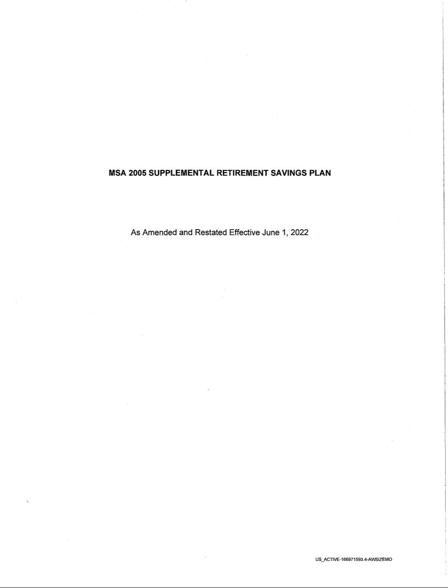

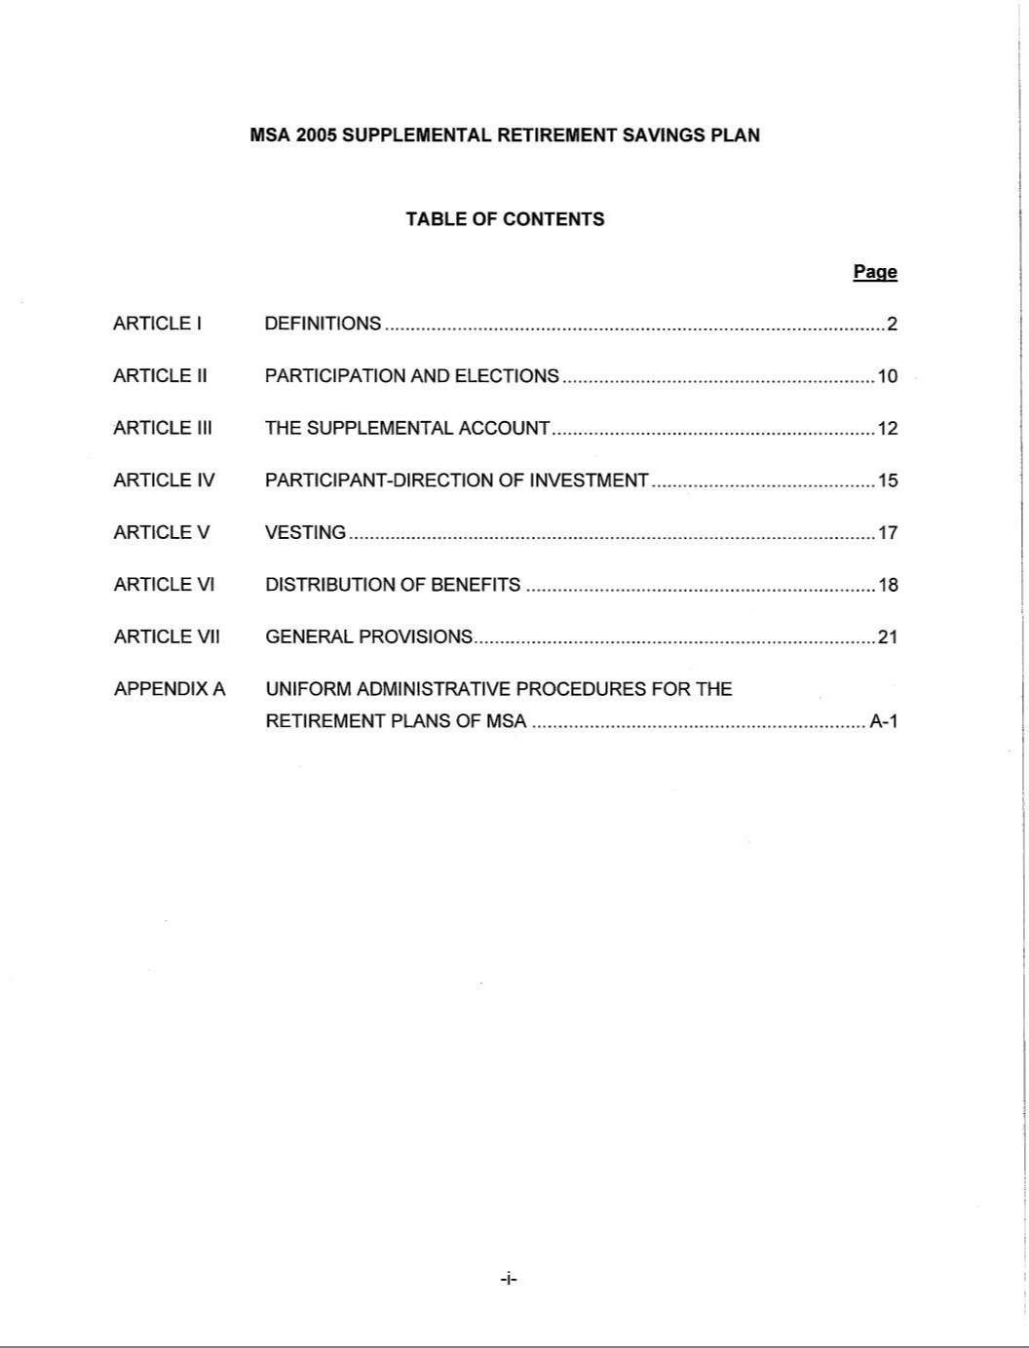

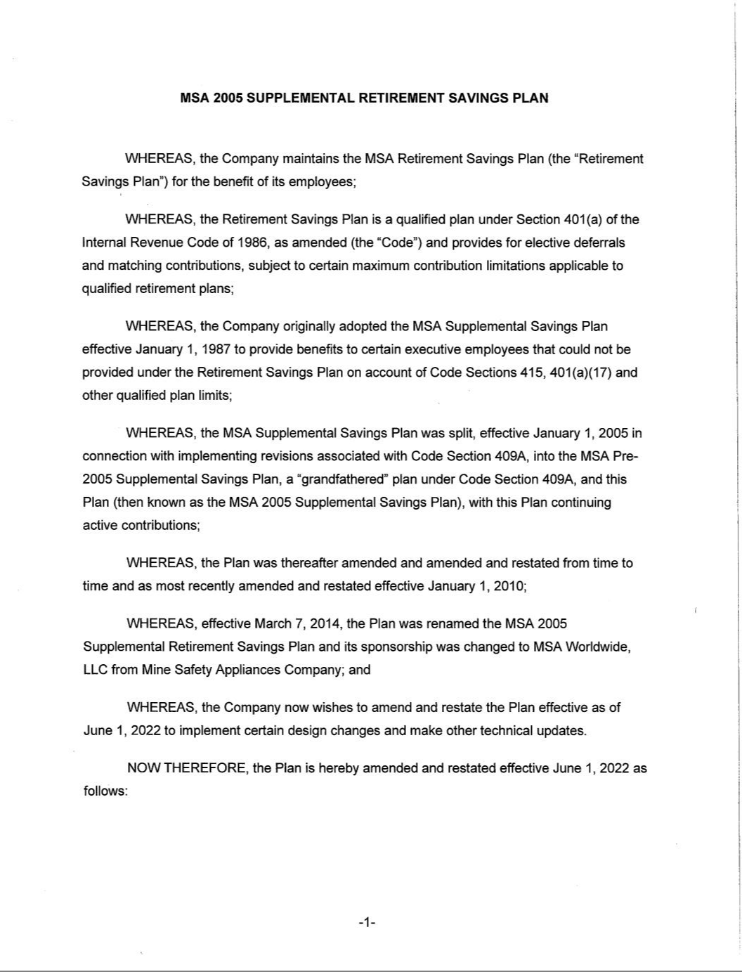

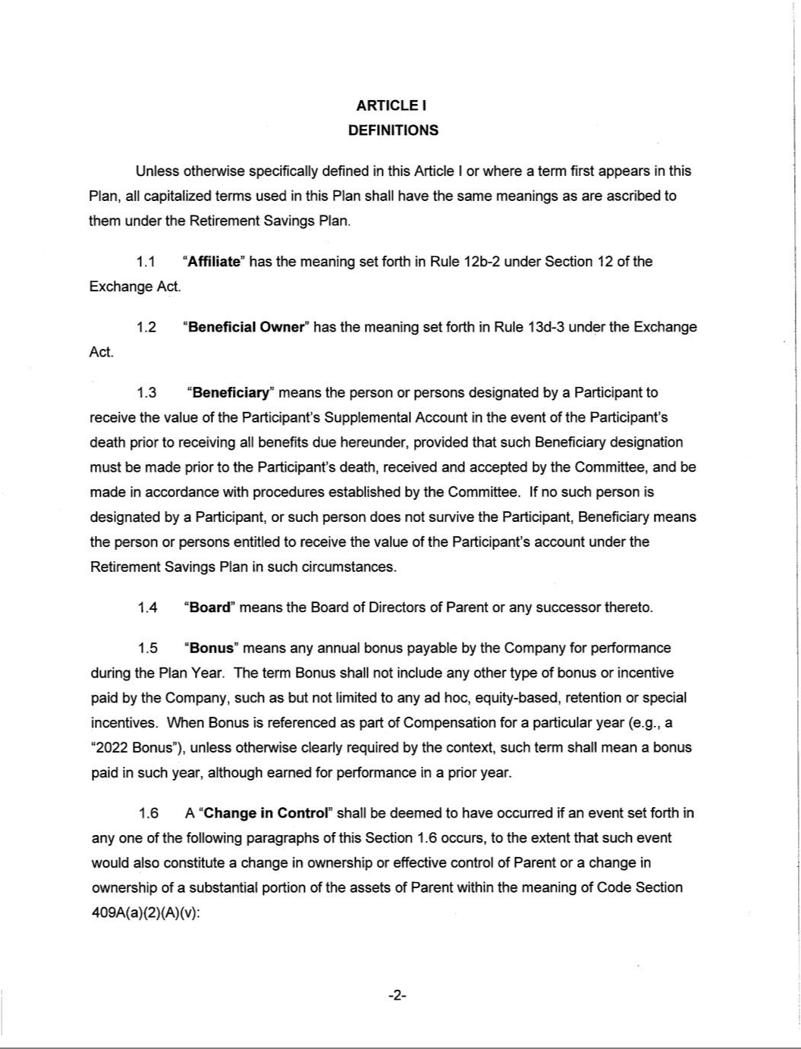

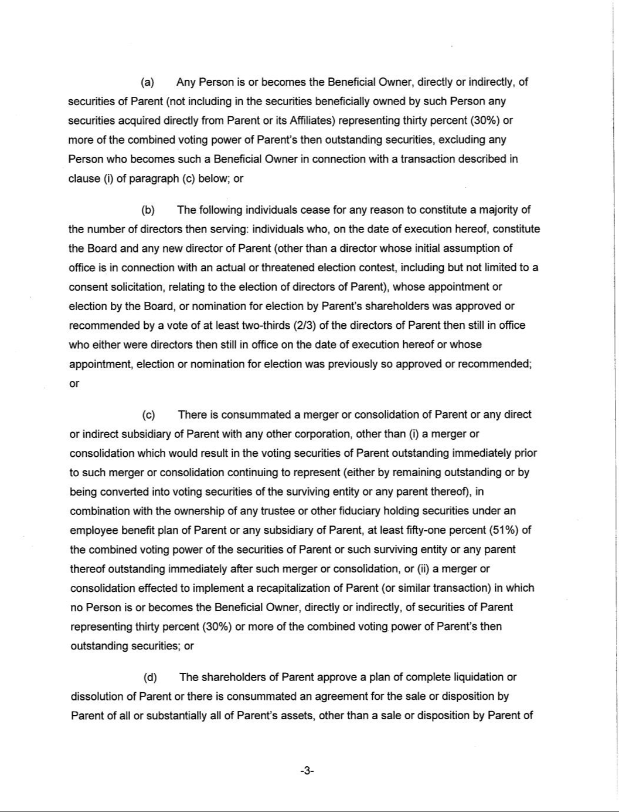

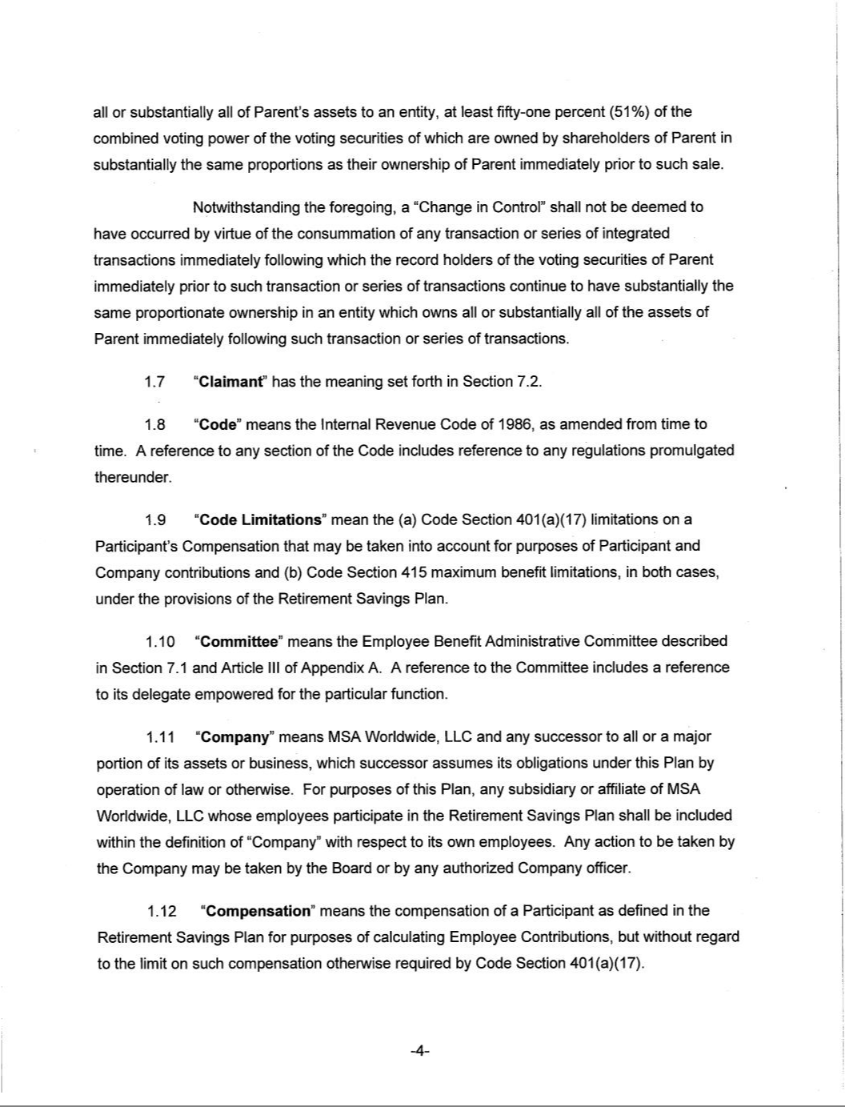

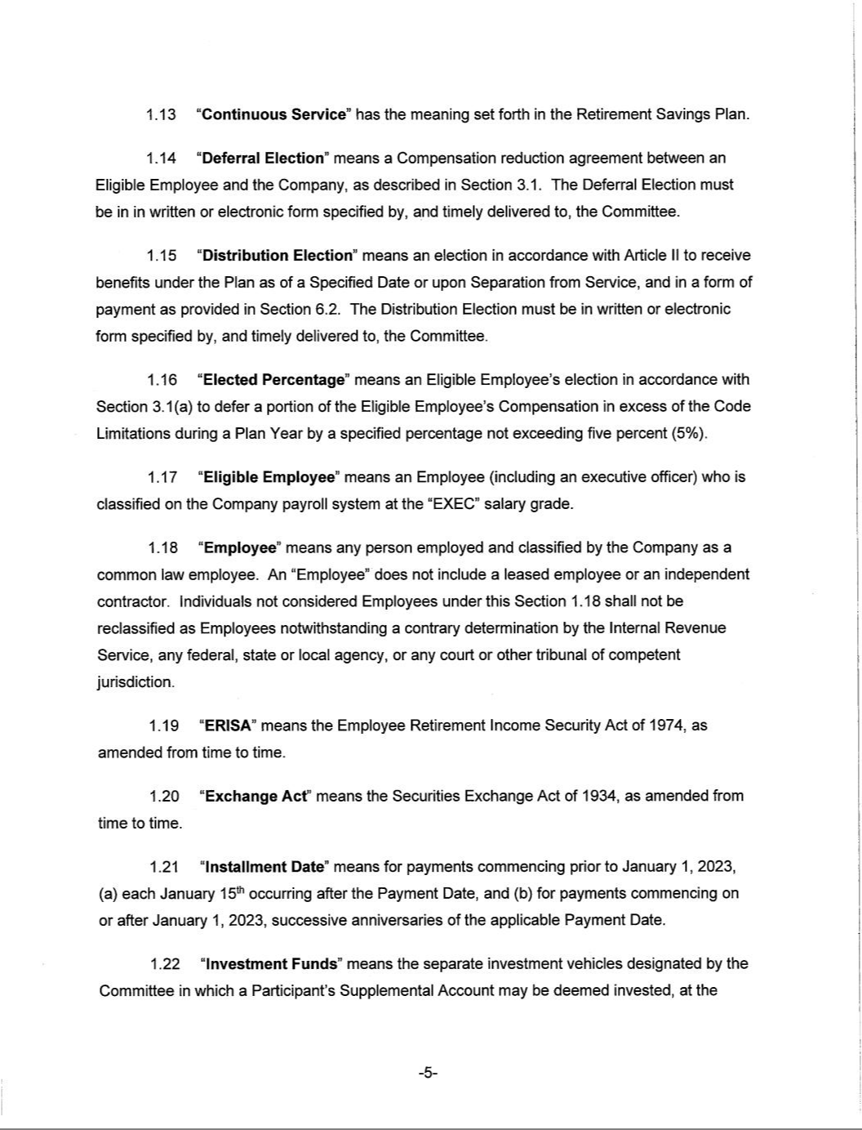

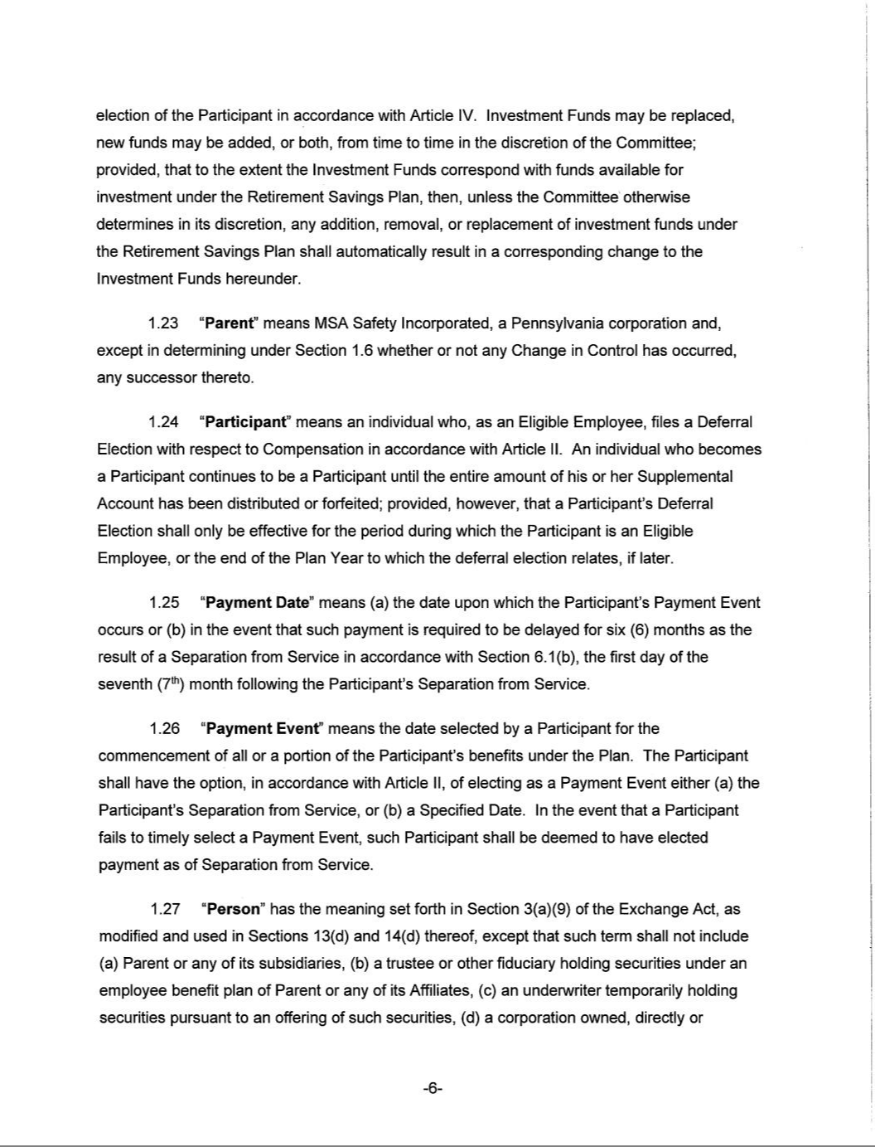

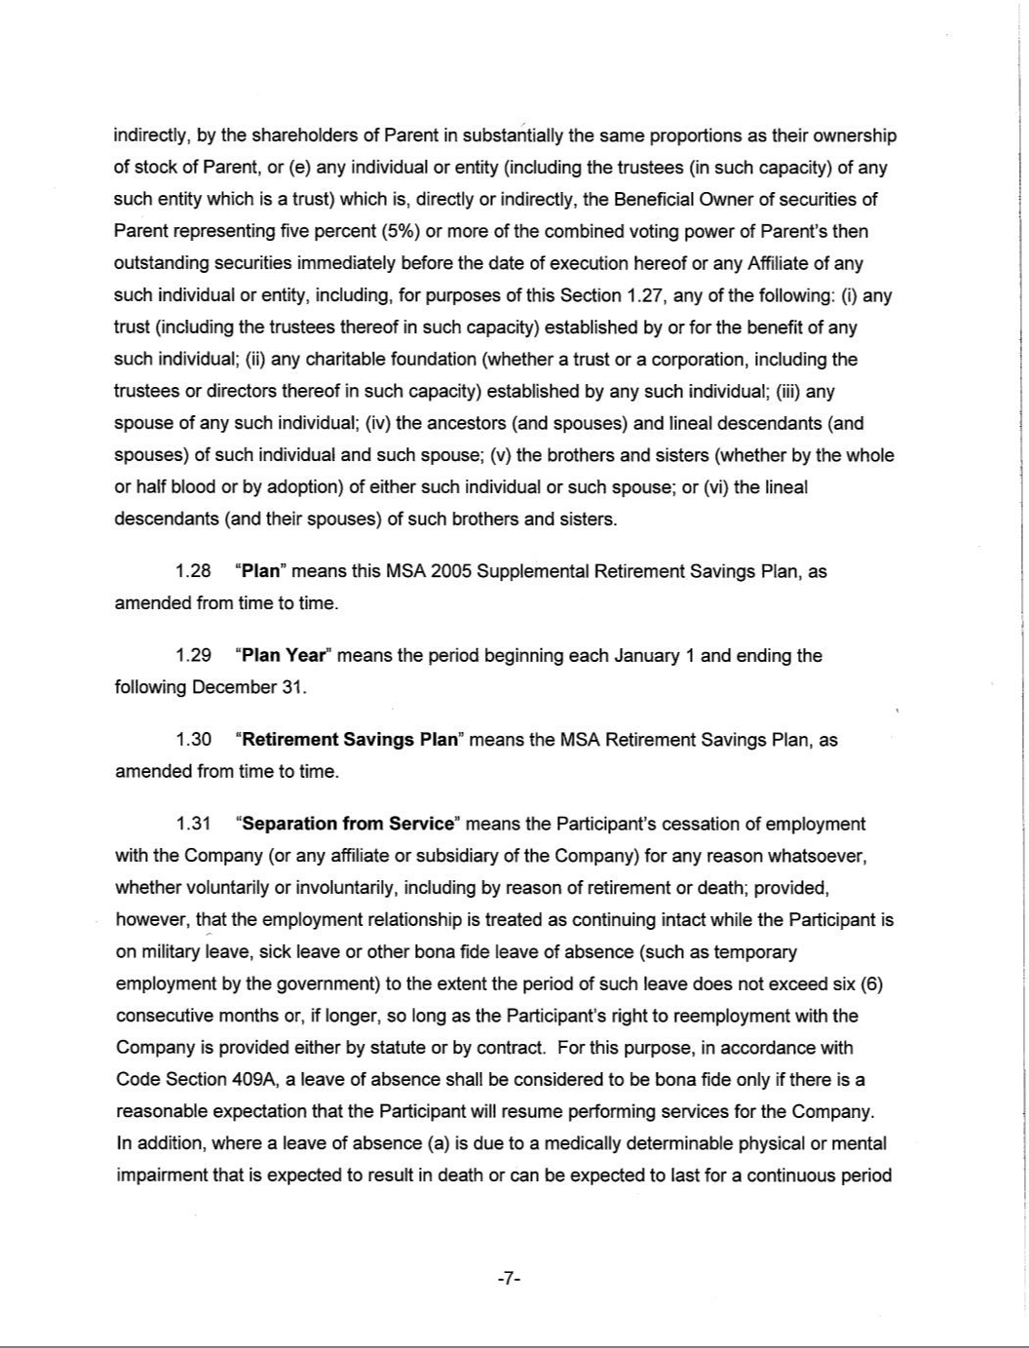

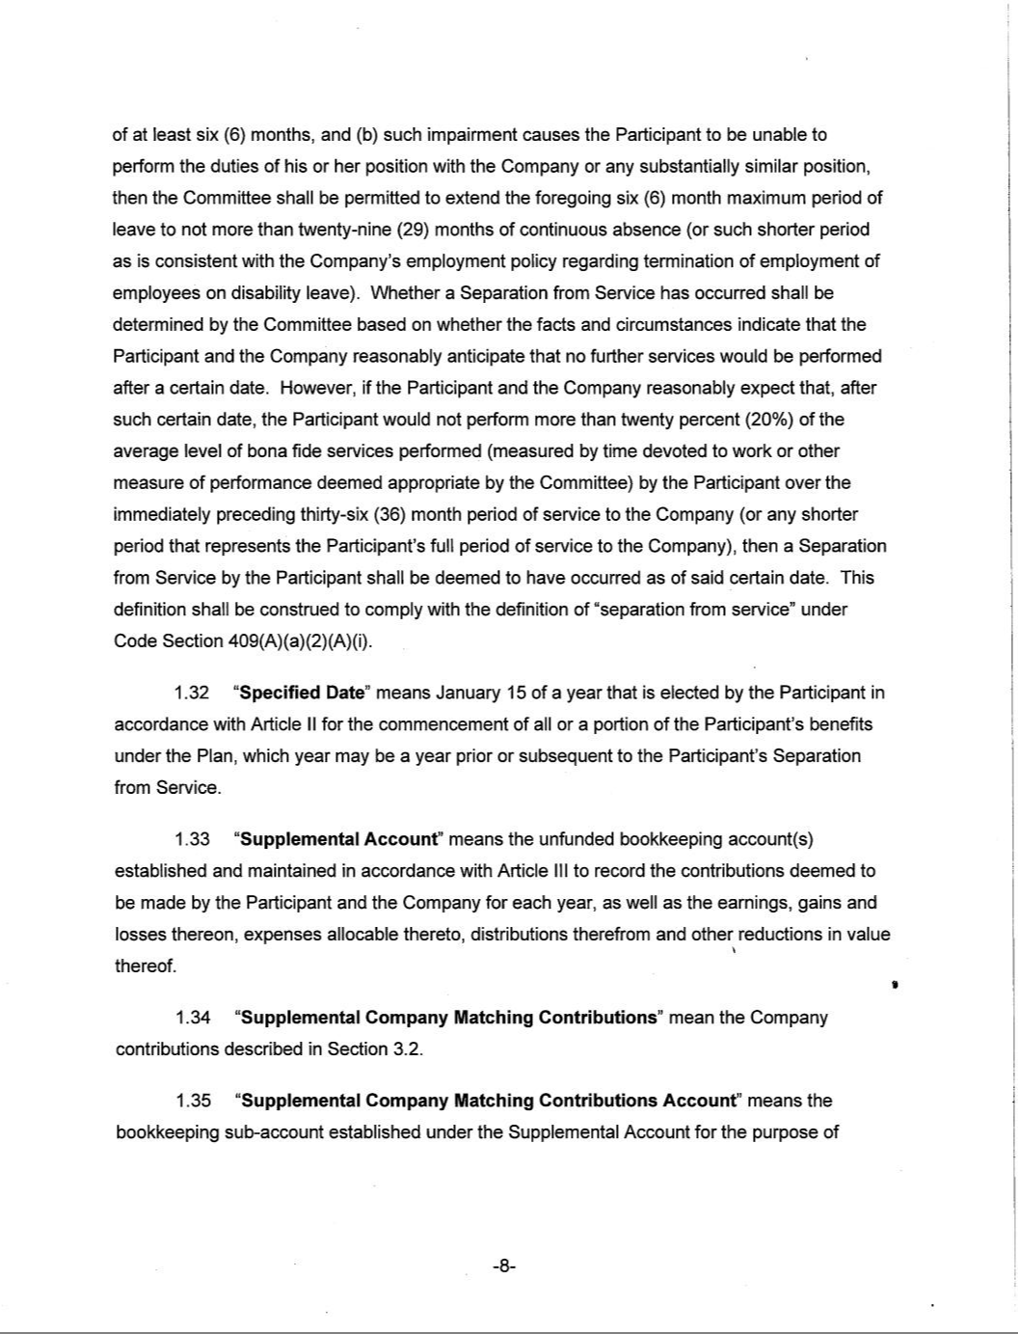

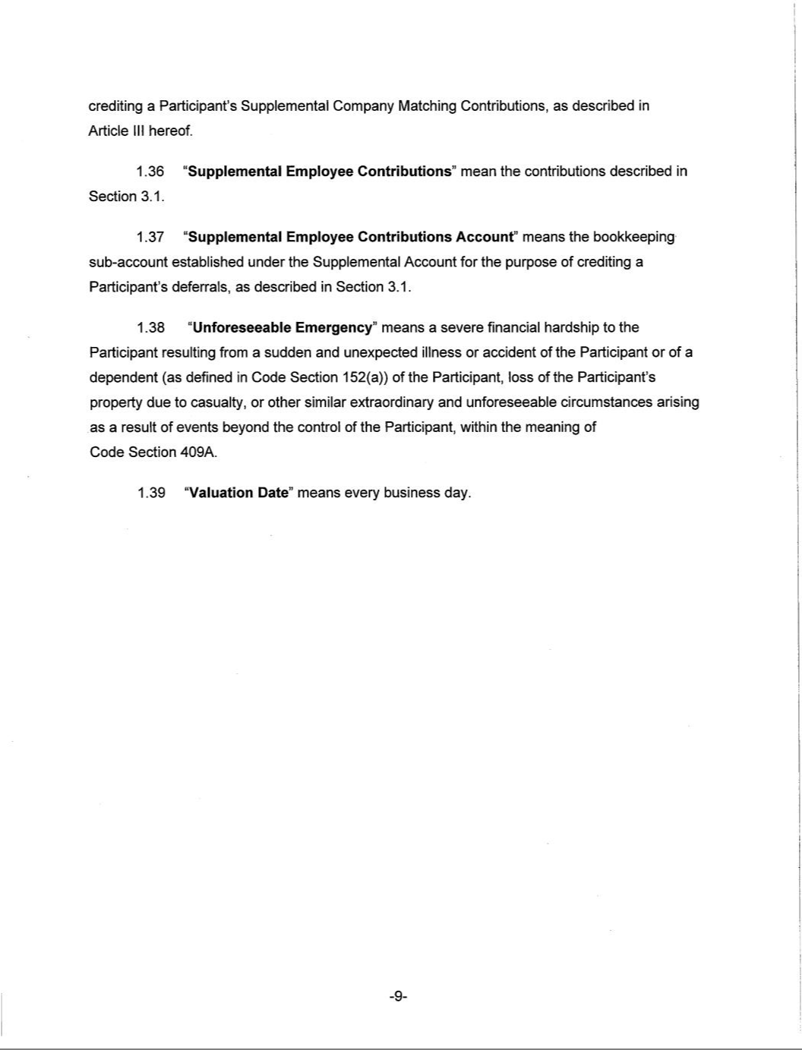

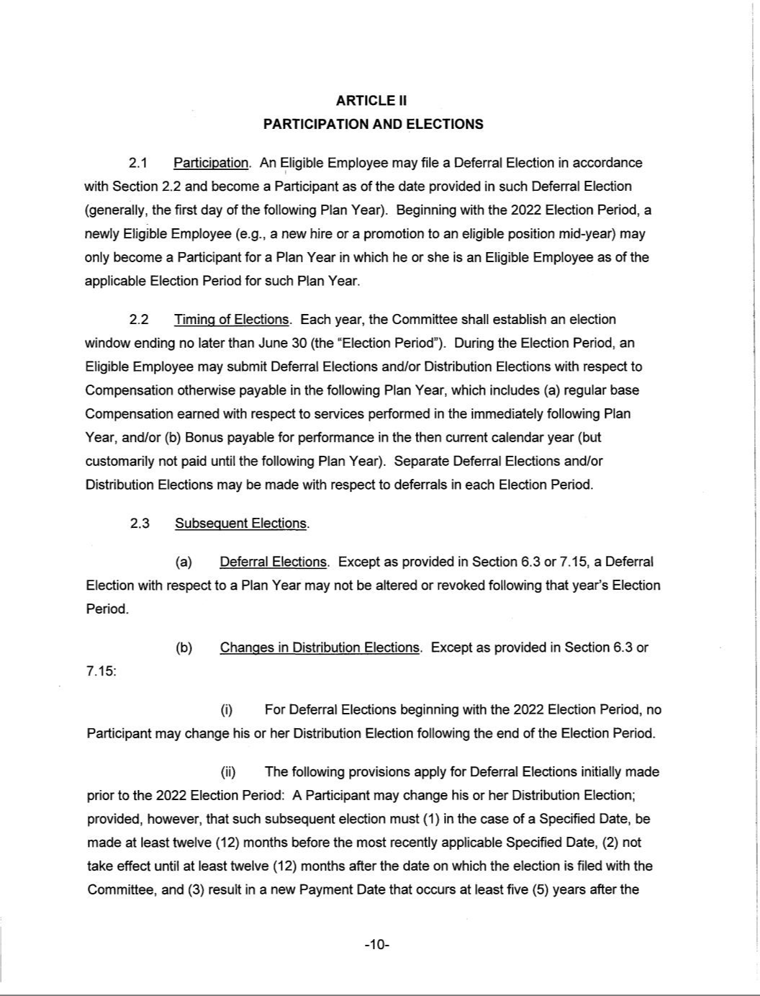



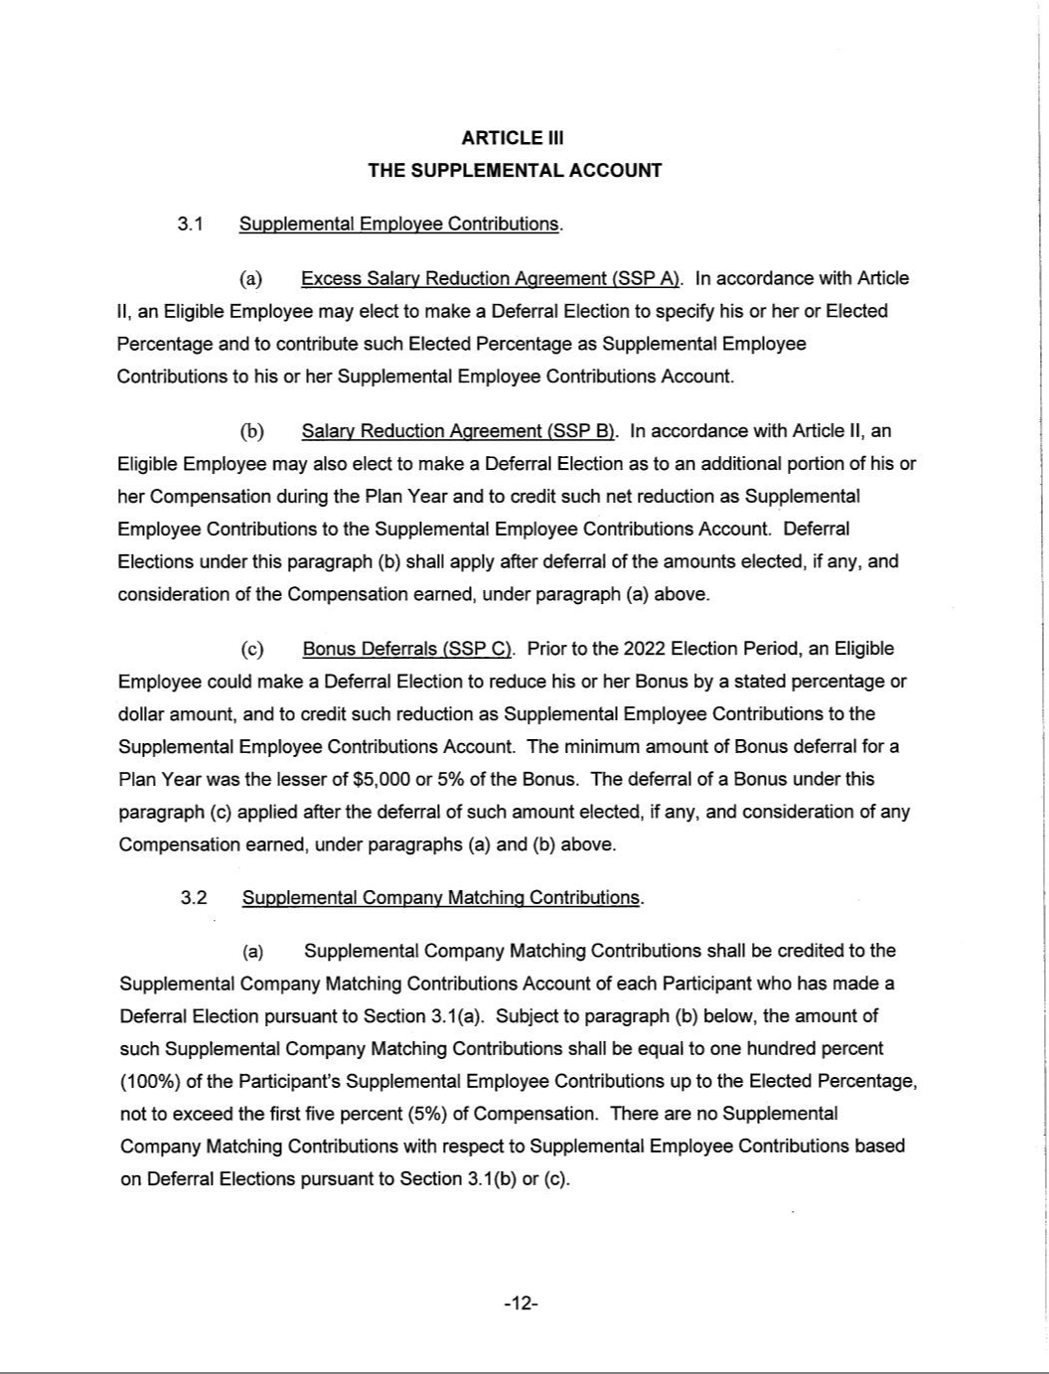

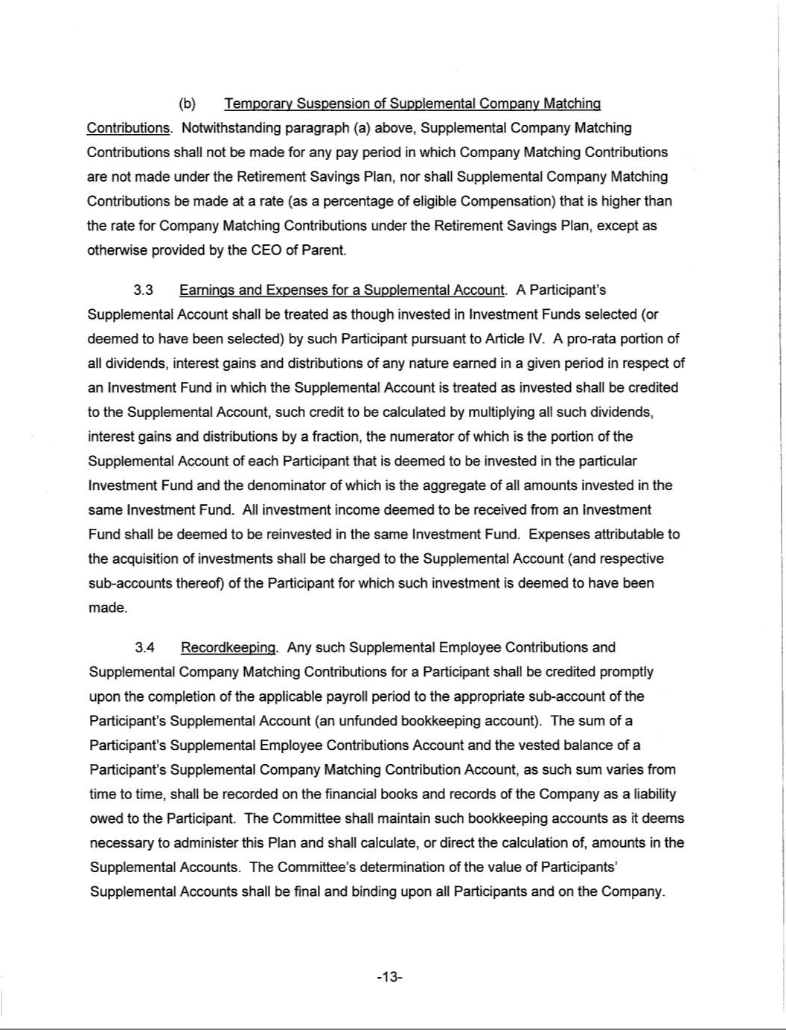



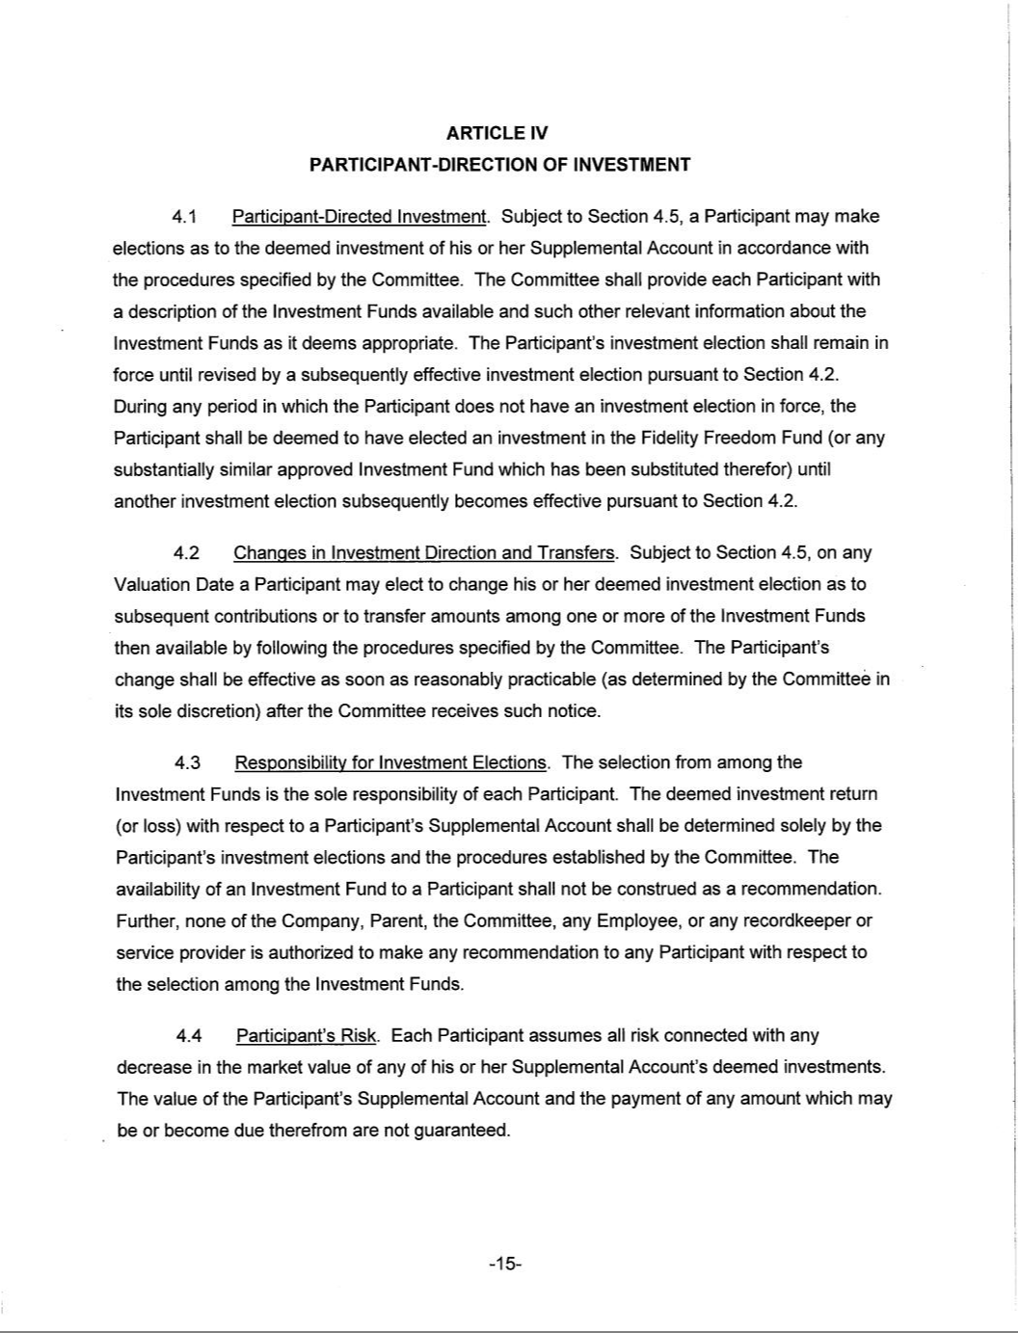

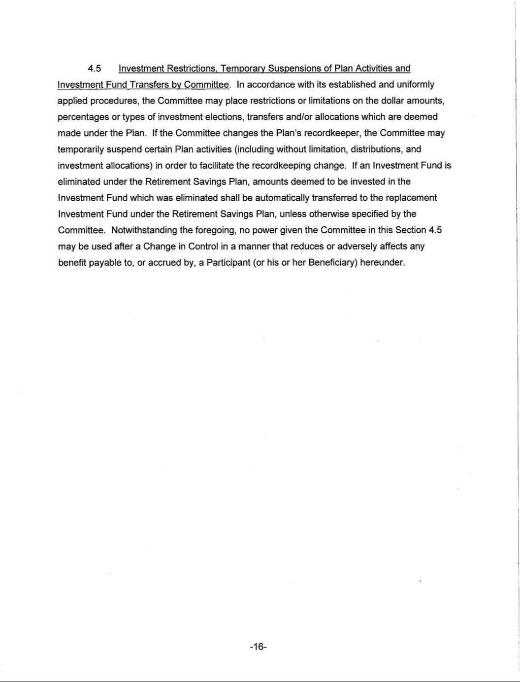

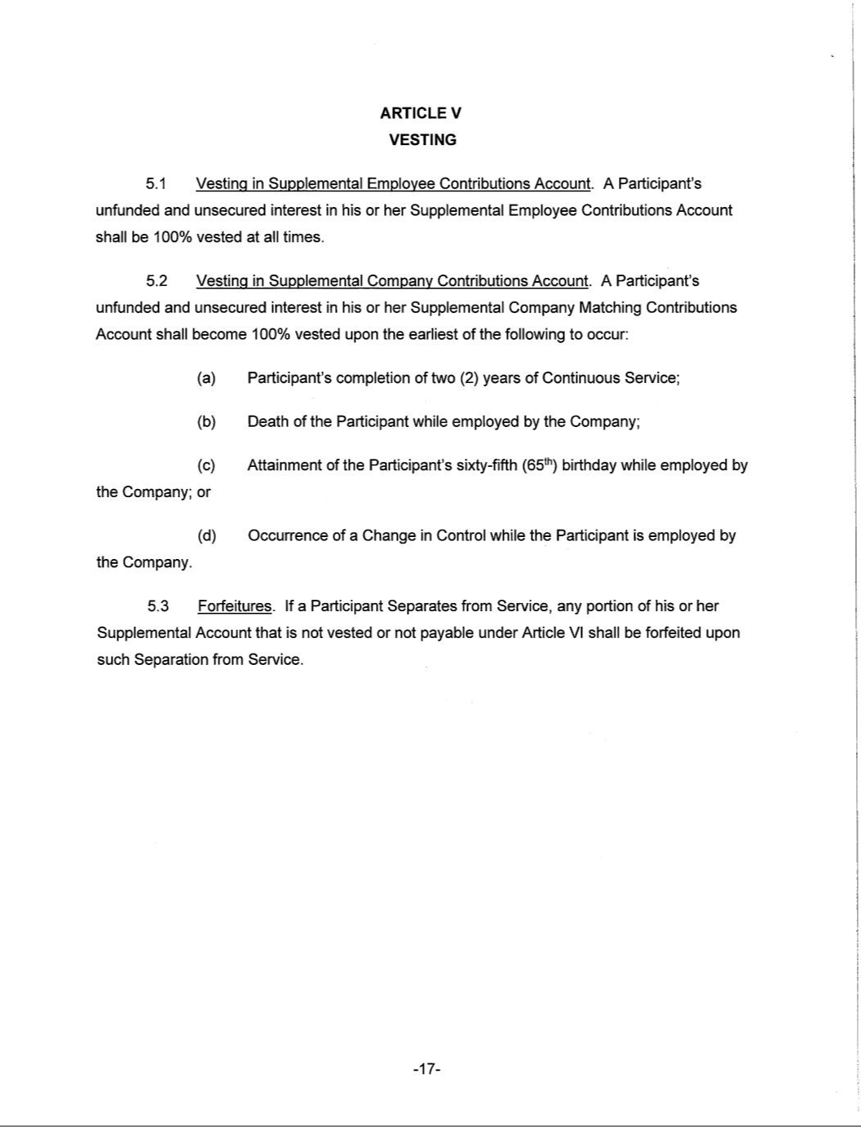

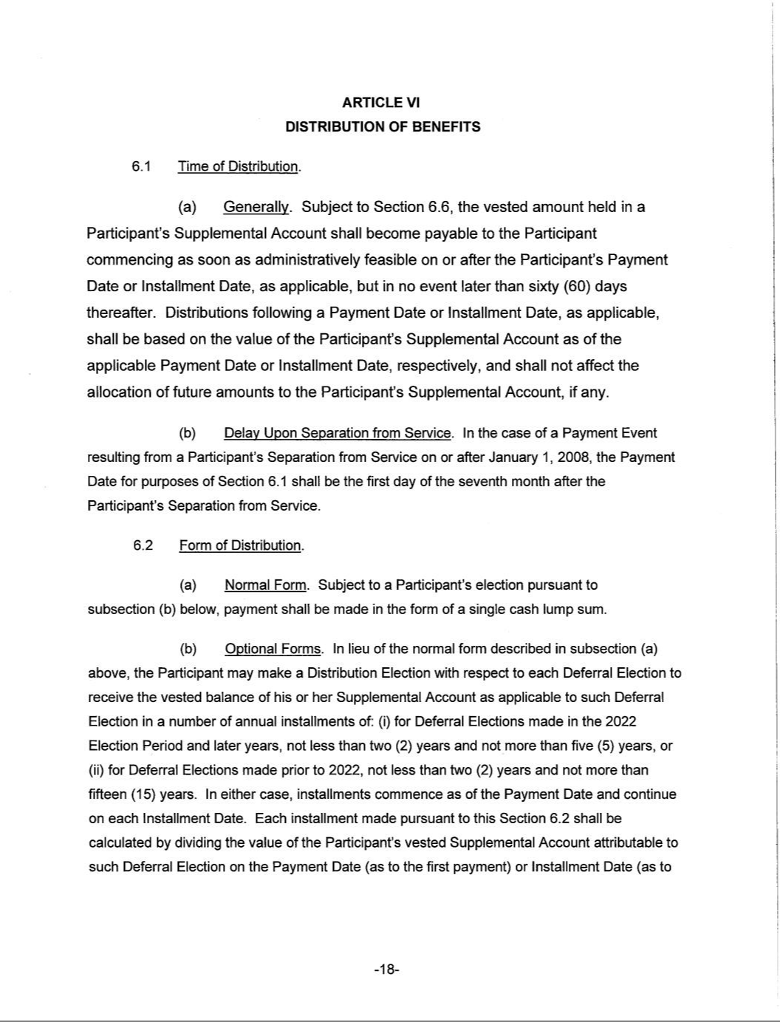

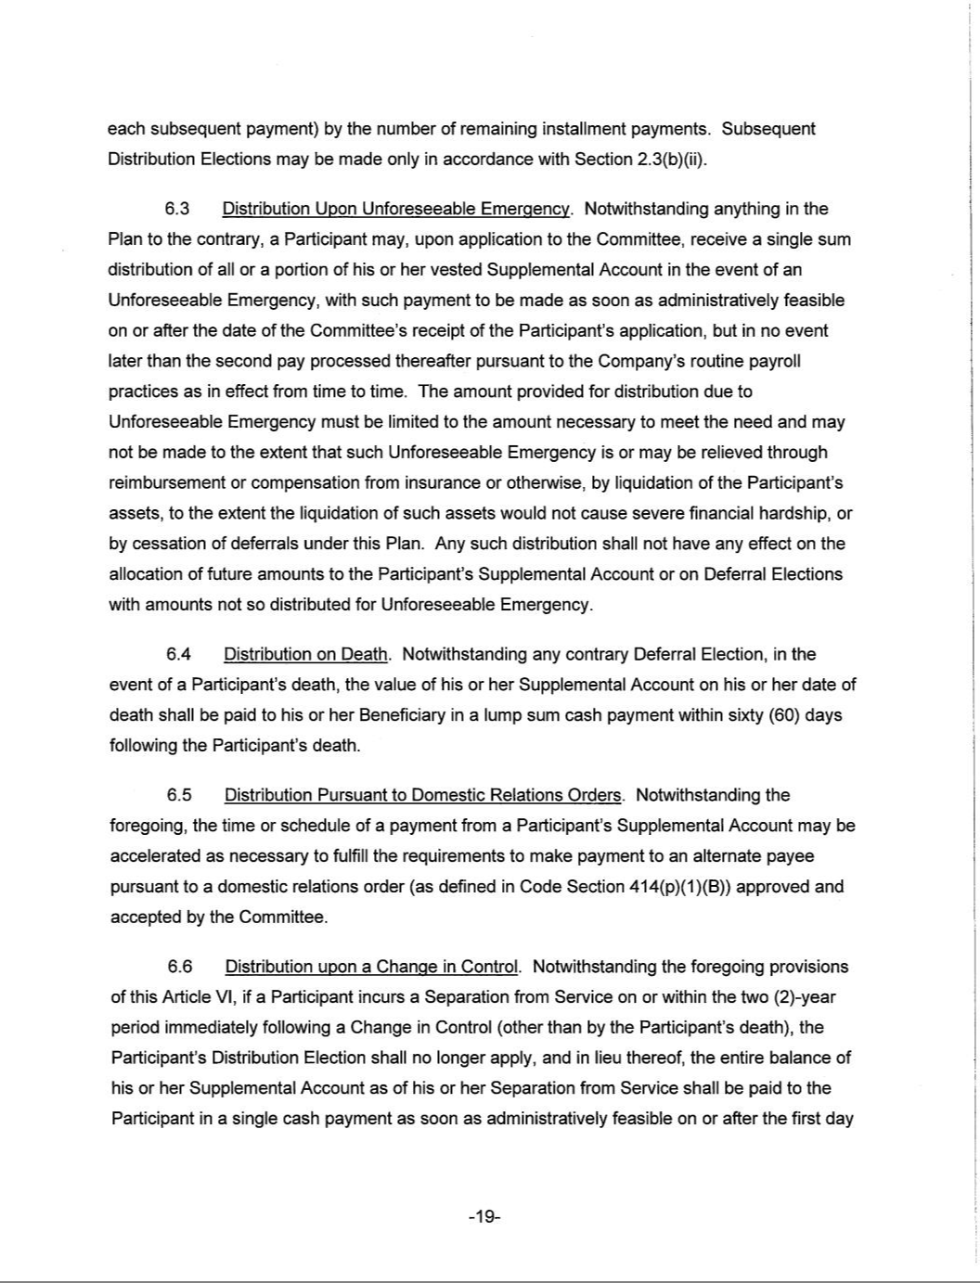

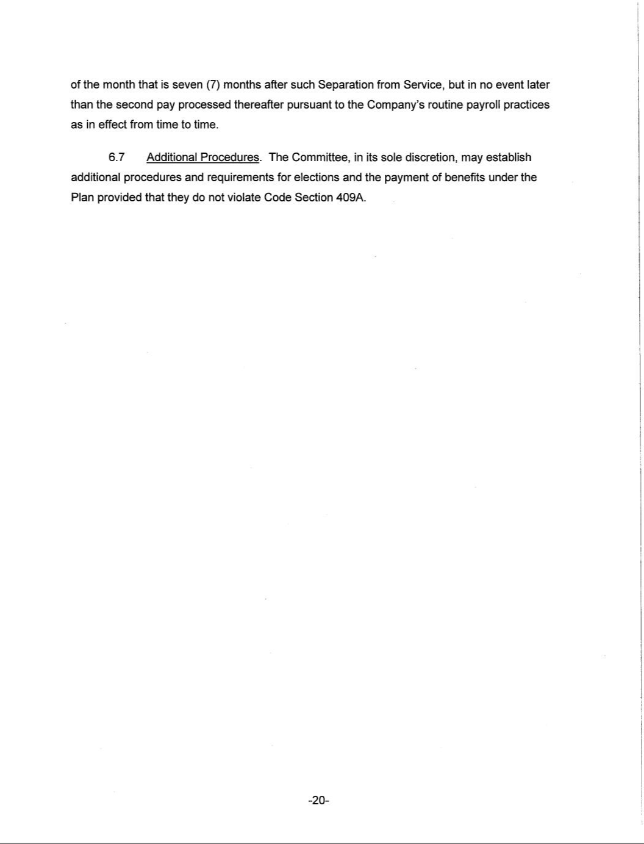

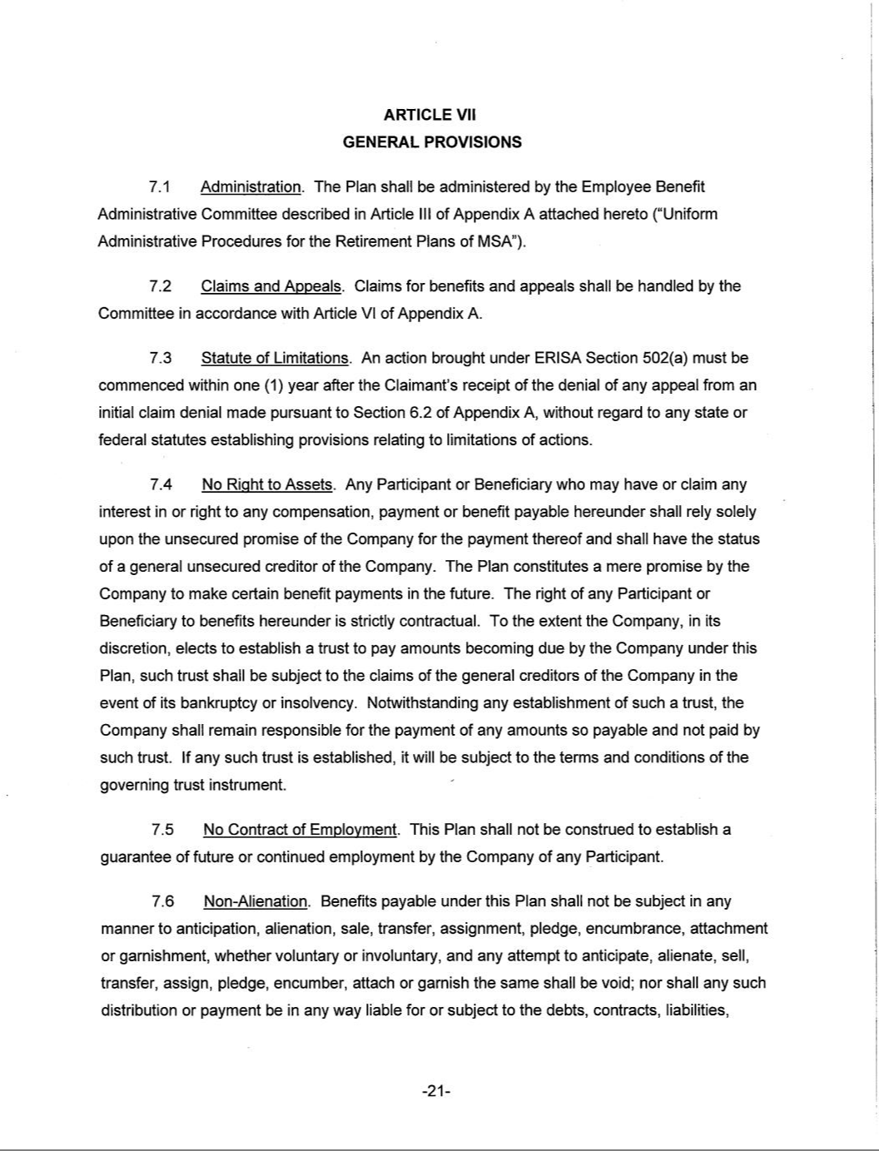

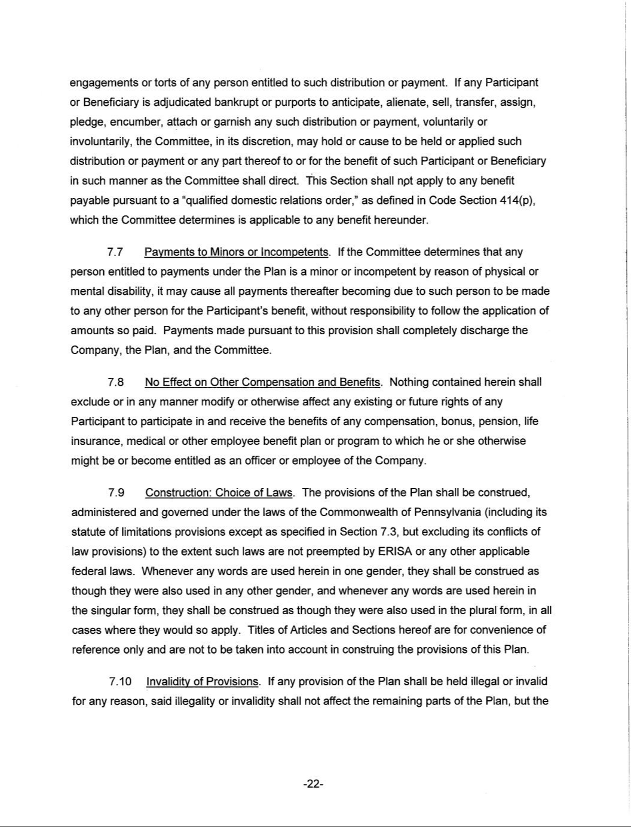

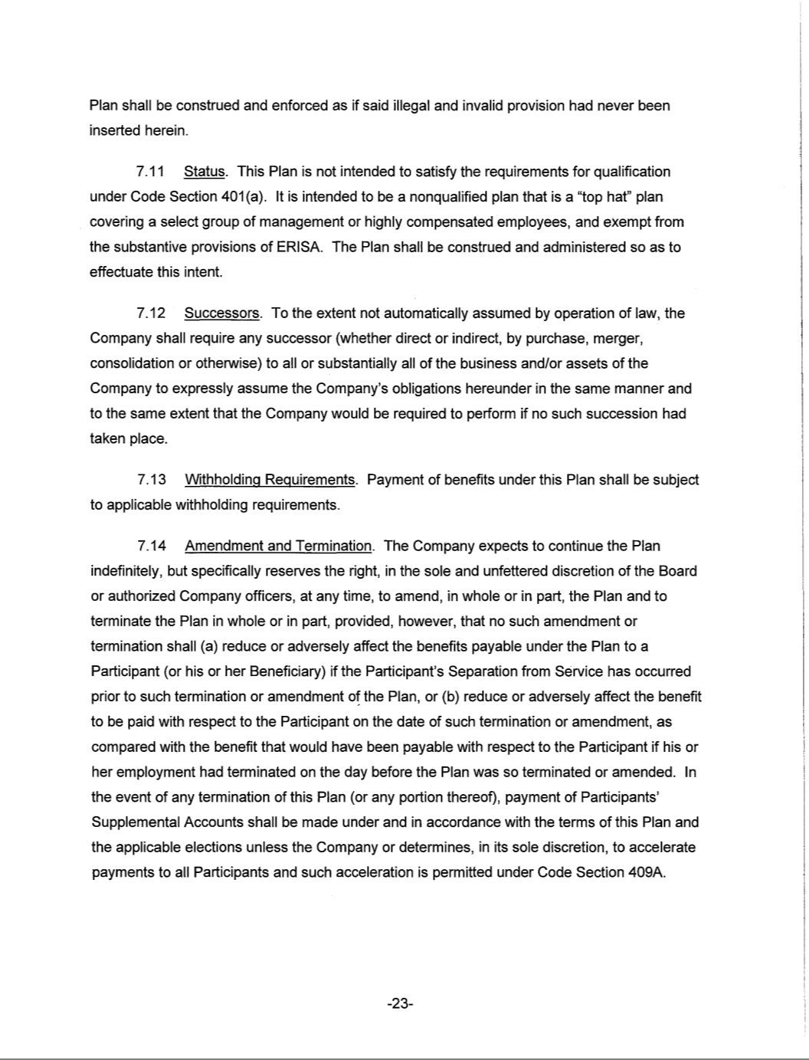

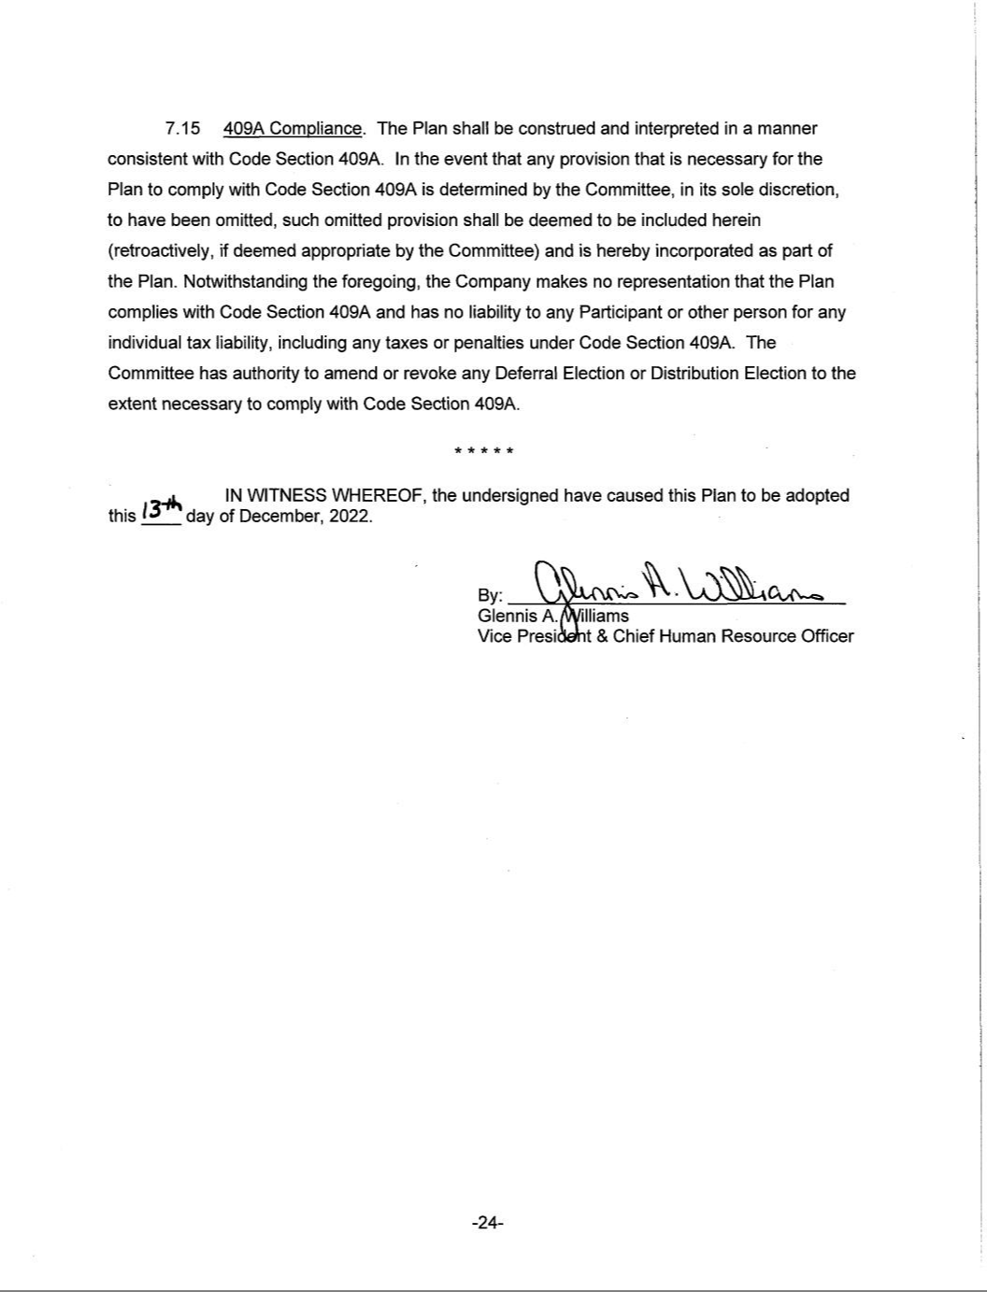

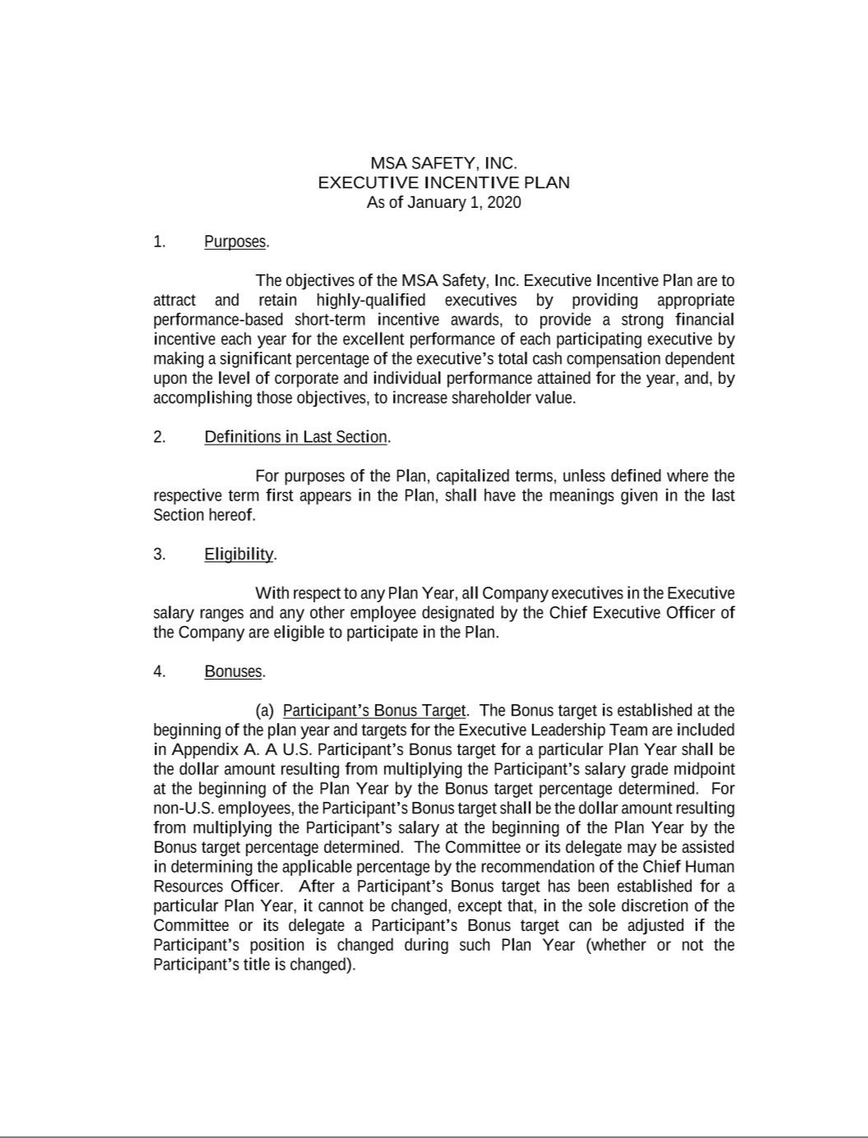

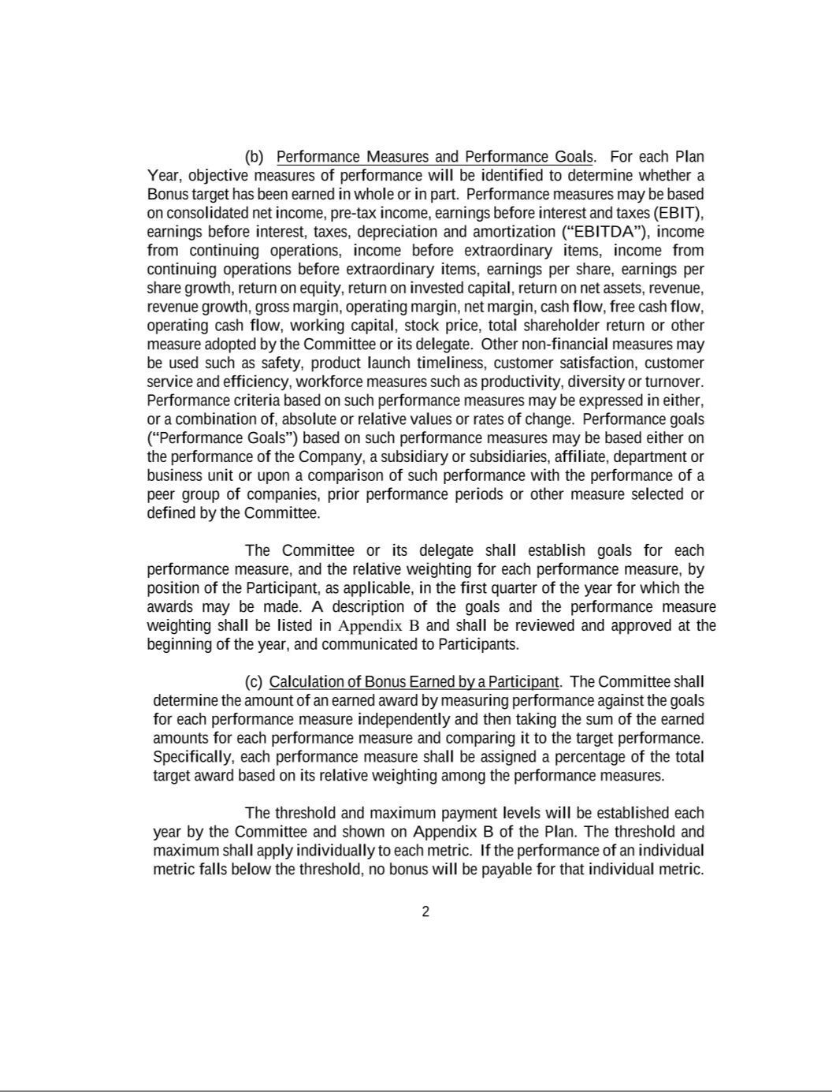

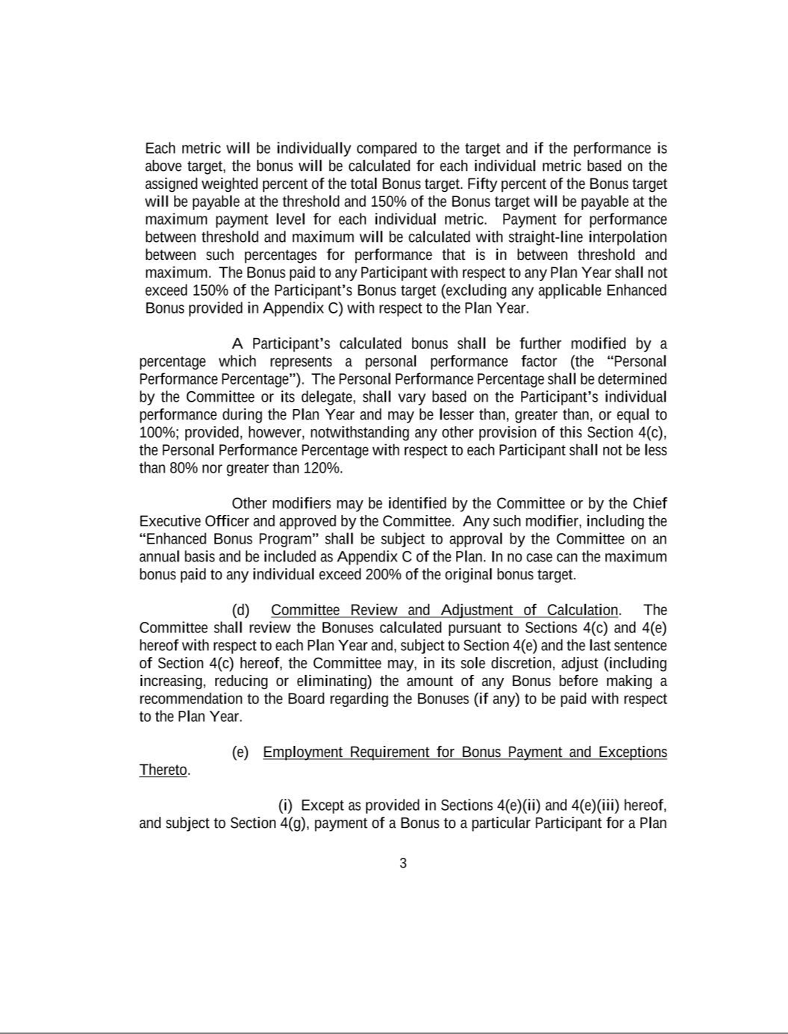

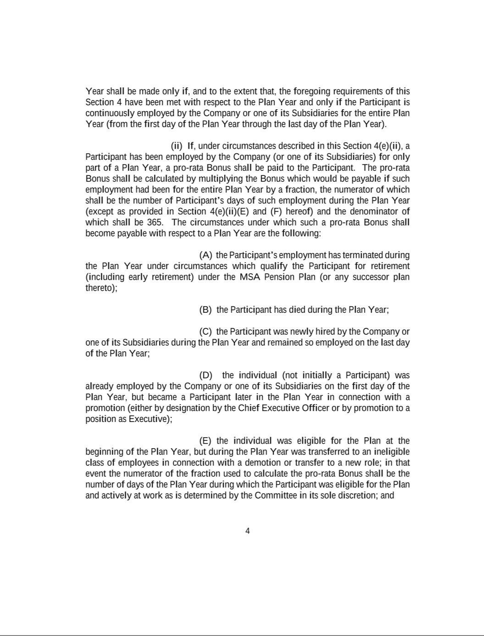

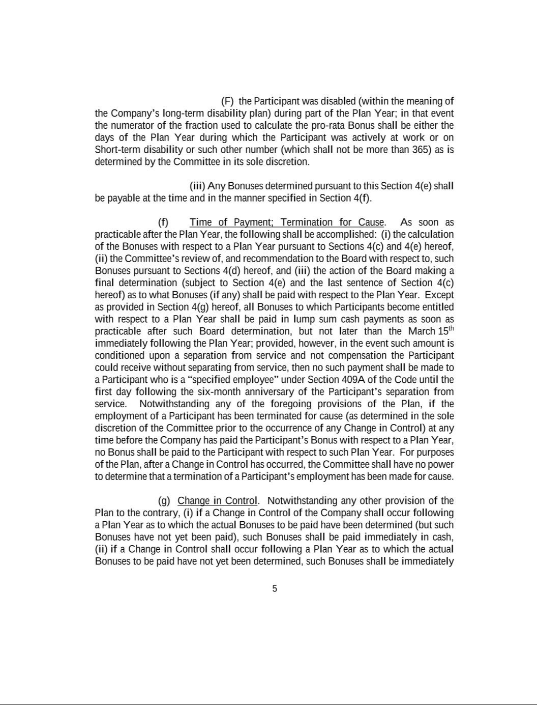

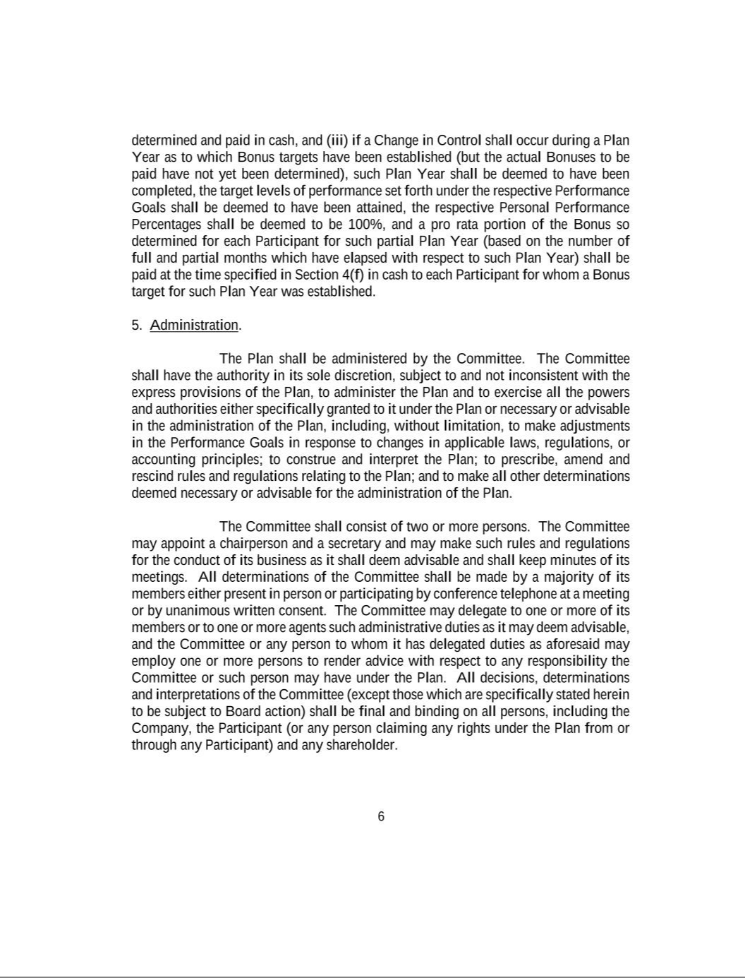

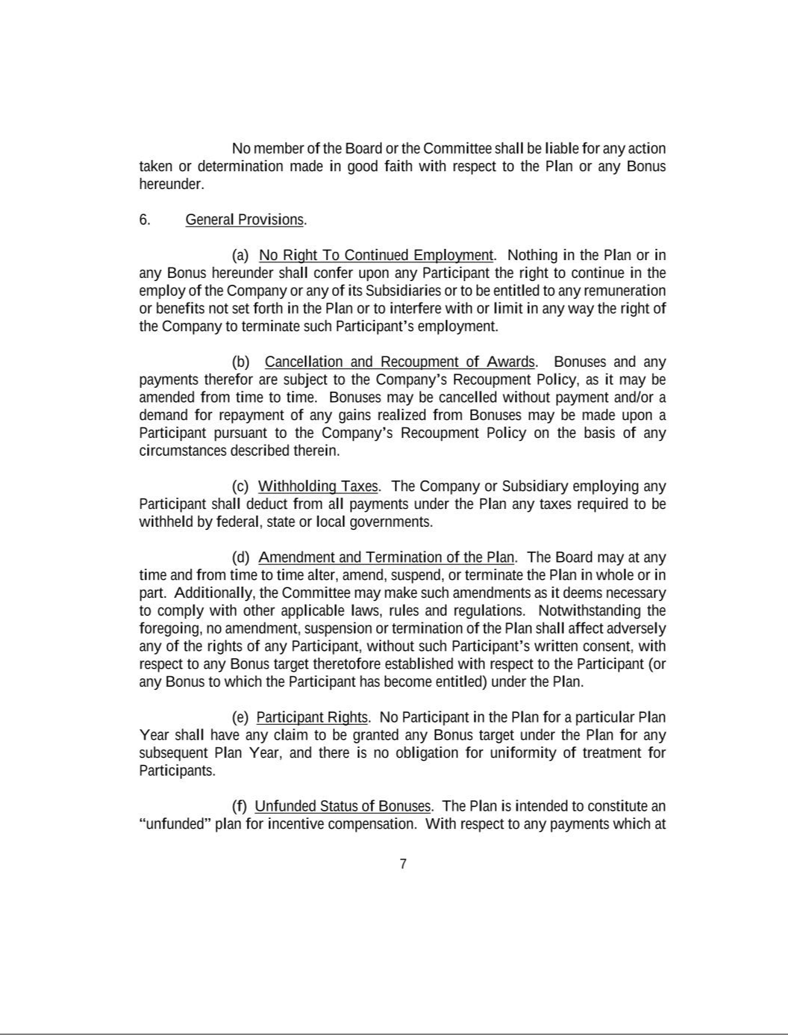

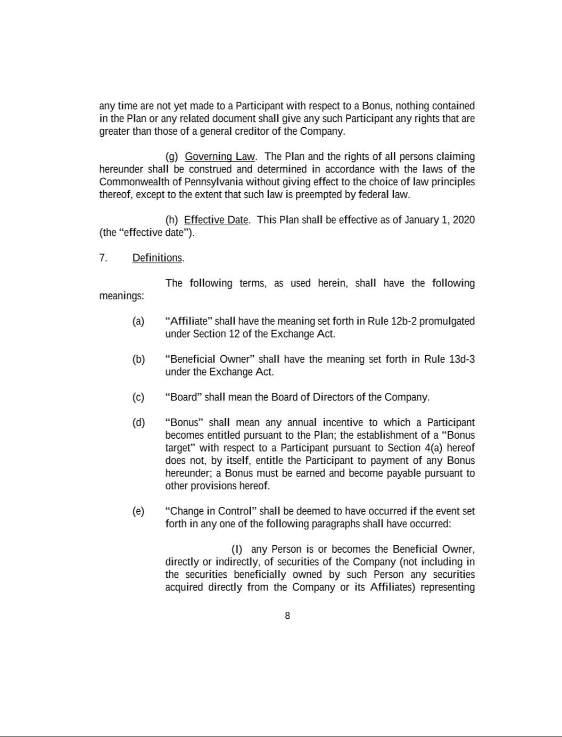

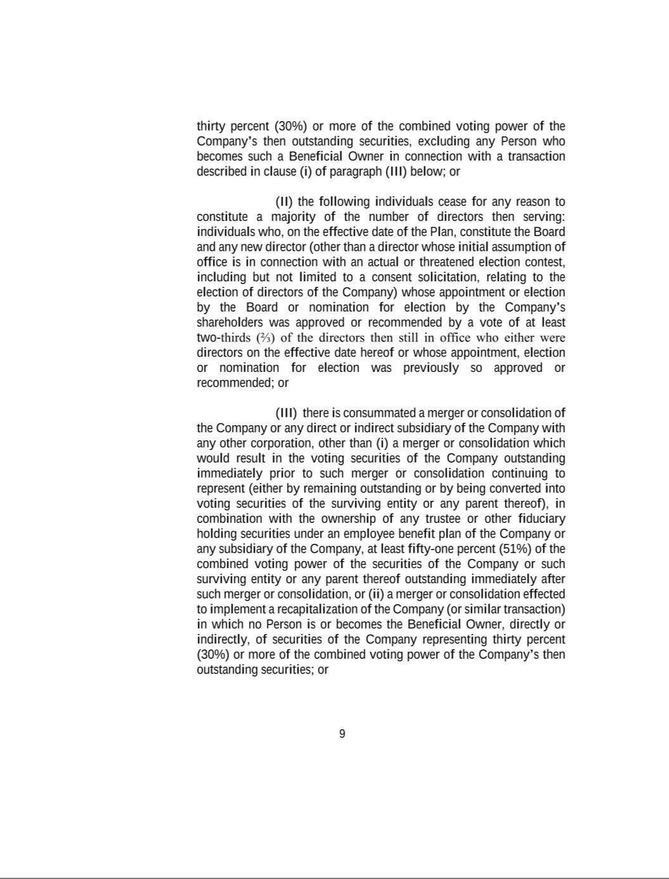

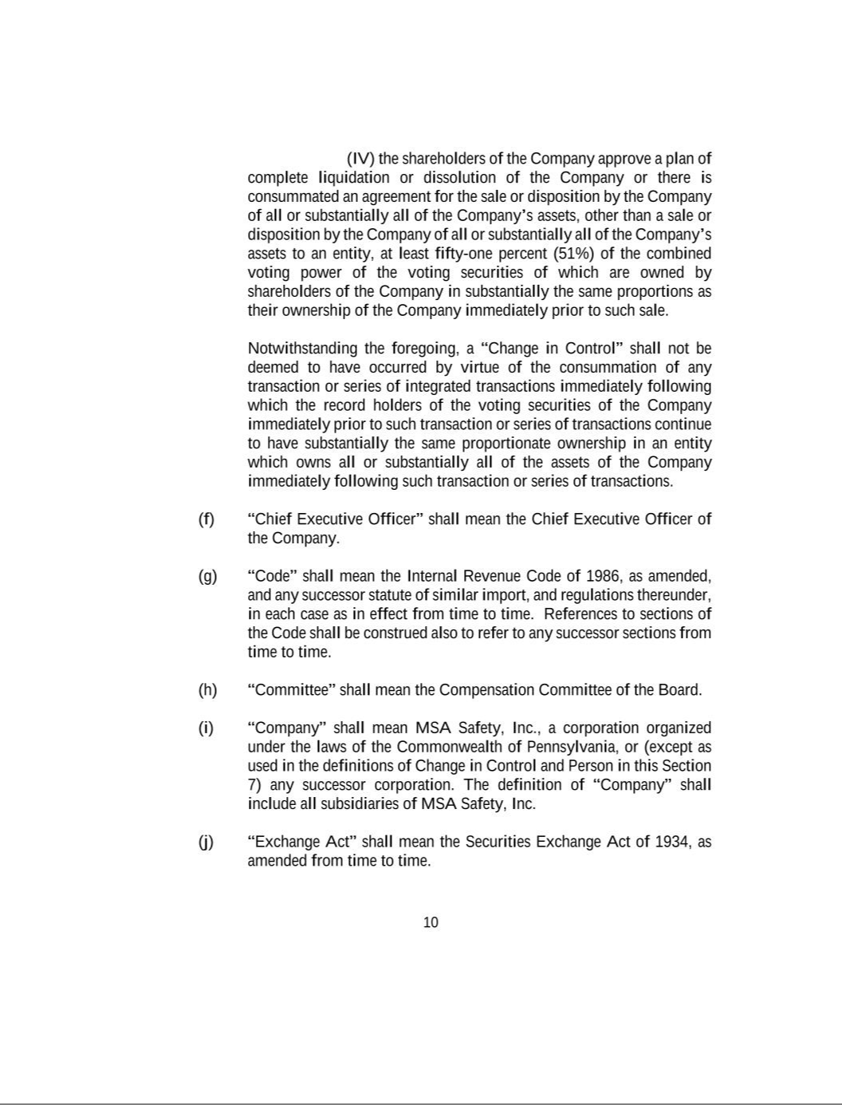

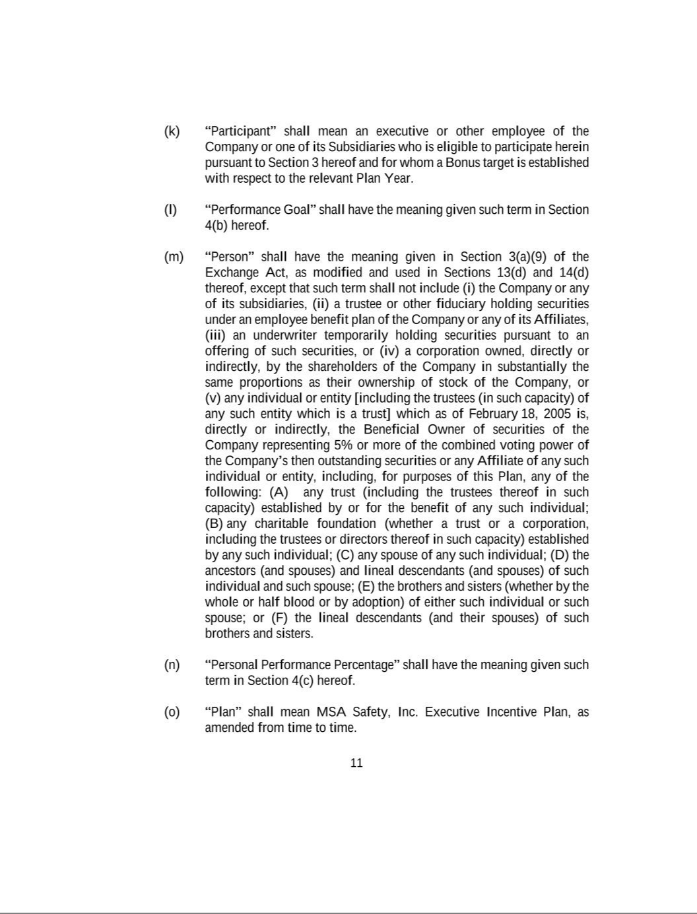



EXHIBIT 21

MSA SAFETY INCORPORATED

SUBSIDIARIES OF THE REGISTRANT

DECEMBER 31, 2022

Name

State or Other Jurisdiction of Incorporation

Compañia MSA de Argentina S.A.

General Monitors Ireland Limited

General Monitors, Inc.

Globe Holding Company, LLC

Latchways plc

Mine Safety Appliances Company, LLC

MSA (China) Safety Equipment Co. Ltd.

MSA (Suzhou) Safety Equipment R&D Co., Ltd

MSA Advanced Detection, LLC

MSA Belgium bvba

MSA Canada Inc.

MSA de Chile Ltda.

MSA de Mexico, S.A. de C.V.

MSA do Brasil Ltda.

MSA Europe GmbH

MSA Europe Holdings GmbH

MSA Gallet Holdings SAS

MSA Innovation, LLC

MSA International, LLC

MSA Italia S.R.L.

MSA Nederland B.V.

MSA Österreich GmbH

MSA Polska Sp. z o.o.

MSA Production France SAS

MSA Produktion Deutschland GmbH

MSA S.E. Asia Pte. Ltd.

MSA Safety Development, LLC

MSA Safety Malaysia Sdn. Bhd.

MSA Safety Pittsburgh Manufacturing, LLC

MSA Safety Sales, LLC

MSA Safety Services GmbH

MSA Spain S.L.U.

MSA Technologies and Enterprise Services GmbH

MSA Technologies and Enterprise Services SAS

MSA Technology, LLC

MSA Worldwide, LLC

Samsac Holdings (Pty.) Limited

Senscient, Ltd.

Argentina

Ireland

Nevada

New Hampshire

United Kingdom

Pennsylvania

China

China

Pennsylvania

Belgium

Canada

Chile

Mexico

Brazil

Switzerland

Germany

France

Pennsylvania

Delaware

Italy

Netherlands

Austria

Poland

France

Germany

Singapore

Pennsylvania

Malaysia

Pennsylvania

Pennsylvania

Germany

Spain

Germany

France

Pennsylvania

Pennsylvania

South Africa

United Kingdom

The above-mentioned subsidiary companies are included in the consolidated financial statements of the registrant filed as part of this annual report. The names of certain other subsidiaries, which considered in the aggregate as a single affiliate would not constitute a significant subsidiary, have been omitted.

EXHIBIT 23

CONSENT OF INDEPENDENT REGISTERED PUBLIC ACCOUNTING FIRM We consent to the incorporation by reference in the following Registration Statements:
- Registration Statement (Form S-8 No. 333-121196) pertaining to the MSA Retirement Savings Plan,
- Registration Statement (Form S-8 No. 333-157681) pertaining to the Mine Safety Appliances Company 2008 Non-Employee Directors’ Equity Incentive Plan,

- Registration Statement (Form S-8 Nos. 333-174601 and 333-157682) pertaining to the Mine Safety Appliances Company 2008 Management Equity Incentive Plan,
- Registration Statement (Form S-8 No. 333-199880) pertaining to the Employee Stock Purchase Plan,
- Registration Statement (Form S-8 No. 333-214397) pertaining to the MSA Safety Incorporated 2016 Management Equity Incentive Plan,

- Registration Statement (Form S-8 No. 333-218078) pertaining to the MSA Safety Incorporated 2017 Non-Employee Directors’ Equity Incentive Plan, and
- Registration Statement (Form S-8 No. 333-231996) pertaining to the Sierra Monitor Corporation 2006 Equity Incentive Plan;

of our reports dated February 16, 2023, with respect to the consolidated financial statements and schedule of MSA Safety Incorporated and the effectiveness of internal control over financial reporting of MSA Safety Incorporated included in this Annual Report (Form 10-K) of MSA Safety Incorporated for the year ended December 31, 2022.

/s/ Ernst & Young LLP

Pittsburgh, Pennsylvania

February 16, 2023

EXHIBIT 31.1

CERTIFICATION OF CHIEF EXECUTIVE OFFICER PURSUANT TO RULE 13a-14(a)

I, Nishan J. Vartanian, certify that:

- I have reviewed this annual report on Form 10-K of MSA Safety Incorporated;

- Based on my knowledge, this report does not contain any untrue statement of a material fact or omit to state a material fact necessary to make the statements made, in light of the circumstances under which such statements were made, not misleading with respect to the period covered by this report;

- Based on my knowledge, the financial statements, and other financial information included in this report, fairly present in all material respects the financial condition, results of operations and cash flows of the registrant as of, and for, the periods presented in this report;

- The registrant’s other certifying officer and I are responsible for establishing and maintaining disclosure controls and procedures (as defined in Exchange Act Rules 13a-15(e) and 15d-15(e)) and internal control over financial reporting (as defined in Exchange Act Rules 13a-15(f) and 15d-15(f)) for the registrant and have:

  - Designed such disclosure controls and procedures, or caused such disclosure controls and procedures to be designed under our supervision, to ensure that material information relating to the registrant, including its consolidated subsidiaries, is made known to us by others within those entities, particularly during the period in which this report is being prepared;

  - Designed such internal control over financial reporting, or caused such internal control over financial reporting to be designed under our supervision, to provide reasonable assurance regarding the reliability of financial reporting and the preparation of financial statements for external purposes in accordance with generally accepted accounting principles;

  - Evaluated the effectiveness of the registrant’s disclosure controls and procedures and presented in this report our conclusions about the effectiveness of the disclosure controls and procedures, as of the end of the period covered by this report based on such evaluation; and

  - Disclosed in this report any change in the registrant’s internal control over financial reporting that occurred during the registrant’s most recent fiscal quarter (the registrant’s fourth fiscal quarter in the case of an annual report) that has materially affected, or is reasonably likely to materially affect, the registrant’s internal control over financial reporting; and

- The registrant’s other certifying officer and I have disclosed, based on our most recent evaluation of internal control over financial reporting, to the registrant’s auditors and the audit committee of the registrant’s board of directors (or persons performing the equivalent functions):

  - All significant deficiencies and material weaknesses in the design or operation of internal control over financial reporting which are reasonably likely to adversely affect the registrant’s ability to record, process, summarize and report financial information; and

  - Any fraud, whether or not material, that involves management or other employees who have a significant role in the registrant’s internal control over financial reporting.

February 16, 2023 | /s/ Nishan J. Vartanian
 | Nishan J. Vartanian
 | Chairman, President and Chief Executive Officer
 | (Principal Executive Officer)

EXHIBIT 31.2

CERTIFICATION OF CHIEF FINANCIAL OFFICER PURSUANT TO RULE 13a-14(a)

I, Lee B. McChesney certify that:

- I have reviewed this annual report on Form 10-K of MSA Safety Incorporated;

- Based on my knowledge, this report does not contain any untrue statement of a material fact or omit to state a material fact necessary to make the statements made, in light of the circumstances under which such statements were made, not misleading with respect to the period covered by this report;

- Based on my knowledge, the financial statements, and other financial information included in this report, fairly present in all material respects the financial condition, results of operations and cash flows of the registrant as of, and for, the periods presented in this report;

- The registrant’s other certifying officer and I are responsible for establishing and maintaining disclosure controls and procedures (as defined in Exchange Act Rules 13a-15(e) and 15d-15(e)) and internal control over financial reporting (as defined in Exchange Act Rules 13a-15(f) and 15d-15(f)) for the registrant and have:

  - Designed such disclosure controls and procedures, or caused such disclosure controls and procedures to be designed under our supervision, to ensure that material information relating to the registrant, including its consolidated subsidiaries, is made known to us by others within those entities, particularly during the period in which this report is being prepared;

  - Designed such internal control over financial reporting, or caused such internal control over financial reporting to be designed under our supervision, to provide reasonable assurance regarding the reliability of financial reporting and the preparation of financial statements for external purposes in accordance with generally accepted accounting principles;

  - Evaluated the effectiveness of the registrant’s disclosure controls and procedures and presented in this report our conclusions about the effectiveness of the disclosure controls and procedures, as of the end of the period covered by this report based on such evaluation; and

  - Disclosed in this report any change in the registrant’s internal control over financial reporting that occurred during the registrant’s most recent fiscal quarter (the registrant’s fourth fiscal quarter in the case of an annual report) that has materially affected, or is reasonably likely to materially affect, the registrant’s internal control over financial reporting; and

- The registrant’s other certifying officer and I have disclosed, based on our most recent evaluation of internal control over financial reporting, to the registrant’s auditors and the audit committee of the registrant’s board of directors (or persons performing the equivalent functions):

  - All significant deficiencies and material weaknesses in the design or operation of internal control over financial reporting which are reasonably likely to adversely affect the registrant’s ability to record, process, summarize and report financial information; and

  - Any fraud, whether or not material, that involves management or other employees who have a significant role in the registrant’s internal control over financial reporting.

February 16, 2023 | /s/ Lee B. McChesney
 | Lee B. McChesney
 | Senior Vice President and Chief Financial Officer

EXHIBIT 32

CERTIFICATION

Pursuant to 18 U.S.C. (S) 1350, the undersigned officers of MSA Safety Incorporated (the “Company”), hereby certify, to the best of their knowledge, that the Company’s Company’s Annual Report on Form 10-K for the year ended December 31, 2021 (the “Report”) fully complies with the requirements of Section 13 (a) or 15 (d), as applicable, of the Securities Exchange Act of 1934 and that the information contained in the Report fairly presents, in all material respects, the financial condition and results of operations of the Company.

February 16, 2023 | /s/ Nishan J. Vartanian
 | Nishan J. Vartanian
 | Chairman, President and Chief Executive Officer
 | (Principal Executive Officer)
 | /s/ Lee B. McChesney
 | Lee B. McChesney
 | Senior Vice President and Chief Financial Officer

